**Ortigas Land Launches Costa Calatagan, An All-Villa Resort & Residential Property**

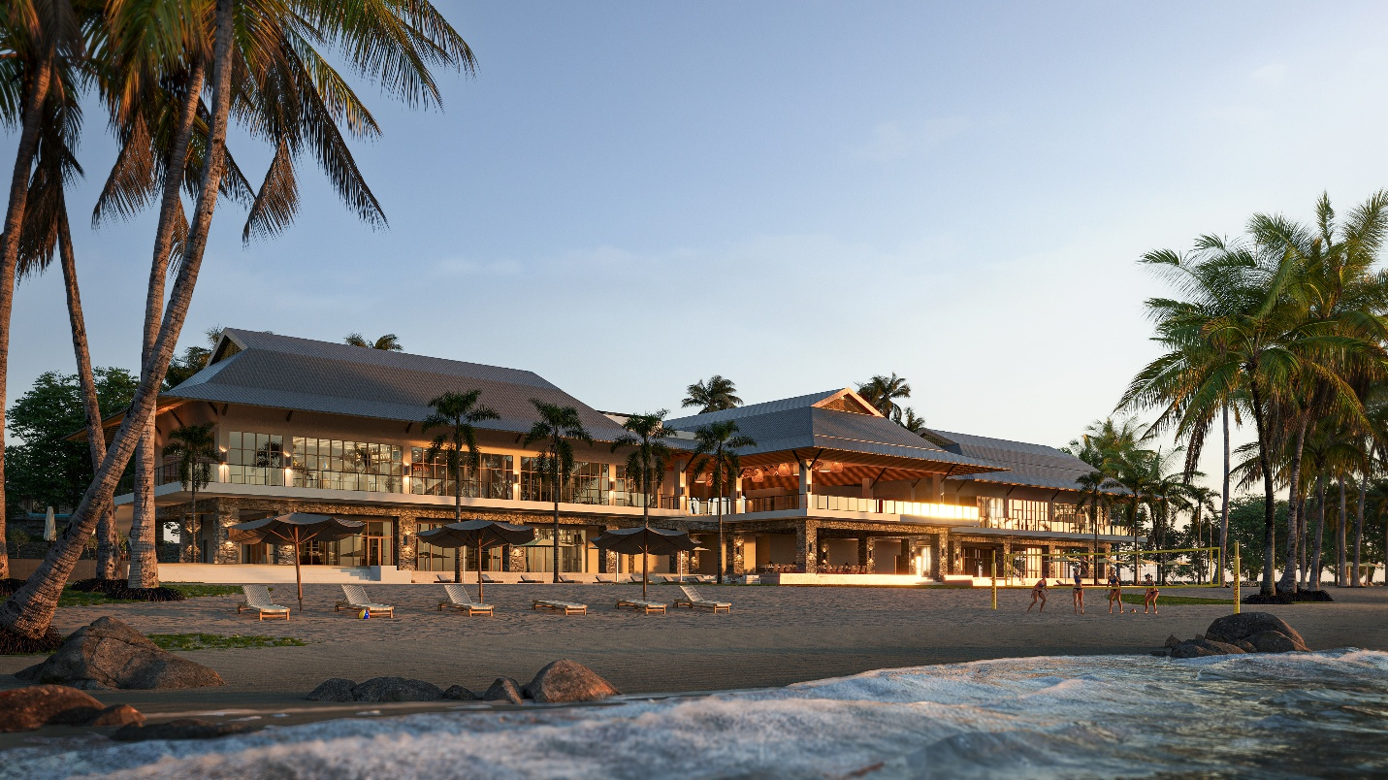

**Calatagan, Batangas, August 5, 2025** — Ortigas Land has officially unveiled **Costa Calatagan**, a 45-hectare masterplanned leisure estate that marks the company’s strategic entry into the coastal development space. Situated along a 424-meter stretch of shoreline in Calatagan, Batangas, the estate is designed as a low-density, all-villa resort and residential destination that emphasizes sustainable planning, local engagement, and long-term livability.

Costa Calatagan introduces a two-part estate structure: an all-villa resort managed by Ortigas Land and a curated collection of private lots. The offering responds to growing demand for drivable luxury destinations and second-home investments that blend leisure, wellness, and real estate stability—within reach from Metro Manila.

## **Experience-Led Coastal Living**

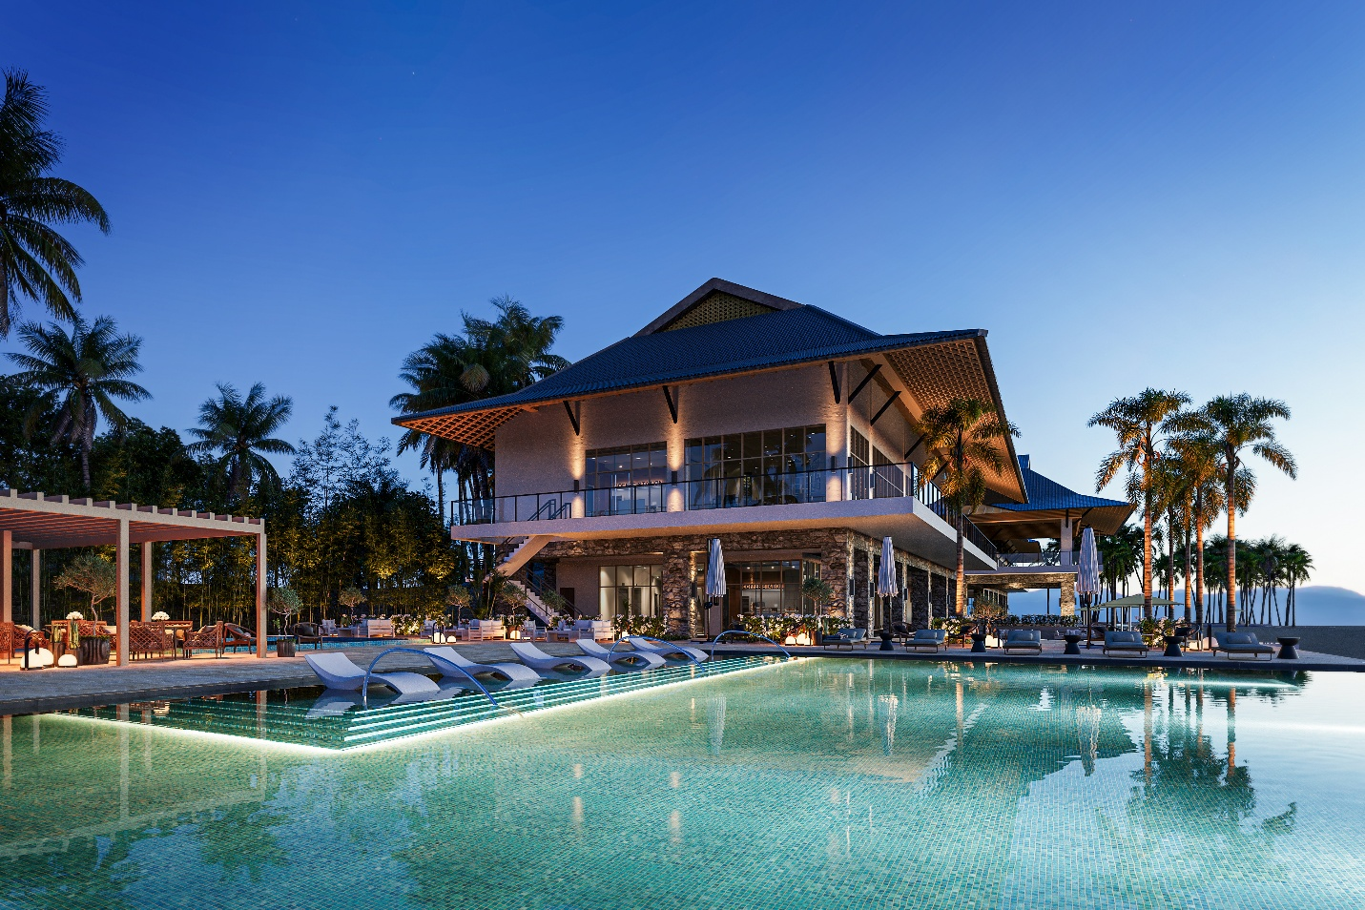

The estate is anchored by wellness-driven experiences that cater to both short-term accommodations and long-term residents. These include a 5-hectare beach, seaside clubhouse with pools, five dining concepts, access to recreational and sports facilities, and natural features such as jogging trails, walking paths, and landscaped orchards. Costa Calatagan is supported by strategic partnerships with local lifestyle providers, including Europa Yachts for charters and tours, and Calatagan Golf Club, located 5 kilometers south—enhancing the broader leisure ecosystem for residents and guests.

Its layout emphasizes ease and openness—through trails, outdoor lounges, and open coastal views. Shared spaces like the beachside clubhouse and sports and recreational facility support relaxation, everyday gathering, and recreation.

**A Coastal Setting That Encourages Wellness**

Costa Calatagan offers a setting where space, fresh air, and natural surroundings quietly support well-being. With preserved terrains, low-impact design, and open access to the outdoors, the estate invites rest and everyday connection with nature.

## **Hospitality Rooted in Local Knowledge**

## Costa Calatagan’s hospitality model will center on local partnerships. Ortigas Land plans to train and hire local residents for future resort and estate roles, focusing on service, sustainability, and operations.

## The hospitality approach will focus on comfort, familiarity, and attentive service shaped by local culture.

## **Sustainable Development with a Long-Term Lens**

## Costa Calatagan applies sustainability through clear, on-ground measures. Mature trees and mangrove areas have been preserved, and the estate’s layout follows the land’s natural topography to minimize site disruption.

## Planned features include solar energy systems, water reuse, and a green farm to support food sourcing and environmental education. These measures are designed to reduce environmental impact while supporting efficient long-term estate operations.

## **Community Integration**

**Costa Calatagan complements—not redefines—the character of Calatagan. Its low-density layout respects the area's natural rhythm while offering new possibilities for residents and visitors.  
As it enters the leisure estate space, Ortigas Land draws from a century of community-building to shape a thoughtful, place-driven coastal environment.**

***Ortigas Land*** *is one of the pioneers in real estate development in the Philippines. Now in its 94th year, the company continues to build great places for life through its iconic estates for living, shopping, business, and entertainment. It is the developer behind some of Metro Manila’s best-known mixed-use projects: Greenhills Center, Capitol Commons, Ortigas East, and Circulo Verde. For more information visit* [*www.ortigas.land*](http://www.ortigas.land/)*.*

Media Contacts:

Strategic Works, Inc.

Jackie Arias

PR Officer

09177104046

jackie.arias@stratworks.ph