A LAbor of Love (It Hurts So Bad)
By Céline Cuadra

Advised by Jennifer Alpert
With Committee Readers Young Joo Lee and Julie Mallozzi

Presented to the
Department of Arts, Film and Visual Studies
in Partial Fulfillment of the Requirements for the
Degree of Bachelor of Arts
With Honors

Harvard College
Cambridge, MA

November 29, 2022

In submitting this thesis to the Department of Art, Film, and Visual Studies and History and Literature in partial fulfillment of the requirements for the degree with honors of Bachelor of Arts, I affirm my awareness of the standards of the Harvard College Honor Code.

“What keeps us going, ultimately, is our love for each other, and our refusal to bow our heads, to accept the verdict, however all-powerful it seems. It’s what ordinary people have to do. You have to love each other. You have to defend each other. You have to fight.”
– Mike Davis, author of City of Quartz: Excavating the Future in Los Angeles, 1946-2022

This thesis is my personal reckoning with the state violence on the streets of my home, Los Angeles. This project is made in conjunction with research and a written thesis produced for the department of History and Literature. The writing argues that Los Angeles is a White, Capitalist racial Project. Through charting that Project as enunciated by the State 70 years back, the writing shows how Los Angeles is not “for all” as portrayed by media and city-led campaigns (such as the most recent anti-hate/discrimination city campaign, LA for All). This was proven primarily through the analysis of the State-led displacement and dispossession of vulnerable populations such as the houseless in Los Angeles.

My art thesis visualizes these concepts through quilt-making, a practice many women and gender-expansive members of my family have engaged in for generations. Using data sets published by the Los Angeles Housing Services Authority, I created a map of the city through ArcGis mapping software that visualized the density of houseless people by census tract in the city. I translated this data into the fabric using Los Angeles Police Department (LAPD) and Los Angeles Sheriff’s Department (LASD) uniforms. The darker the color of the fabric, the higher the density of houseless people in that given area. I chose to use Police uniforms as the source textile for the quilt because under Section 11 of the Los Angeles Municipal Code, the police are the primary enforcers of Ordinance 41.18, which states that “no person shall obstruct a street, sidewalk, or other public rights-of-way… by sitting, lying, or sleeping, or by storing, using, maintaining or placing personal property.”

This ordinance has, in the past, essentially made houselessness and subsequently houseless people illegal. The Supreme Court Case Jones v City of Los Angeles found enforcement of the Ordinance to be unconstitutional because it violated the eighth amendment rights of houseless people, criminalizing an entire identity and class of people without providing adequate solutions to house those criminalized. The ordinance was struck down by court order, with the provision that once Los Angeles had built at least 1250 shelter beds, enforcement of 41.18 could resume along with certain stipulations. Now, 41.18 has been enforced, though only at specific sites or areas where the city deems visible houselessness illegal. Those sites make up 20% of Los Angeles now, with thousands of sites still being processed and voted on by City Council. With LAPD and LASD in charge of removing unhoused people from those sites, unhoused people are continuing to be denied proper care and housing and are instead met with brutalization and trauma at police hands. The policy suggests police and sanitation workers take everything from houseless sites and either dump them or move them for unhoused people to collect from the city. What ends up happening is what has come to be known colloquially as a “sweep,” unhoused people and their belongings are swept away from the site while sanitation workers use power hoses to clean the sidewalk and police relocate the unhoused to another part of the city, stripped of their personal things and their agency.

My quilt asks what it means to visualize Los Angeles not through references to classic geographic mapping but instead through references to the State violence that spans the entire city. I wanted to call attention to the expansive geography of State violence in Los Angeles, while also questioning how the displacement of vulnerable people changes the landscape of the city. My intentions were to create an object imbued with love that also highlights violence. A quilt like this one is a labor of love, a labor that honors my home and the people who are most vulnerable there. Moreover, because the quilt is based on data sets collected in February of 2022, this quilt honors a very specific moment in time in Los Angeles, reminding us of the fact that while these numbers will continue to change, I’ve taken the time to dwell on this moment and its impact.
The quilt is entirely hand stitched, accumulating to hours of labor resulting in literal blood on my hands. This physical process has been equally important to the final project, as I continue to question my role as at best a bystander but at worst a complicit accomplice of the State. In my life, I have worked hard to be an accomplice of the vulnerable and marginalized. I believe primarily in the power of communities and collective care. I’ve worked hard to develop an academic and artistic praxis that reflects this radical love and care I have for the people I share land and life with.

For my final installation, I will be pairing the quilt with a mattress viewers will be invited to sit or lay on. The mattress has the shape of a person’s body embedded in it, the only visual reference to a body or bodies in the project aside from using clothing as my source fabric. I felt it necessary to call attention to the body in some way, especially as people’s literal bodies are the bearers of State violence. Through absence, I allude to a body but allow viewers to come to expansive conclusions as to whose body it is.

I’ve also composed a soundscape to be paired with the mattress and quilt. I wanted something minimal, cozy, and thoughtful, something that reminds me of home and could transport viewers there. It includes field recordings from the city of Los Angeles.

For my final review, I will be presenting only the quilt, though for the project’s installation in the Carpenter Center there will be the full soundscape, mattress sculptural work, and the quilt.

All materials were sourced from the city of Los Angeles.

Process Images

Mapping Houselessness

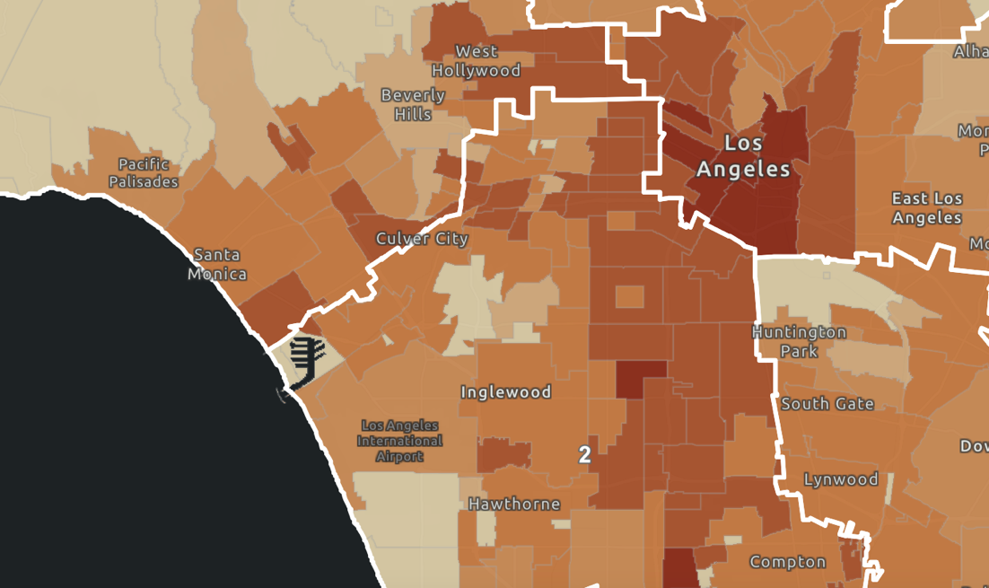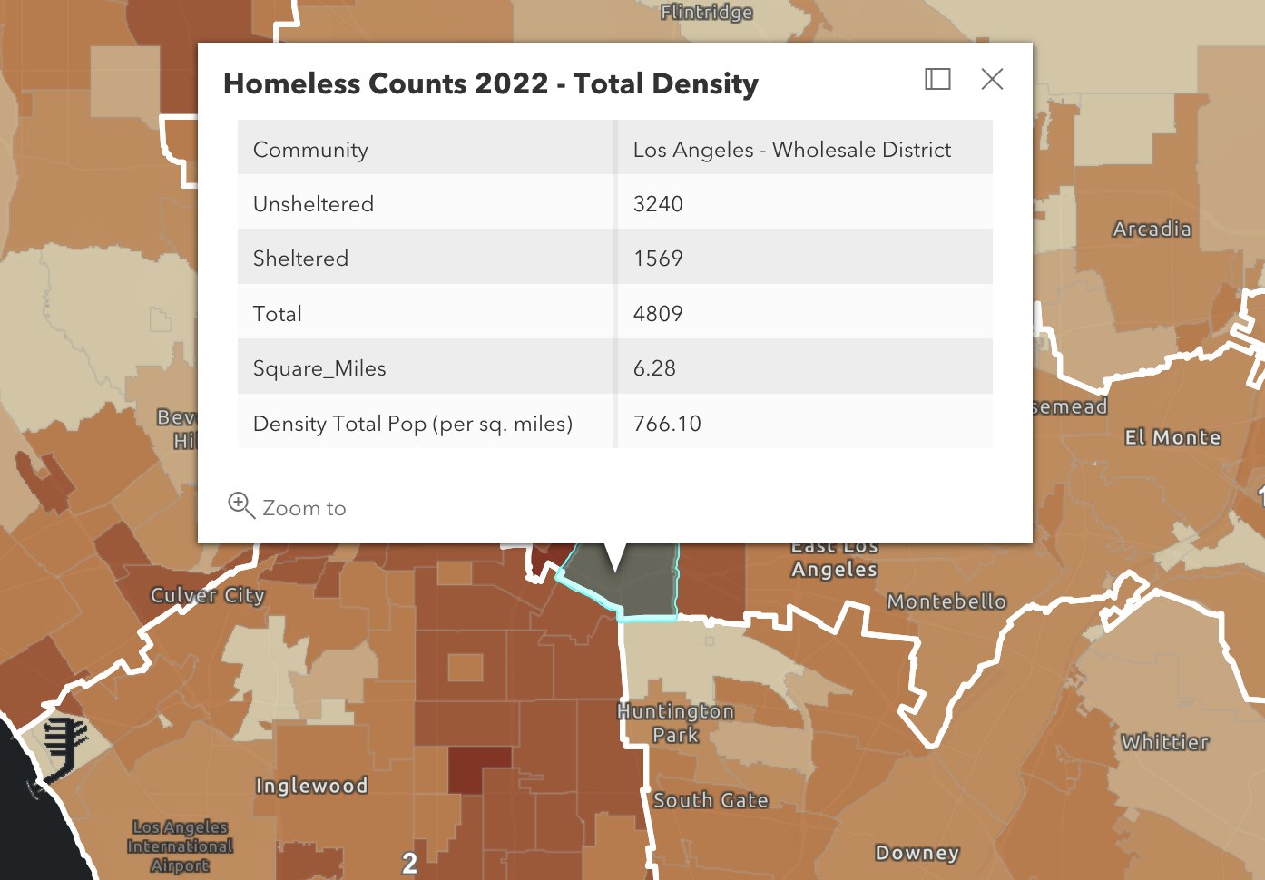
Embedded Date in ArcGIS Map
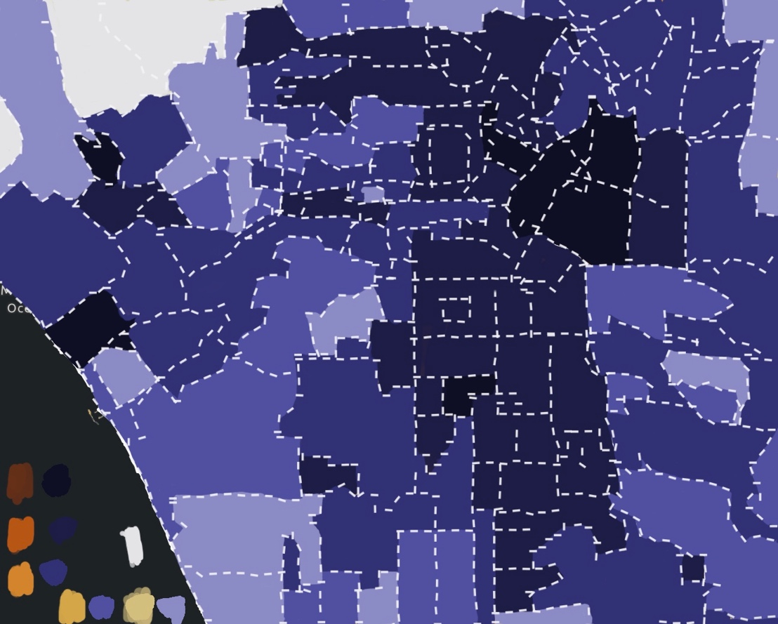
Testing different color schemes using Procreate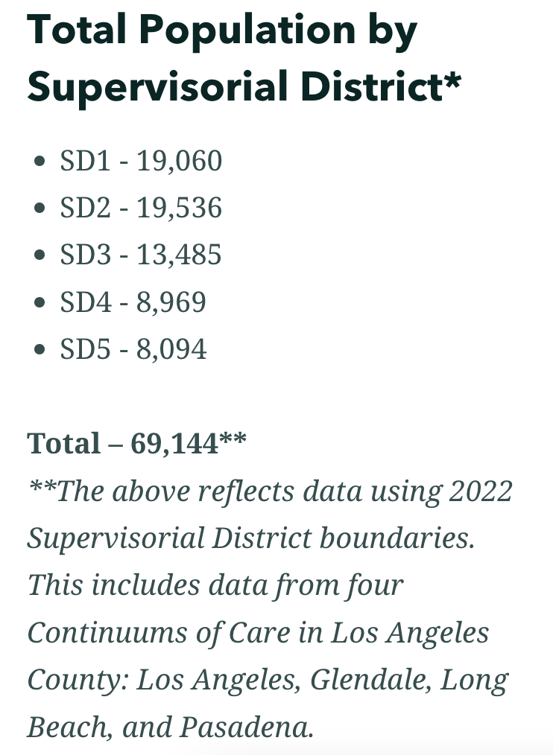

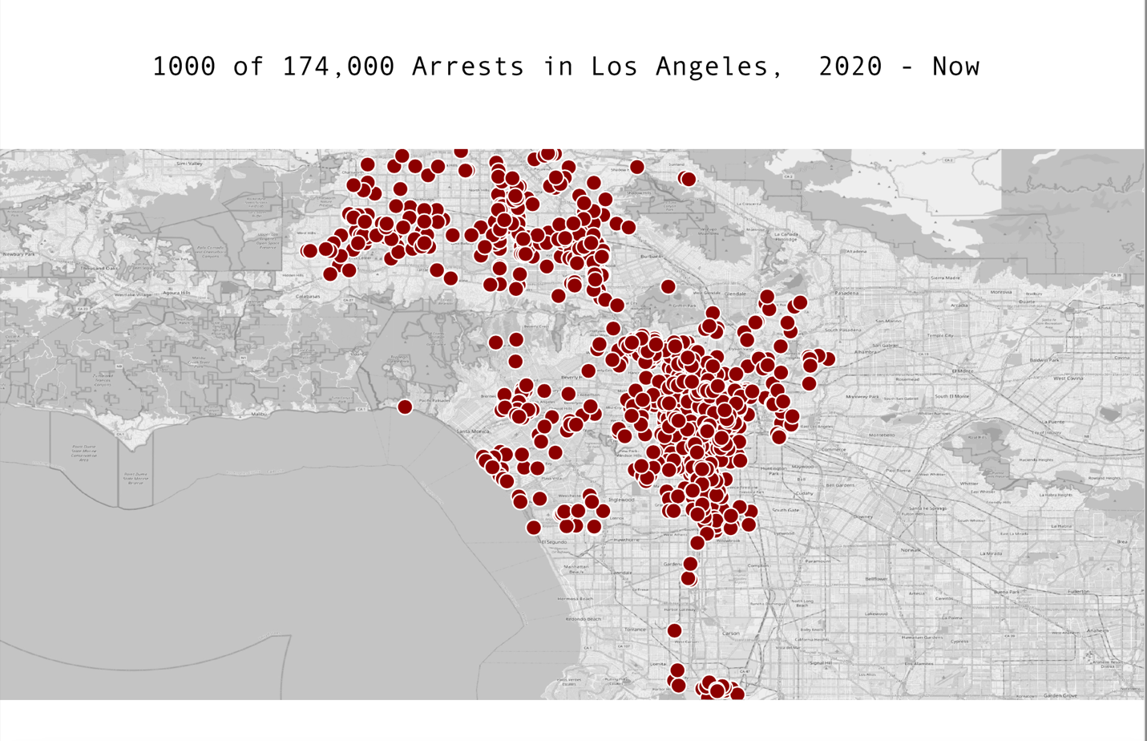

Deeper color = Higher Density of Hate Crimes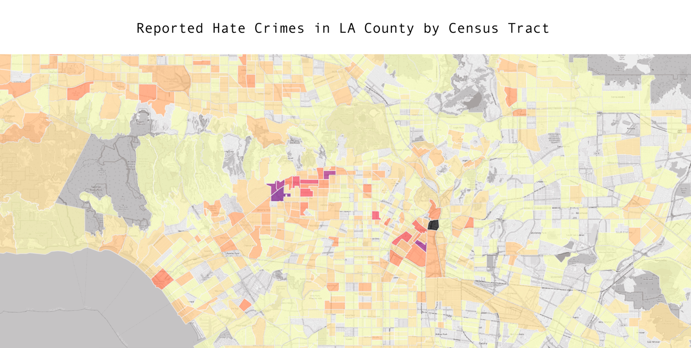
Darker Color = Blackout zone (less internet access per capita)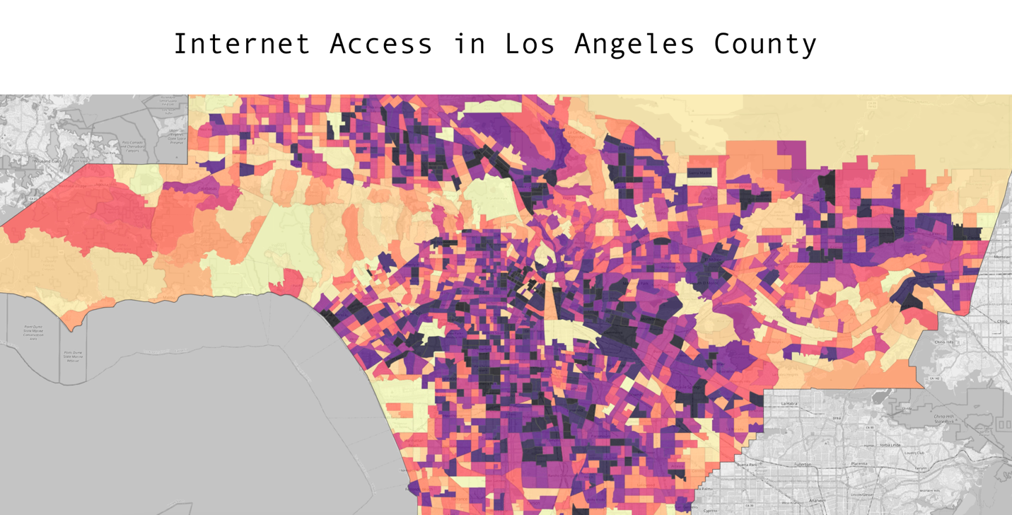

List of Works

A LAbor of Love (It Hurts So Bad) –
Quilt made of Los Angeles Police Department Uniforms, Los Angeles Sheriff’s Department Uniforms, Cotton Fabric, Linen Fabric, Thread, Los Angeles Housing Services Authority Data Set

To the Tune of Los Angeles –
Soundscape with a field recording of Mariachi Plaza in Boyle Heights by LA Listens; MIDI Instrumentation, voice, and words by Céline Cuadra

