Announcement, December 2024

Support structures for support structures 2024

Fellowship to support five UK-based artists and collectives working at the intersection of art, and community practice returns

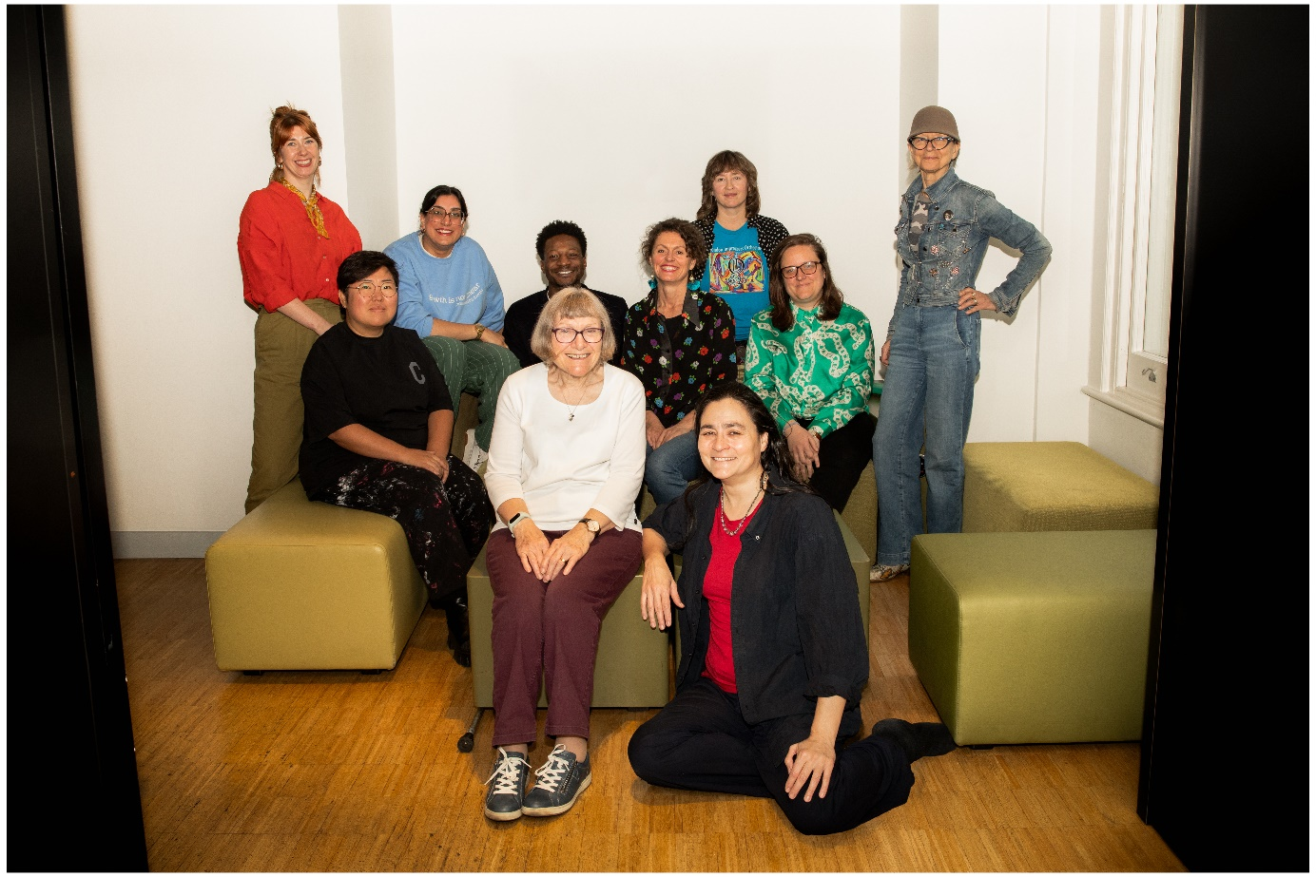

Image: Camila Bañol Montoya

Serpentine is delighted to announce the awardees of the Support Structures for Support Structures programme: Ashley Holmes, Janie Doherty, Roo Dhissou, Taey Iohe and Noisy Women Present co-founders: Faradena Afifi, Maggie Nicols, Gwendolyn Kassenaar and Marion Treby.

In its second iteration, the fellowship consists of an unrestricted grant given to each artist and collectives across the UK, a development from the first programme (2021) focused on London. Recipients will be provided with a network of support, and mentoring sessions at a timely moment in their careers.

The programme supports artists who have demonstrated a commitment to experimenting with and producing projects that have an impact on their communities and address social urgencies.

Support Structures for Support Structures was conceived in 2021 in collaboration with Pavilion architect Sumayya Vally and Amal Khalaf, Serpentine's Civic Curator and with support from artist Lynette Yiadom-Boakye. Given the scale and visibility of the Pavilion commission, Vally recognised its life-changing impact, which she wanted to extend to other artists. The fellowship is grounded in the history and current work of the Serpentine Civic and Education programme, which supports artists to work with people and communities across London to respond to the complexities of social change. Designed in the recognition that many creative practitioners who work within community practices need to be supported by grant initiatives or institutions in a sustainable way, the fellowship aims to overcome this barrier via the creation of new platforms of exchange.

Twelve visual arts professionals and community leaders were invited to nominate two individuals and collectives from across the UK whose work they believe had been making a significant contribution to their communities through their artistic practice. This year’s nominators included: Barby Asante, Alvaro Barrington, Beverley Bennett, Other Cinemas, Resolve Collective, Skin Deep, Jade Foster, Jacob V Joyce, Rita Keegan, Kim McAleese, Jade Wilson, Nicole Yip and Abbas Zahedi.

Alongside an unrestricted grant, the fellowship consists of a development programme of a 1-day gathering and round table, access to a mentor of the fellows' choice, moments for collective learning and developing discourse around these practices and projects.

The programme recognises that interdisciplinary artistic practices that centre collaborations with communities expand beyond traditional definitions of art. These practices are often experienced through in-depth processes and interventions in the public domain and become opportunities to rethink cities and neighbourhoods, question our understanding of how knowledge is shared, and experiment with new models for creative economies.

The 2021 recipients of Support Structures for Support Structures were Barby Asante, Beverley Bennett, Blak Outside, FerArts Collective, Jacob V. Joyce, Nawi Collective, Other Cinemas, Skin Deep, RESOLVE Collective and Abbas Zahedi.

Notes to Editors
Serpentine’s Public Practice integrates our work across education and civic spheres to redefine the role of the arts during periods of social change. In 2022, Serpentine’s Civic & Education department presented Radio Ballads at Serpentine North (31 March - 29 May 2022) and Barking Town Hall (2-17 April 2022). The critically acclaimed exhibition featured Sonia Boyce, Helen Cammock, Rory Pilgrim and Ilona Sagar. Pilgrim’s project RAFTS was nominated for the 2023 Turner Prize.
In 2023, Serpentine’s Civic & Education, with Koenig, released How We Hold: Rehearsals in Art and Social Change. The book is the culmination of the teams’ ongoing work of facilitating collaborations between artists and local communities via institutions of care, education, labour and other vital social matters. Designed to be used both within organisations and as a tool to critique them, How We Hold supports dissenting and oppositional conversations, and offers pragmatic challenges to neoliberal and colonial models of education and administration still found in museums, arts organisations, and other institutions today. The book uplifts and celebrates the creativity and resistance of artists and organisers, and the many people who have shaped these projects—from children in nursery to labour organisers, educators and carers, young people in academy schools and those navigating the immigration system—who find hope, possibility, and life in the most difficult of circumstances.
Between 2018 and 2024, artist Jasleen Kaur was invited to lead Everyday Resistance, Part of Changing Play. Parents from the Portman Early Childhood Centre worked with Kaur to ask how cooking and eating together can be a site of resistance. Kaur’s work is an ongoing exploration into the malleability of culture and the layering of social histories within the material and immaterial things that surround us. Her practice examines diasporic identity and hierarchies of history, both colonial and personal. She works with sculpture, video and writing. She’s nominated for this year’s Turner Prize.
The 2025 five awardees were selected by a panel comprising Serpentine representatives, Sumayya Vally and Lynette Yiadom-Boakye.

Support Structures for Support Structures 2024 nominees include:

Ashley Holmes (b. Luton, 1990) is a Sheffield-based artist, DJ and broadcaster working with sound and collaborative projects to produce work for exhibitions, performance and radio. His practice is centred around social, historical and relational knowledges and iterations of Dub, Blues and Grime music. Recent projects and performances have explored melancholic spaces between these genres and the culture of bootlegs, riddims, versions and covers to amplify frequencies, voice and memory. Ashley hosts Tough Matter, a monthly show on NTS Radio and is a resident on Mondo Radio and at No Bounds Festival, Sheffield. He facilitates Open Deck, a series of gatherings started in 2018, giving space to collectively listen and hold discursive space around relationships to music, sound, memory and oral histories.
Janie Doherty is a dance artist from Derry, based in Belfast, Northern Ireland. After graduating with a BA Hons in dance in University of Ulster, she joined Echo Echo Dance Theatre Company as an ensemble member creating work for the outreach programme and trained in a deep, authentic way of improvisation coined ‘poetic movement’ by artistic director Steve Batts. Through facilitating dance in a variety of halls, rooms and places, she built up an acute awareness of how to guide groups in an artistic way, dancing through life with thousands of people of different ages and abilities. She is interested in creating empathetic resonance in the audience. She believes our lineage is carried in our bodies, we have embodied our ancestors and intergenerational trauma is passed down through us. She qualified as a sports masseuse, to wring out the flesh in others, to help shift pain, old emotional war wounds and sadness. To help others feel light.

Roo Dhissou is an artist and doctoral researcher who works with communities, diasporas and her own histories. Using community engaged practice, craft, cooking, performance and installation she explores how communal and individual identities are formed. Roo has worked with Birmingham Museum and Art Gallery, New Art Gallery Walsall, The Bluecoat, Tate Liverpool, Primary, Eastside Projects, Ikon Gallery and more recently internationally in Spain, Canada and Poland via residencies. She is currently working on a practice-based PhD, fully funded by AHRC. Her title is Cultural Dysphoria: exploring British Asian women artists’ experiences through arts practices. Roo is the recipient of several awards, most notably the Tate Liverpool artist award 2020 and is part of permanent collections in New Art Gallery Walsall, Surrey Art Gallery and The Arts Council Collection.

Taey Iohe is a transdisciplinary artist, writer and listener, born near the Han River, and now based near the River Lea and Ching. Grounded in collective care, humility, and eco-crip belonging, Taey’s practice embraces varied media, including sound, language, moving images, and social engagement. Their work explores what ‘leaks’ from the meta-narratives of our living systems, experiencing leakage as both a symptom of pain and a pathway to healing. Taey focuses on what seeps across boundaries in waterways and ecotone sites, and how we perceive these subtle voices as forms of slow resistance.

They initiated Care for Collective Curatorial, nurturing collaborative practices as a liberatory, experimental curriculum centring ESEA diaspora experiences. Taey co-founded a research-practice working group, Decolonising Botany, presenting A Refusing Oasis at Documenta 15 — a durational performance exploring solidarity within anticolonial struggles as an artist duo, Breakwater with Youngsook Choi. Taey is a member of the Feminist Duration Reading Group, contributing to creating communal spaces discussing feminist movements and stories. Taey organised a gathering of cooks, growers, gardeners, and activists for Stone Soup: A Broth, A Shipwreck, and All the Fugitive Seeds, a collaborative event with Rasheeqa Ahmad and Rachel Pimm. The circle focused on engaging with, sharing, and reflecting on the earthly ingredients supporting bodily repair and collective grief, honouring how these ingredients have journeyed across borders. Taey is a Research Associate at the Centre for Contemporary Art in Derry~Londonderry and teaches Fine Art at Chelsea College of Arts.

The Noisy Women Present or TNWP is a collective of avantgarde artists, performers and musicians working with methodologies and traditions of improvisation that champion diversity and social inclusion. Their work supports and sustains a network of diverse communities across London and throughout the UK. TNWP is committed to resisting structures of exclusion that marginalise the work of non-binary, trans, multi-ethnic, neuro diverse and disabled women musicians, artists, and performers. The gatherings organised by TNWP involve women as performers, differently abled persons from a variety of class backgrounds, cultures, genders, sexualities, ages, disabilities and neurodiversities. TNWP uses multi-media technologies, dance, movement sound and art to elicit change through a collective practice of social virtuosity.

Criteria for Nominations:

Artists and/or Collectives:

- Who demonstrate exceptional imagination, and vision, working in the spirit of experimentation and innovation.

- Who are at the forefront of social practice, community practice and collaborative working, or are engaging in, stimulating and/or challenging the current debate in this area of work.

- Who have developed a significant body of work or made a significant impact on a social or community level over the past 3+ years and are regularly producing work;

- We are particularly interested in new forms of praxis that are situated between disciplines, and challenging inherited modes and models of practice to develop different ways of working that may offer other imaginations for our current world and its crises.

- This fellowship is for artists and collectives who are at a significant stage in their career. This would include those at the cusp of breaking through to greater recognition or those who have been sustaining this practice for many years without financial or institutional support.

In addition, the artists or collectives must meet the following eligibility criteria:

- Artists or collectives must be living or working in the UK and have done significant work in their cities or towns;

- There is no age restriction.

About Serpentine

Building new connections between artists and audiences, Serpentine presents pioneering contemporary art exhibitions and cultural events with a legacy that stretches back over half a century, from a wide range of emerging practitioners to the most internationally recognised artists, writers, scientists, thinkers, and cultural thought leaders of our time.

Based in London’s Kensington Gardens, across two sites, Serpentine North and Serpentine South, Serpentine features a year-round, free programme of exhibitions, architectural showcases, education, live events and technological activations, in the park and beyond the gallery walls.

The Serpentine Pavilion is a yearly pioneering commission, which began in 2000 with Dame Zaha Hadid. It features the first UK structures by some of the biggest names in international architecture.

Public art has emerged as a central strand of Serpentine’s programme. Major presentations include a collection of Eduardo Paolozzi’s sculptures (1987), Anish Kapoor’s Turning the World Upside Down (2010), Lee Ufan’s Relatum – Stage (2018-19), Christo and Jeanne-Claude’s London Mastaba in the Serpentine Lake (2018), I LOVE YOU EARTH by Yoko Ono (2021), Dominique Gonzalez-Foerster’s In remembrance of the coming alien (Alienor) (2022), Gerhard Richter’s STRIP-TOWER (2023) and Yayoi Kusama’s Pumpkin (2024).

Proud to maintain free access for all visitors, Serpentine reaches an exceptionally broad audience and maintains a profound connection with its local community.

For more information, please contact:

Nicolas Smirnoff, Head of Media Relations, NicolasS@serpentinegalleries.org; +44 (0) 757 0291 018
Esther Saunders-Deutsch, Press Manager, EstherS@serpentinegalleries.org; +44 (0) 787 9198 129

Follow


@Serpentineuk
@Serpentineuk
@SerpentineGalleries

