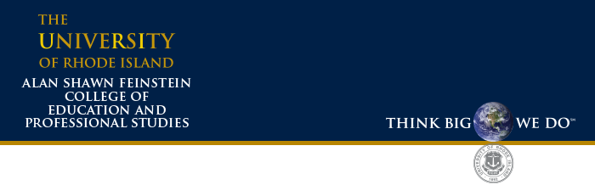

February 27, 2024

**Celine Cuadra** of the **Paul Cuffee Charter School** has earned **5** Professional Learning Units (PLUs) for completing **5** hours of professional learning as a participant in the **GEMS-Net Initial Workshop: Weather & Water Part 2**. The workshop was held on **October 17, 2023**.

During the workshop participants engaged in the following professional learning activities:

* Development of grade level/span content knowledge specific to Next Generation Science Standards (NGSS) expectations including anchor phenomena, science and engineering practices, disciplinary core ideas, and crosscutting concepts.
* Development of pedagogical content knowledge and knowledge of curricular implementation opportunities related to integrating NGSS and CCSS through grade level specific coursework and resources.
* Development of educator effectiveness through engaging in strategies designed to integrate science and disciplinary literacy including discourse, modeling, research and writing.

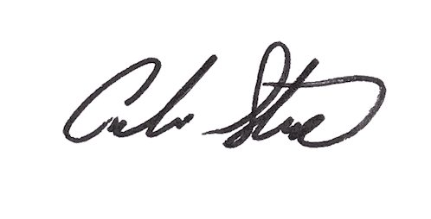

Caroline Stabile, PhD

Co-Director, GEMS-Net

ASF College of Education and Professional Studies

University of Rhode Island

[carolinestabile@uri.edu](mailto:carolinestabile@uri.edu) / 401-874-6008