# **Ortigas Land Introduces Costa Calatagan, a Community-Centered Coastal Estate in Batangas**

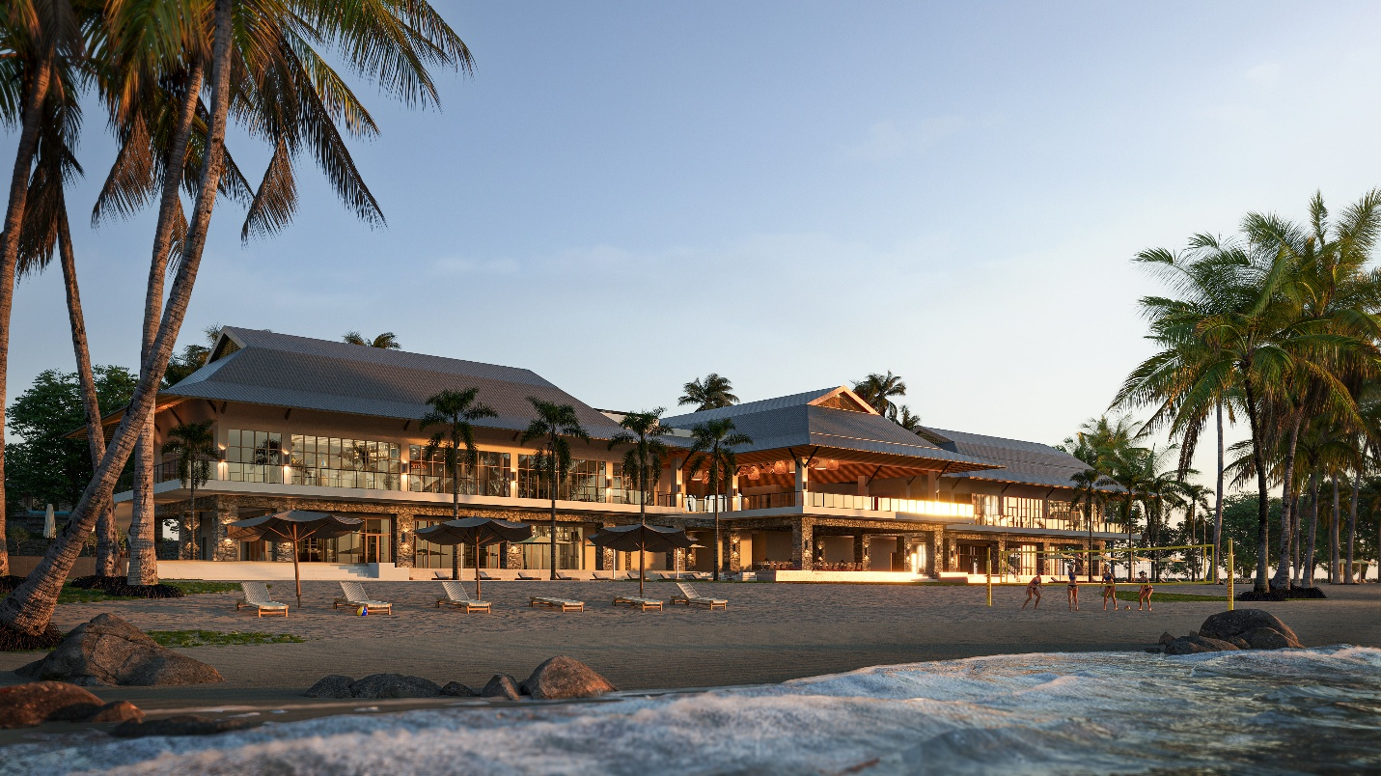

***Calatagan, Batangas, August 5, 2025***— Ortigas Land today announced the official launch of **Costa Calatagan**, a 45-hectare mixed-use leisure estate located along a 424-meter beachfront in Calatagan, Batangas. With direct access via the Zobel Highway, the project represents the company’s first entry into the resort-residential segment.

The estate integrates two primary components: an all-villa resort managed by Ortigas Land and a residential enclave offering a total of 219 lots. Phase 1 recorded a 94% take-up on launch day, underscoring robust market demand for leisure-integrated properties within drivable distance of Metro Manila. Phase 2 is slated to open in 2026, in parallel with the resort’s soft opening.

**Integrated Masterplan Anchored on Low-Density Development**

Costa Calatagan is master-planned as a low-density, mixed-use leisure estate with operational synergies between its hospitality and residential components. Shared amenities include a 5-hectare beach, seaside clubhouse with pools, a sports and recreation facility, and a pedestrian trail network, designed to promote connectivity, open space preservation, and long-term asset value. Rolling terrain was optimized to enable natural separation between product clusters and to enhance view corridors across the development.

The estate is supported by strategic lifestyle partnerships, including Europa Yachts, which provides residents and guests with access to yacht charters and boat tours, and the Calatagan Golf Club, located approximately 5 kilometers south of the estate or about a 10-minute drive. These partnerships expand the area’s recreational ecosystem and broaden appeal among experience-driven end-users.

**Resort Component: Long-Term Hospitality Asset Under Ortigas Management**

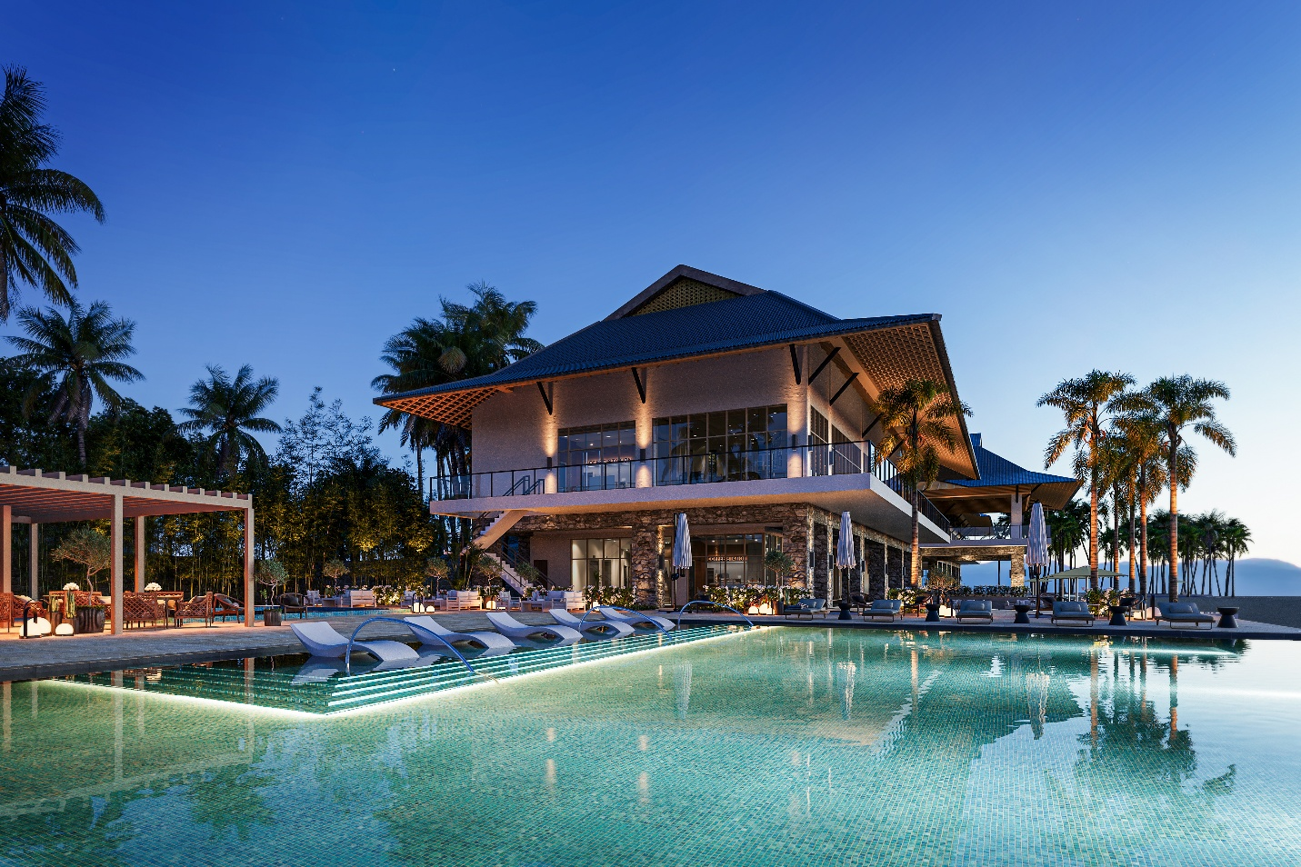

The resort component consists of over 123 villas and will be operational in phases in 2026. The Ortigas-managed resort will offer dedicated hospitality operations and service architecture tailored to high-value, low-density stays. A welcome pavilion with a guest pool, five on-site dining concepts, and integrated access to select estate amenities are key features of the resort experience.

**Private Villas: Exclusive Homes in a Nature-Rich Estate**

The Private Villas are positioned for long-term homeownership, with lot sizes ranging from 450 to 700 square meters, offering flexibility for custom-built residences designed for retreat and recreation.

A defining feature of the estate’s residential design is the absence of back-to-back lots, enhancing privacy, light, and airflow throughout. Many lots are situated within preserved mango and acacia orchards, providing natural shade, tree cover, and a mature, immediate landscape identity.

Private Villa homeowners will also gain access to exclusive amenities, including a dedicated clubhouse with an infinity pool and a yoga pavilion nestled in the orchard area—both placed to deliver a quiet counterpoint to the resort’s hospitality core.

**Infrastructure and Sustainability Commitments**

Costa Calatagan integrates sustainable estate systems including solar power, water reuse, and a planned green farm to support F&B and serve as an educational hub. It also aims to partner with local academic institutions to build a trained hospitality workforce aligned with estate values.

This estate marks a new step for Ortigas Land, drawing on its mixed-use experience and applying a clear, well-managed approach to coastal development.

***Ortigas Land*** *is one of the pioneers in real estate development in the Philippines. Now in its 94th year, the company continues to build great places for life through its iconic estates for living, shopping, business, and entertainment. It is the developer behind some of Metro Manila’s best-known mixed-use projects: Greenhills Center, Capitol Commons, Ortigas East, and Circulo Verde. For more information visit* [*www.ortigas.land*](http://www.ortigas.land/)*.*

Media Contacts:

Strategic Works, Inc.

Jackie Arias

PR Officer

09177104046

jackie.arias@stratworks.ph