DISPLACEMENT AND DISPOSSESSION IN THE LOS ANGELES WHITENESS PROJECT
OR
THE PEOPLE V LOS ANGELES CITY COUNCIL
by

Celine Cuadra

Presented to the
Committee on Degrees in History and Literature
and the Department of Arts, Film and Visual Studies
in Partial Fulfillment of the Requirements for the
Degree of Bachelor of Arts
With Honors

Harvard College
Cambridge, MA

October 27, 2022

Word Count Page: 18085 words

“What keeps us going, ultimately, is our love for each other, and our refusal to bow our heads, to accept the verdict, however all-powerful it seems. It’s what ordinary people have to do. You have to love each other. You have to defend each other. You have to fight.”
– Mike Davis, author of City of Quartz: Excavating the Future in Los Angeles, 1946-2022

***

This thesis is dedicated to my Mami, Hermana and Abuela who loved and raised me to be the scholar I am. My Tio, Tia and Primos who supported me and included me in their family right next door. My Tios, Tias, and Primos in Uruguay who I miss dearly. Mis antepasades, whose lives I can only imagine but somehow still know intimately.
I love and am so proud of you all.

***

This thesis would not be possible without the incredible Professor Jennifer Alpert. She has been the kindest, most helpful, most knowledgeable advisor. An Argentinian through and through, a scholar who practices what she preaches, a person who loves her work and community and listens so closely. I love her for these things and more, I cannot thank her enough.

I would also like to thank all the educators who have supported me throughout my academic career. Dean Luke Leafgren, Professor Tomashi Jackson, Professor Annette Lemieux, Professor Analia Tebaldi, Professor L Rodriguez (LROD). My primary educators Mr. Owens, Ms. Cordell, Ms. Pappert, Dr. Valverde, Dr. Spano, Ms. Freidal, Ms. Morris, and Ms. Mendez. You have all taught me immeasurable lessons, thank you thank you!

This project would not be possible without the community of friends I am lucky to have. Weiwen Balter, Alex Cholewa, James Nathanael Garavito, Ethan Harris, Sterre Hesseling, Ria Modak, Collin Nascimento, Samantha Podwall, Emily Wulf, Syd Xiong; I feel strange writing your full legal names. Thank you for talking to me. I love you all.

Lastly, to anyone who has ever fought for a better Los Angeles. Thank you for taking care of my city and my people. Born and raised in the Heart of Screenland, I can proudly say There’s no place like home.
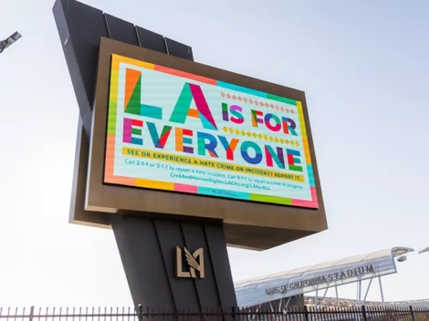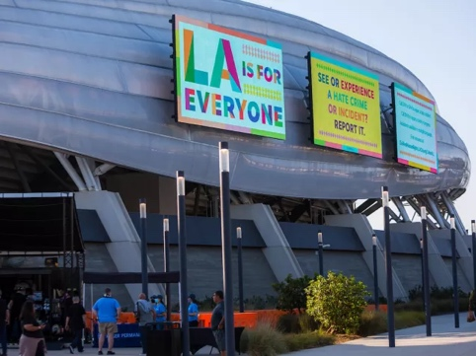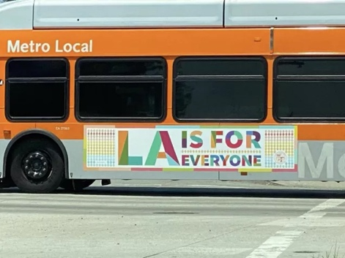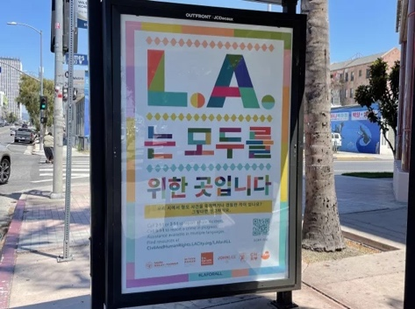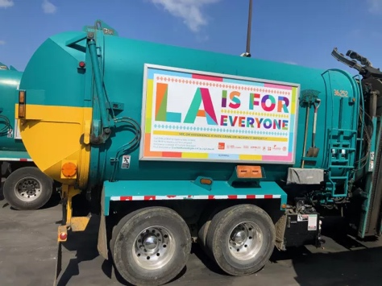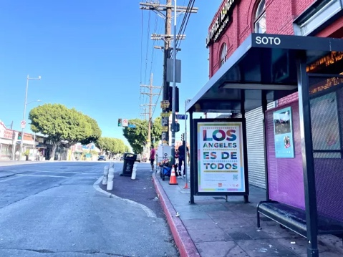

Images from the LA for All Campaign Site (https://civilandhumanrights.lacity.org/laforall/thecampaign)

INTRODUCTION: “LA FOR ALL”

From city buses to sports stadiums, from LAX terminals to bus shelters, the phrase “LA is for Everyone” was plastered across the city of Los Angeles starting May 26th of 2021. The colorful signage, spanning 12 languages across the county, inaugurated what has now become a multi-year art campaign known as LA for All. The goal of the campaign is simple: to affirm publicly and visually to the expansive LA population (the international jet setters at LAX, the tourists in Hollywood, the unhoused folks sleeping on bus benches) that anyone and everyone has a place in the city. Mayor Eric Garcetti shared his thoughts at the campaign’s opening event, stating that "LA for All reaffirms what Los Angeles is and can be at our best: a place where everybody belongs and where no one should face discrimination, bigotry, or violence because of who they are, what they look like, who they love, or what they believe.” On twitter, where Mayor Garcetti posted about the event and asked viewers to report hate by calling 3-1-1, user @collectiveyawn responded: “Very cool, can I report LAPD?”
This interaction, though brief, highlights the massive disparity between how the City of Los Angeles advertises the Project of Los Angeles as opposed to how marginalized residents of LA experience it. The term Project recognizes Los Angeles as both a physical geography and a constructed and imagined landscape. In the American and global imaginary, some may know Los Angeles for its multiculturalism, as the second most populous city in the country with 33% of the total population identifying as an immigrant. Others may know it for its police department’s militarism and brutality, stemming back to the LAPD beating of Rodney King and the subsequent riots. To the disdain of many, the city is imagined as an immigrant friendly, progressive haven for its status as a sanctuary city. For others, LA is an opportunistic and lucrative site for lavish Hollywood and New Money wealth. The Project of Los Angeles may be recognized as many different things to many different people. Here, the Project will go on to be recognized as a hub of wealth and resources hoarded by the wealthy and powerful, leaving historically dispossessed residents unable to access it.
City leaders over the past ten years have taken measures that seemingly prove a liberal and progressive Project of Los Angeles; in November of 2018, the city legalized street vending. This follows the decriminalization of street vending in 2017, which the city claims was in response to heightened ICE presence and deportations after the election. This signals to the uncritical but news-informed public that the safety of undocumented immigrants in Los Angeles is priority. But why legalize after tens of years of illegal activity and policing of street vendors? Legislation like this, which claims to have the interests of immigrants at the forefront, reveals instead the expert manipulation by legislators into making residents believe they have delivered on promises of progressive change.
LA City Councilmembers only gain from legalizing street vending, and street vendors, while promised some new protections, gain very little. To start, legalization casts city council and more broadly the State in a favorable light, making them appear immigrant friendly and progressive. With a more critical lens, legalizing street vending can be understood as a lucrative economic opportunity for the city that doubles down on their right to police and control public space. As a generative economic opportunity, legalizing street vending means the 50,000+ vendors on the streets of Los Angeles now must apply for permits, which include thousands in fees and much more in regulation compliance. A Los Angeles County Department of Public Health Code compliant mobile food facility requires “a hand washing sink…three compartment warewashing sinks with overhead protection… multiple water tanks… mechanical refrigeration… and mechanical exhaust ventilation equipment”. This kind of cart would weigh more than 700 pounds and cost thousands of dollars, an unrealistic investment for street vendors who make $15,000 a year, on average. As explained by a 2021 report by Public Counsel and UCLA School of Law Community Economic Development Clinic, “selling unpackaged food incurs a minimum of $10,000 in startup costs, plus $5,000 in annual fees. For workers earning an average of only $15,000 per year, this amounts to a ban.”
As for policing, the ordinance does little to end policing against undocumented people. Criminal charges were already rare prior to legalization amongst street vendors—out of 50,000, only 22 were convicted in 2016 according to the city attorney’s office. While even 22 arrests are too many, the reality is most street vendors in Los Angeles are still susceptible to arrest, ticketing, and harassment from police because of poorly designed food laws. Today, fewer than 200 of the 50,000 street vendors in Los Angeles County have legal vending permits. The 2021 report by Public Counsel and UCLA School of Law Community Economic Development Clinic explains how vendors “must navigate multiple offices, secure multiple prerequisite documents without adequate support, and follow a dizzying process only explained in English.” The ordinance which legalized street vending states in Section D. Enforcement, 1.(b) that vending without a valid license or permit would result in:
(1) An administrative fine of $250 for a first violation.
(2) An administrative fine of $500 for a second violation.
(3) An administrative fine of $1,000 for a third violation and each subsequent violation.
(4) A violation occurring after 12 consecutive months with no violation shall be considered a first
violation.
Thousands of vendors are susceptible to police violence, costly citations, and arrest in 2022 due to lack of permits.
The ordinance that legalized street vending successfully expands State control of public space. In the ordinance, city council specified only that only 2 stationary vendors are allowed per block. Per NPR, “in the piñata district, there are easily 100 vendors lining East Olympic Boulevard on the long block between Kohler and Merchant streets.” Moreover, vending is now prohibited within 500 feet of “the Hollywood Walk of Fame, Universal Studios and El Pueblo de Los Angeles Historical Monument… Dodger Stadium, the Hollywood Bowl, the Staples Center and the LA Coliseum on event days.” These are all extremely popular, tourist trafficked sites that for generations have housed street vendors. Now, the LA Municipal Code explicitly bans their presence there.
City council claims they legalized to protect the vulnerable undocumented community of street vendors, but legalizing the practice does nothing to protect these vendors from the broader systems of policing and deportation. City council, as a representation of the larger, white and capitalist State system it is a part of, does not concede anything in legalizing street vending; they are not shifting power away from themselves systemically to protect the dispossessed undocumented community. Instead, they are formalizing a centuries old practice to gain capitalist control of public space, generate tax revenue and revenue through vendor permit applications and infractions, and lastly, potentially surveil and track a vulnerable population. Then Councilmember Curren Price said on November 28, 2018, the day of the vote, that “we’re going to help thousands of micro-entrepreneurs come out if the shadows and become part of LA’s formal economy.” With less than 200 of 50,000 street vendors permitted in 2022, its evident that the councilmember’s promise was never a policy backed plan. All this considered, legalizing street vending can now be understood as a control tactic by the city that further polices a vulnerable community and refuses to address the larger systems that oppress and harm these historically dispossessed residents. The little that legalization has guaranteed for these dispossessed residents, at most, temporarily grants them capital and power in the form of legal business that has historically been associated with whiteness. This capital is temporary and conditional on the city’s approval. This minor shift in power is granted only because the vendors fit within the city’s capitalist and entrepreneurial goals.
Ordinances like these are a part of a larger trend of policies that media dubs “progressive” legislation in Los Angeles. However, this perception coupled with the reality of these regulations perfectly illustrate the Critical Race Theory concept known as interest convergence. This phenomenon arises when white powers grant certain privileges to formerly disenfranchised or disempowered communities. Interest convergence, as explained by scholar Derrick Bell, is at its start, almost always viewed as progressive in the mainstream for its perceived expansion of civil rights. However, legislation like this often reinforces the white, capitalist status quo without reforming or abolishing the broader systems that originally caused the disenfranchisement. Bell provides Brown v. Board of Education as an example of the interest convergence phenomenon, which legally ended segregated education in the United States in 1954. However, the Supreme Court case has done little to end the current reality of segregated schools, which is caused by the larger systems of socioeconomically segregated communities.
Using interest convergence to understand Los Angeles City Council policies reveals that the project of Los Angeles, as undertaken by the LA City Council, is a whiteness project that seeks to displace and remove people of color through what legislation dubs as “revitalization” campaigns. “Revitalization campaigns” have a long history in Los Angeles going back at least 70 years to the Chávez Ravine displacement. Historically, promises of urban renewal and “revitalization” in the form of new or renovated public spaces, such as parks, or new housing developments have rarely led to either of these outcomes. When State promises do come true, they almost always come at the cost of displacement and violence against historically dispossessed people. “Revitalization,” then, can be understood as a weapon against the poor that seeks to remove poverty without adequately addressing it. “Revitalization” gains its positive connotation through media campaigns. Through comparison of the 1950s Chávez Ravine displacement alongside the 2021 Echo Park Lake displacement, a notable legacy of media dubbed as “humane” or “progressive” displacement in the form of “revitalization” becomes apparent. “Revitalize,” in Los Angeles, means to remove current (often poor or racialized) life with the promise to replace it with new vitality. The new life takes the form of renewed green spaces, businesses, and other forms of private capital development.
Through continued legislation and city ordinances that criminalize people of color and public activities by marginalized residents, Los Angeles City Council affirms that the city is not, in fact, for all. As representatives that legislate in the stead of “all”, Los Angeles City Council has written ordinances since 2000 that make apparent that they do not wish to include dispossessed Angelenos in their “all” as signified through their legislation around the term “public”. Instead, Los Angeles has reworked the term “public” to include only those in the city aligned with whiteness and capitalist growth.
Moreover, LA City Council decisions reflect a changing racial order in the larger United States. Scholar Eduardo Bonilla-Silva argues the United States is currently undergoing a shift from a bi to tri-racial system. In this tri-racial system, whites are at the top, then a middle class of “honorary whites” that reap some of the benefits of the “wages of whiteness” (such as decent work, housing and higher education), and the bottom of the racial hierarchy occupied by the “collective black,” a primarily non-white and poor group. The tri-racial hierarchy is made up of “traditional” whites, new “white” immigrants, white assimilated Latines and other light-skinned multiracial people who comprise the new “white” category; light skinned Latines, certain Asian Americans and other multiracial people making up “honorary white”, and reservation-based Natives and dark-skinned people of African, Asian, and Latin American descent as the “collective black.” This racial hierarchy is like that of many Latin American nations, whereas the bi-racial system was already an outlier globally . This Latin Americanization of the Los Angeles racial order is aligned with the current demographics of the city, which is predominantly Latine or of Latine descent. Los Angeles City Council illustrates this new racial hierarchy extremely well, with councilmembers occupying the white and honorary white classes despite the multi-racial backgrounds of the council (Native, Latine, Asian).
Issues of power in Los Angeles cannot be delineated by using only Bonilla-Silva’s tri-racial system. To achieve a fuller understanding of power and dispossession in Los Angeles, I use an intersectional approach which recognizes class, race, gender, and documentation alongside other identities as markers of status. Consequently, this thesis identifies specific members of Los Angeles within Bonilla-Silva’s tri-racial coupled with a class-based analysis of said residents. Combined, these lenses work together to identify which members of the LA public have growing power in its politics and who is increasingly dispossessed. This thesis identifies how the LA City Council uplifts residents with capital, including but not limited to housed members of the white and honorary white categories, while simultaneously displacing and removing members of the collective black, unhoused, and otherwise dispossessed people from the city. Through these policies and actions, Los Angeles City Council reifies Los Angeles as a whiteness project that protects capital and erases poverty.
My thesis also investigates the social impacts of government induced displacement on majority-minority communities. Through constant government sanctioned displacement, communities begin to self-police and differentiate amongst themselves. This is analyzed through news articles as well as rhetoric directly from housed residents against unhoused residents, who housed residents do not accept as true community members due to their lack of capital in form of land ownership. Whether subconscious or explicit, analyzing publications from housed residents shows that these Angelenos use meritocracy narratives alongside qualifiers like property ownership and education to justify their right to public space and disqualify the unhoused from those spaces. By identifying two different forms of state sanctioned displacement: government induced gentrification (i.e. revitalization projects) and houseless sweeps, this thesis argues that displacement in Los Angeles cannot be accepted as a natural phenomenon caused by the economic whims of white upper-class residents. Displacement in the context of Los Angeles is a systemic, racial, and capitalist project by the State that is propped up by and policed by the upper classes. The consequence of this is the erasure and removal of poor people of color from the physical landscape of the city.
Chapter one of this thesis situates current displacement in the city by firstly analyzing the progression and development of gentrification and displacement studies in the United States. Through directly quoting residents alongside the inclusion of social media postings, this thesis challenges the prioritization of quantitative and theoretical understandings of displacement in the broader field of displacement studies. Instead of understanding displacement solely through data, which flattens the experiences of people into statistics, I focus on including digital and verbal testimonies as qualitative understandings of displacement and its sociopsychological effect on dispossessed individuals, families, and broader communities. Chapter one begins the work of centering and thus honoring marginalized residents’ experiences as important inclusions in displacement studies. Using the 1950s Chávez Ravine displacement alongside the 2021 displacement of houseless encampments from Echo Park Lake as examples, this chapter implicates the city of Los Angeles in the intentional displacement of marginalized communities through their emphasis on revitalization. Through analyzing the displacement of these historically dispossessed communities, this thesis recognizes that in a capitalist city like Los Angeles, these populations are excluded from resources and pushed out in favor of “new life” because of their lack of capital and subsequently, under capitalism, their lack of “inherent value.”
Chapter two of this thesis is concerned with displacement beyond revitalization campaigns. This section broadens the discussion from unhoused sweeps and their intersection with revitalization campaigns by questioning City Council’s expansion on the policing of public space. By limiting use of public parks, limiting the physical range of protests in public spaces like sidewalks, and reducing the amount of time for public comment in city council meetings, Los Angeles is altering the legal and social understanding of the word public. Through close reading of the Los Angeles Municipal Code alongside Ordinance 41.18, which prohibits sitting, sleeping, lying, or otherwise occupying the public right of way, this chapter argues the legal definition of public has changed to exclude poor people of color. Instead of outright defining the term public, LA City Council defines the term in the Municipal Code through specifying what it is not. The emerging definition of public that the Council has formed is one that excludes the behaviors, practices, and existences of the poor and the unhoused, leaving them subject to State sanctioned violence through ordinances that criminalize their existence.
My conclusion begins the work of honoring community care and responses to state violence at the hands of the City of Los Angeles and law enforcement. While chapters one and two sought to prove that city activities reify Los Angeles as a capitalist, whiteness project; my conclusion centers the effects of this project on racialized and poor members of the community. This is primarily achieved through reflection on this project and its research with my mother and grandmother, two Latin American immigrants to Los Angeles who have had their own experiences with undocumented status and low-income. This reflection is further by the recent controversy which has resulted in the resignation of the council president and impassioned calls for the resignation of two more councilmembers. My work proves that beyond their explicitly racist and classist statements, LA City Council and the State have historically shown through their policies that they do not recognize those without economic or social capital in the city as community members deserving of public spaces or belonging. My conclusion reminds us that very real harm has happened at the hands of councilmembers long before the general public became explicitly aware of it through their privately racist remarks. Demanding their resignation places the LA public in the perfect position to ask ourselves: what do we want for our future? Who do we want to represent us in those goals? Where can we form coalitions? And most importantly, when these systems inevitably continue to fail us, how do we take care of each other in the face of ongoing state violence?

CHAPTER ONE
REVITALIZATION: THE REMOVAL OF CURRENT LIFE

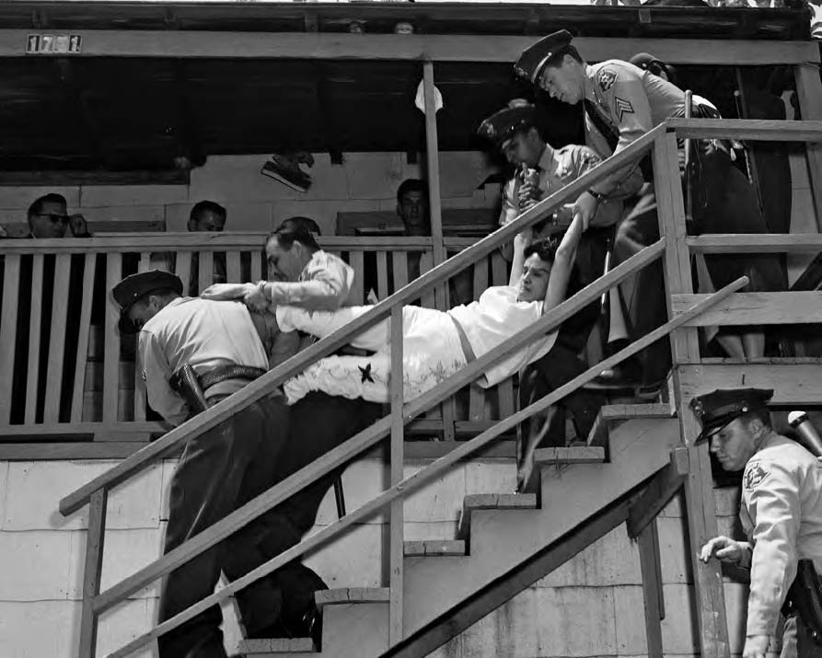
Aurora Vargas is carried by Los Angeles County Sheriff’s deputies after her family refused to leave their house in Chávez Ravine. May 8, 1959. Source: Hugh Amott, Los Angeles Times

DISPLACEMENT STUDIES: UNDERSTANDING 70 YEARS OF ERASURE

.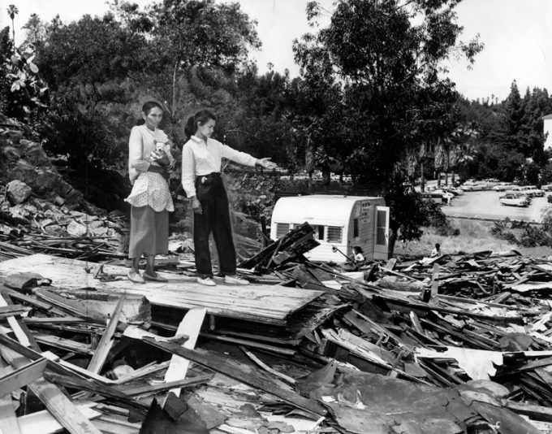
Mrs. Abrana Arechiga and her daughter, Mrs. Vicki Augustain, look at the ruins of one of their Chavez Ravine homes Date: May 14, 1959.
The destruction of Chávez Ravine, a tight-knit and self-sufficient majority Mexican community in the hills of Los Angeles, exemplifies the failures of the 1949 and 1954 Housing Acts. The Acts were meant to generate urban renewal through clearing impoverished communities, referred to in the title of the Acts as “slums.” Public housing projects would replace these “slums” nationwide. In 1949, Los Angeles received federal funds and Mayor Fletcher Bowron approved a housing project that would contain 10,000 new units. Thousands were meant for the Chávez Ravine community.
In July of 1950, Chávez Ravine families began to receive eviction notices from the City Housing Authority (CHA). The CHA had designated Chávez Ravine as the most “blighted area in the city in need of rehabilitation.” By 1953, the CHA had repeatedly promised displaced families that “this project is going to be built for you, we’ll give you temporary housing.... [Y]ou’ll have first priority, you can have whatever you want.”
This echoes the offers for temporary housing at Echo Park Lake in 2021. There, 209 members of an unhoused encampment and community were violently displaced by 400 riot police. The Park was shut down for 3 months and reopened in the summer of 202, after a $500,000 revitalization effort, entirely fenced. Those fences still stand in October of 2022. In both instances, Los Angeles displaced poor and historically dispossessed people to make way for private capital and development. Through these actions, Los Angeles can be understood as a capitalist whiteness project that has accommodated to its upper class spanning back 70 years.
70 years prior to the Echo Park Lake Displacement, Los Angeles forcibly removed the families occupying Chávez Ravine from their homes for revitalization. Police carried several individuals, including Aurora Vargas (pictured above), out of their homes. Through erasing them and their livelihoods, Los Angeles city officials made room and prioritized new life. This new life would take the form of sanitized revitalization, with cookie cutter apartments replacing the individually hand built homes of the Ravine. The CHA maps and plans erased Chávez Ravine’s dirt roads, lined with the most privately owned housing by Mexican Americans in all of Los Angeles County. Instead, the maps detailed plans for parallel paved streets that would house thousands of new, rentable dwellings in what would be called Elysian Park Heights. The Mexican landowners were forever dispossessed from their land in the Ravine.
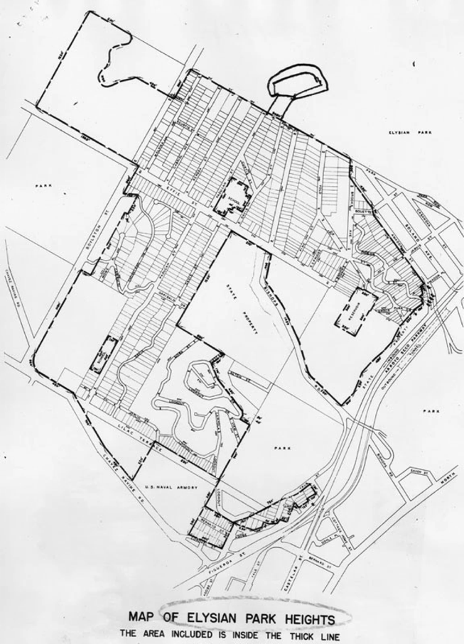
Map of Elysian Park Heights. Herald-Examiner Collection, Los Angeles Public Library
The CHA never fulfilled its promise of “first priority” and public housing, as the next mayor of Los Angeles, Norris Poulson, canceled the public housing project even though most of the residents of Chávez Ravine had already been removed. In his book Popular Culture in the Age of White Flight, scholar Eric Avila argues the Los Angeles urban elite attacked and ultimately succeeded in killing the Chávez Ravine urban renewal campaign as “subsidized housing within the vicinity of downtown did not suit the elite visions of privatized redevelopment.” Mayor Poulson and the LA elite’s successful end to the “socialistic” public housing projects cleared the way for their desired private re-development of the greater downtown Los Angeles area. With the slums cleared and no obligation to house the displaced Mexican community in Chávez Ravine, the Los Angeles elite were able to pursue a more “American” project: Dodger’s Stadium.
Chávez Ravine is a specific instance of failure for the 1949 Housing Act; the 49 and 54 Housing Acts, however, were largely a failure nationwide. They failed in part because of Cold War era hysteria and fears against “creeping socialism” in the form of public housing projects. Beyond the Red Scare narrative of communist housing, in more practical terms, large-scale “slum” clearance was extremely difficult, and officials lacked an adequate response on how to house dislocated people. These factors combined led to an early and compelling academic interest in understanding displacement and how it affected the dispossessed. In his 1966 book, Grieving for a Lost Home, Mark Fried observed how relocation undermines the established interpersonal relationships and group ties of the people involved and, in effect, destroys the group identity.” Fried conceptualizes urban displacement as a trauma which disrupts our understanding of social relationships like home and community, and by extension belonging.
As the State ditched urban renewal campaigns due to unpopularity and defunding, displacement became recognized in academia primarily as early gentrification. Gentrification was extremely misunderstood at the time due to the difficulties in pinpointing direct causes or patterns. For this reason, writings on gentrification tend to overemphasize the role of gentrifiers over other potential actors and causes. Simply put, studying gentrifiers in the form of upper-class citizens and landlords was the most obvious way to analyze the issue. Consequently, geographers like Chris Hamnett or David Ley theorized that gentrification was due to rising ground-rents and changing consumption preferences in a post-industrial society. This stood in heavy contrast to authors like Neil Smith, who argued under a Marxist framework that gentrification should be understood as “a movement of capital, not of people.” Smith’s contributions helped show how capitalist urbanization causes displacement. In doing so, he highlighted the role of new actors in the process such as legislators, financial institutions, and law enforcement. This was an analysis that had been absent in previous works that conceptualized displacement as a conflict primarily between landlords and tenants. All these authors, however, tended to overprioritize changing social demographics in their displacement studies, meaning their conclusions led to theorizing based on the assumption that displacement was an inevitable outcome of rational economic decisions regarding the housing market.
To this date, the only national study in displacement in the United States concluded that gentrification was negligible. This work took a quantitative approach, and while the numbers may lead to a negligent conclusion, gentrification is extremely pertinent in the lived experiences of the historically dispossessed. As previously mentioned, gentrification as a form of displacement is difficult to study in social sciences as it requires quantitative methodological work that focuses on an invisible population, that is, a group of people that are no longer physically there. Due to these issues, writings within gentrification studies in the last 15 years have argued that analysis needs to de-emphasize quantitative analysis and instead prioritize a conceptual and philosophical understanding of gentrification.
These understandings are more in line with the goal of this project, which includes understanding the effect on displacement broadly on community, belonging and livelihoods. In 2009, Mark Davidson noted that “within the current discussion of displacement… an abstractive empirical background has lost touch with the very meaning of displacement itself.” He goes on to expand the definition of displacement, recognizing for the first time that “a people can be displaced— unable to (re)construct place— without spatial dislocation.” By recognizing that a people do not have to be physically removed to feel displaced, Davidson makes room for a broader understanding of displacement that recognizes the emotional impacts of gentrification processes, such as a changing neighborhood where new construction and revitalization causes a sense of displacement. This places gentrification as not only the movement of a people or of capital, as Smith had noted, but as a struggle over culture and cultural productions that leave those affected (in Los Angeles-- the low income, immigrants, and other generally dispossessed peoples) with a serious trauma and strips them of social understanding of community.
These works start to complicate gentrification and displacement as they allow for nuances that go beyond the linear dynamic of landlord/tenant disputes. They are limited, however, as they lack significant critical inquiry into the racialized nature of displacement. As showcased in Chávez Ravine, displacement has always been a racially motivated phenomenon in the United States. This illuminates how since the 1950s, Los Angeles has used language like “urban renewal” or “revitalization” to justify the classist and racist erasure of poverty and people of color. Previous contributions to displacement studies have dedicated themselves understanding the effects of displacement on communities. I stand on these works, in conjunction with Critical Race theory and a historical lens to achieve an interdisciplinarity that mirrors the intersectional lives of the populations I am writing on. Working together, these lenses allow for a more nuanced and fuller understanding of displacement that recognizes economic inequality’s effect on community building alongside understanding racial inequality and the nature of capitalist displacement as a white racial expansion project.

UNDERSTANDING WHITENESS AND PROPERTY OWNERSHIP AS A CAPITALIST RACIAL PROJECT
Whiteness is an unnamed racial hierarchical system that serves as the foundation of Western Civilization. Author Ruth Frankenberg expands on the construct in their article, Growing up White: Feminism, Racism and the Social Geography of Childhood:
“Firstly, it is a position of structural advantage, associated with ‘privileges’ of the most basic kind, including for example, higher wages, reduced chances of being impoverished, longer life, better access to health care, better treatment by the legal system and so on…Secondly, whiteness is a ‘standpoint’ or place from which to look at oneself, others and society. Thirdly, it carries with it a set of ways of being in the world, a set of cultural practices, often not named as ‘white’ by white folks but looked upon instead as ‘American’ or ‘normal’.”

Scholar Peter McLaren notes however, that “Whiteness is unfinalizable, but compared to other ethnic formations, its space for maneuvering in the racialized and genderized permutations of U.S. citizenship is infinitely more vast.” What is meant by this is while we can approach definitions of whiteness, its meaning is constantly expanding and changing. Concepts like Eduardo Bonilla-Silva’s term “honorary white” recognize this mutability and expansion of whiteness in the 21st century. This is accompanied by a growth in the occupation of physical space to accommodate the expansion of whiteness, all to the detriment of those deemed non-white.
Critical Race Theory scholar Cheryl Harris, in her 1933 article in the Harvard Law review explained how theorizing whiteness as property allows us to understand the economic, social, and physical impact of expanding occupation of space by white residents. Harris notes a capitalist dynamic between the conceptualization of whiteness and Blackness in this country, a dynamic created by slavery. While whiteness can be understood in our legal system as a form of property, Blackness has been understood as an object in the eyes of the law. She writes, “Whiteness – the right to white identity as embraced by the law – is property if by ‘property’ one means all of a person’s legal rights.” This did not end with slavery, however, as “Whiteness as property…continues to assist in the reproduction of the existing system of racial classification and stratification that protects the socially entrenched white power elite.” Whiteness as property affects every dimension of a person’s lived experience, of relevance to this thesis is the interplay between whiteness and belonging, property ownership, and displacement.
The phrase “whiteness as property” recognizes the connection between race and class status. Peter McLaren explains how in the United States, “Racism emerged as the ideology of the plantocracy. It began with the class of sugar planters and slave merchants that dominated England’s Caribbean colonies. Racism developed out of the ‘systemic slavery’ of the New World.” Racism separated the work force into two clear hierarchical classes: a white upper class and a lower class made up of people of color. Author Alex Callinicos explains that “Racism…gives white workers a particular identity, and one moreover which unites them with white capitalists.” While this racial solidarity between white capitalists and upwardly mobile white people is certainly prominent in theorizing displacement, due to the expanding nature of whiteness, the 21st century has seen racialization in the form of “honorary white” that temporarily aligns capital-oriented marginalized folks with white actors.
Gentrification in majority-minority cities functions clearly within the tri-racial system because it requires an expanded understanding of whiteness. For example, in East Los Angeles, upwardly mobile, entrepreneurial Latines who espouse gentefication narratives which promote Latine ownership of the barrio are granted “honorary white” status. By aligning themselves with LA state powers and white, upper class Angelenos, these Latines are granted proximity to whiteness that integrates them into the social fabric of the broader community. As recognized community members, “honorary white” Latines can access guarantees of housing, business ownership, education, and other powers. These commodities are extended because of the inherent productivity and use white and “honorary white” Latines proudly boast. “Whiteness as property,” as Harris explains, recognizes an understanding of whiteness that is not only racial but capital in nature. Through capital accumulation, upwardly mobile and business oriented Latines are subsumed into the “white” and “honorary white” racial strata.
Low income Latines do not have access to these commodities for exactly the opposite reasons. In a white and capitalist society, marginalized communities that might include intersections of undocumented, poor, and non-English speakers have little to no inherent value or obvious “product” to contribute to society. Because they lack property or other forms of capital, these people are consequently not viewed as community members by upper classes, who can legally construct community through their inflated political power as owners of capital. Instead, low income and racialized Latines are most often “invisible” workers in white landscapes (i.e., gardeners, housekeepers, line cooks—jobs that require arguably artistically skilled labor but are not valued as such). As invisible workers and unrecognized community members, low income and racialized Latines are at risk of physical displacement or at least feelings of displacement in gentrifying neighborhoods, as previously noted by Mark Davidson. In Los Angeles, “honorary white” Latines are at best complicit, at worst perpetrators of this displacement within their communities because of their valuation of capitalist ownership of land and entrepreneurship. In viewing landownership and other forms of capital as a qualifier for merit, these Latines deem themselves worthy of community resources and belonging while the historically dispossessed are not.
Beyond intra-community conflict, capitalist agents in Los Angeles (such as city officials, developers, and private interest groups) appropriate radical language alongside free market ideology and meritocracy narratives that support white, upper-class residents’ desire for more private developments alongside sanitized public spaces. The exponential rise in luxury housing projects and private land developments in the city over the last few years has been to accommodate the white racial expansion project of LA elite capitalism. As for the creation of sanitized public spaces, capitalist politicians have created programs such as the CARE+ teams (Comprehensive Cleaning and Rapid Engagement) to displace and erase poverty from the city’s public landscape. When Mayor Eric Garcetti called the displacement of the unhoused the “liberation of public space”, he intentionally refocused discussions on poverty in Los Angeles onto the white public’s right to parks and leisure. Angeleno politicians, in these comments, support the sometimes unconscious, other times explicit middle- and upper-class belief that they deserve public spaces more than the poor and unhoused do. Furthermore, these discussions frame the unhoused not as community members deserving of housing and resources where they choose to live but instead as public enemies, stealing public land and resources from the community. The poor and unhoused in Los Angeles are in fact members of their communities, but under white racial capitalism, the State does not allow them to access resources such as parks and other public spaces that are conventionally entitled to the public. In doing this, the State creates an exclusionary legal definition of public. This is developed further in Chapter 2.

FROM CHÁVEZ RAVINE TO ECHO PARK: THE DESTRUCTION OF RADICAL COMMUNITY THROUGH REVITALIZATION
Although the City Housing Authority alongside the LA Times and some private interest groups framed Chávez Ravine as a “blighted” community of “a few ramshackle dwellings… rusty tin cans, rotting tires, moribund mattresses and broken beer bottles,” members of the Chávez Ravine community had another story to tell. A former resident recalls the community before the CHA displaced them:
There were dances in the churchyard. Pageants held in the street. Weddings in which the whole community joyously participated… Flowers, gorgeous blooms, dahlias fit to grace any show display. Gardens, orchards, livestock. Cow’s and goat’s milk—cheese of every color, kind, and consistency. Cactus broiled, baked, preserved. At night, bonfires—music wafted over the air. Chavez Ravine was the only place in the city that had not over-crowded school accommodations… and without traffic hazards to eat out the hearts of mothers.
This description of community events and shared resources recall another Angeleno community no longer in existence because of city induced displacement. At the start of 2020, Echo Park Lake became the home to a growing community of unhoused encampments. On February 13 of 2020, @echoparkriseup , a now inactive Instagram account that was run by the unhoused community in Echo Park, made its first post. Over the course of the next year, @EchoParkRiseUp made 29 posts total, many of which show the unhoused community at Echo Park working alongside local grassroots organizations to clean up the park, create hand washing stations, share meals in community with each other, create two food donation tent pantries, set up four showers at the park, and employ residents of the encampment to do various jobs in operation of the encampment. A post from August 7th of 2020 details how the camp’s unhoused board of directors and homeless citizen oversight committee had started “to offer $10/hour to 10 residents (8 at Echo Park, 2 at Grant Park), to do jobs including park security, shower monitor, donation inventory, donation tent distribution, police and community liaisons.” Other posts show video testimonials from encampment residents about how they enjoy and appreciate the growing Echo Park community and living there. It is abundantly clear from Echo Park Rise Up’s Instagram as well as other accounts (such as @groundgamela, @ktownforall, @streetwatchla, @peoplescitycouncil and more) that the houseless community at Echo Park was thriving and organized around the ideals of community, decent work, and humane resources.
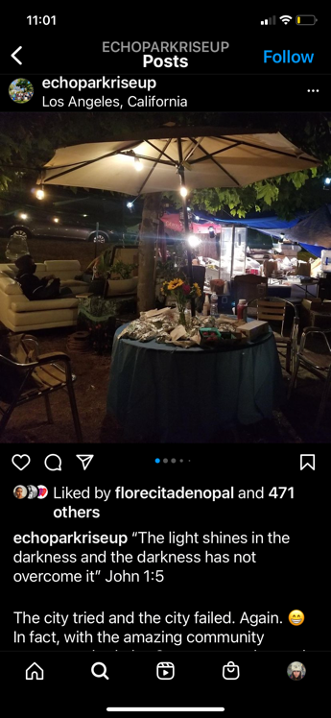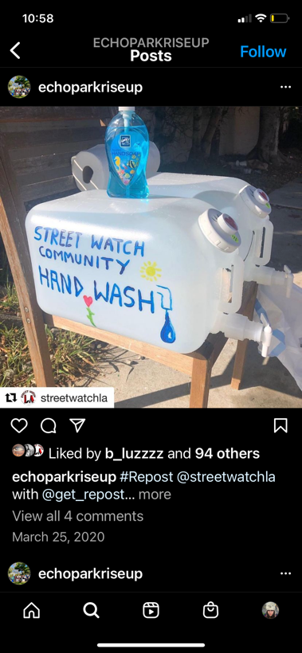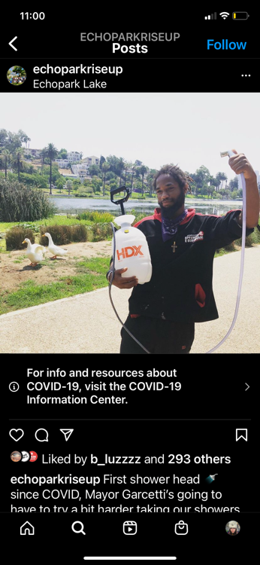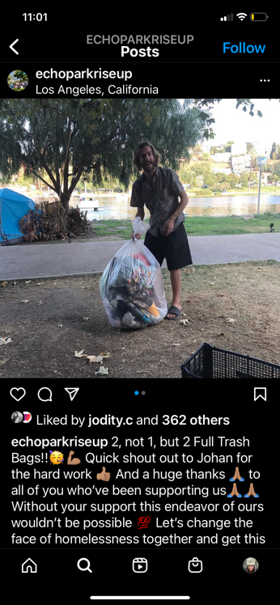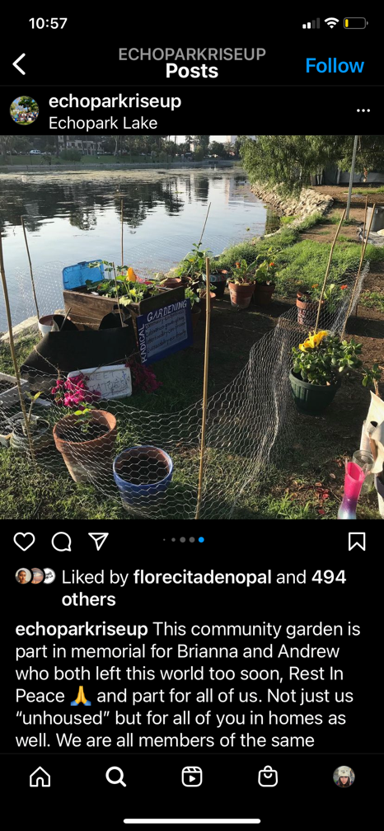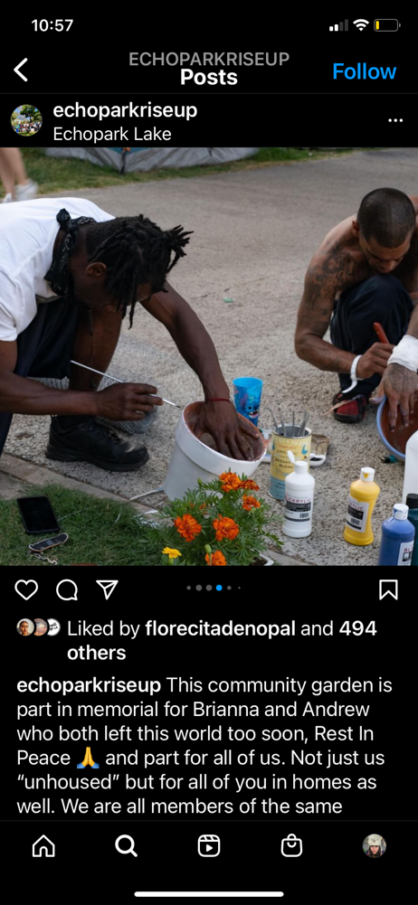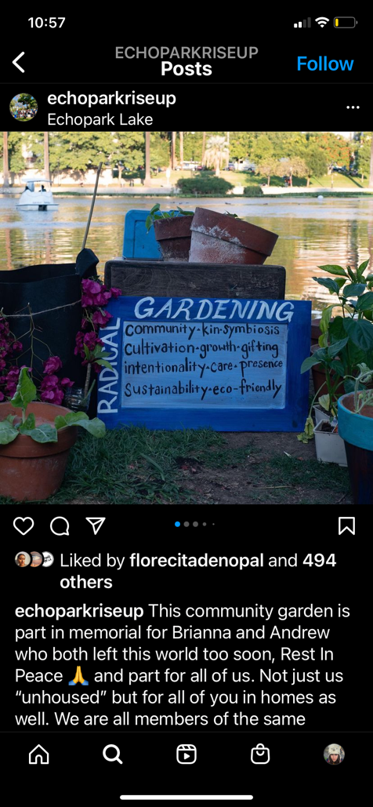

The City violently displace the Echo Park Lake houseless community after 3 days of protests on Thursday, March 25th of 2021. Councilmember Mitch O’Farrell issued a 24-hour notice that the park would be completely fenced off with all houseless people removed and the encampments destroyed for the purpose of a $500,000 restoration project. That evening, 400 police officers engaged in “a full-scale militarized police seizure of public space” at the park to enforce the fencing and brutalize peaceful protestors, resulting in the arrests of 180 protestors and ultimately the removal of 209 members of the unhoused community. Over the course of the 3-day displacement, Los Angeles spent $2 million dollars in police salaries and overtime, $250,000 to install CCTV cameras and $104,000 to install fences.
Over the next year, UCLA’s After Echo Park Lake research collective partnered with the LA Homeless Services Authority (LAHSA) to track former park residents. Of the 178 people who were moved into interim housing, only 18 people have obtained rental subsidies and 4 have received permanent housing, according to data from the Los Angeles Homeless Services Authority. The long-term findings of the report reveal the displacement to have been a housing failure, affirming it as a true “sweep” as called by activists, an attempt by the State to remove and push around unhoused residents instead of addressing their needs. The report published by LAHSA in April of 2021 showed that there were 183 initial placements of Echo Park Lake residents: 151 inro Project Roomkey, 22 in Project Homekey, 6 in a winter shelter and 5 in A Bridge Home temporary shelter. Of those 183 placements, only 168 went through. 15 people didn’t complete the initial placement, and as of February of 2022, 69% of initial placements had exited the system. This means 15 people who have confirmed their return to houselessness, 82 who have essentially disappeared and are unknown, and 48 in temporary shelters waiting on permanent housing. Only 17 people have been placed in permanent housing.
It is evident that the City was not concerned with housing the unhoused residents of Echo Park. Instead, City Council favored the displacement to erase poverty from an iconic Los Angeles Park, using “revitalization” as an excuse to violently displace some of the most vulnerable people in the city. This violent displacement caters to the housed, capital bearing residents of Echo Park, who made a petition on Change.org, a popular site for digital petition signature collection, a petition called “Save Echo Park Lake.” The petition gained 5,598 signatures after being widely circulated on the app Nextdoor. The app, used by 1 in 3 American households, is meant to facilitate neighborhood discussion but instead has become known as a platform for racism and racial profiling. The petition claims that
Housed citizens around the lake have reported the following incidents occurring:
- Nearly daily incidents of unhoused people stalking, harassing, spitting, and using hate slurs against the housed citizens who actually paid to live here and want to use the park they also paid for
- Ongoing animal cruelty against the geese and ducks of our beautiful park committed by mentally unstable unhoused individuals
- Rampant drug use and drug sales
- Prostitutions of unhoused women by the men of the lake
In reading the Change.org petition, meritocracy justifications that support the “whiteness as property” theory are extremely evident. Firstly, petitioners choose to refer to themselves as “housed citizens.” Instead of using a word like resident which refers to location, the petitioners choose to identify themselves as “citizens”, invoking a nationalist, American and historically exclusive cause that references a sense of belonging and legality. Next, they go on to explain verbal harassments the housed citizens have been suffering, people “who actually paid to live here and want to use the park they also paid for.” Here, the petitioners assert themselves as worthy of a public resource because they have capital in the form of land ownership. By foregrounding this capital in their discussion of the park and the unhoused community living there, the petitioners justify the erasure of poverty from Echo Park by stating that the poor don’t have a right to the public space simply because they didn’t pay to be there.
The Echo Park situation has already been used as grounds to displace even more people in the city of Los Angeles. In October of 2021, city council identified nearly 300 new sites where they would like to ban houseless camping under a law that was passed in August. When discussing the matter, Eric Garcetti is quoted in the LA Times as saying “You don’t have to choose between these things. The liberation of public space and housing people is not either/or. If you do it right, it’s both. We’ve shown that in the park settings so far.” Reflecting on the numbers, Garcetti’s statement is categorically untrue. Echo Park has proven to be a failure in providing legitimate and stable housing for the unhoused community there, with well over half of those people back onto the streets. Secondly, Garcetti’s quote perfectly illustrates the manipulation and appropriation of radical language for what are ultimately capitalist means. Calling violent policing and displacement “the liberation of public space,” appropriates a click bait radical term in order to frame unhoused people as an oppressive class, stealing from the Los Angeles public. Although subtle, this shifts the blame for unhoused encampments and the inhumane circumstances people face on the streets onto those impoverished people, instead of the failures of a city working under capitalism, which does not allow for basic care programming to address resident’s needs.
Calls for revitalization and renewal in Echo Park did not begin with the houseless community, however. Echo Park has history of white calls for urban renewal going back to the mid 1900s. At the turn of the century, Echo Park was post card perfect, with its brand-new lake reservoir perfect for picnicking and the Pacific Electric Red Car that conveniently dropped residents off at the lake with access to the rest of the city. This changed as the white middle and upper class moved out into more suburban developments and the trolly was discontinued, making way for recent immigrant working class families from Central and South America to move in. The still majority white upper class of the greater Los Angeles downtown did not support the shifting demographics of this downtown proximate community. They claimed, just like the Chavez Ravine community, that “blight” had taken hold of Echo Park’s hills. An LA Times article went so far as to ask, “Which Way for Echo Park – Inner City Oasis or Slum?” While low-income residents fought for federally assisted housing in Echo Park following the 1968 passage of the Fair Housing Act, white residents seem to have won by successfully creating the city’s first Historic Preservation Overlay Zone in the 1980s. In doing so, Echo Park did not see the socialist urban renewal initially feared in the 50s with the Elysian Park Heights housing project. In the same LA Times article, Dial Torgerson wrote how “Echo Park’s hill liberals are now fighting for federally assisted housing for the underprivileged. People keenly aware of a housing shortage find themselves saying: poor, go elsewhere.”
Urban renewal did make it to Echo Park Lake in 2011, when the city allocated 45 million dollars to clean up Echo Park Lake. The Park was closed for 2 years, and during the grand reopening in 2013 the city put forth the Glendale Corridor Gang Injunction, a civil lawsuit against six alleged gangs. Despite low crime rates, the injunction was passed quickly and quietly, criminalizing graffiti, loitering, and other perceived forms of gang related activity. Injunctions have a history of being strategically placed in bordering neighborhoods undergoing revitalization, allowing law enforcement to remove people of color, particularly youth, from white neighborhoods. Muñiz theorizes that the most powerful aspect of injunctions is its ability to terrorize residents into fleeing public space, even if its in their own neighborhood. In the Echo Park context, Soriano argues that the effects of the injunction were that Echo Park’s non-white and low-income population did not feel welcome in a park seemingly legally designated for white residents and owners in Echo Park.
The 2011 injunction demonstrates a legacy of criminalization in Echo Park’s public spaces, where the City creates and enforces legislation that instills fear into marginalized folks to cater to white pleasure and leisure. Ordinance 41.18 of the Los Angeles Municipal Code, which legally justified Councilmember O’Farrell’s sweep of Echo Park Lake, continues this legacy of criminalization to erase poverty and make room for the capitalist white racial expansion project. In the case of Echo Park Lake, City Council used a historically proven as racist and capitalist promise of urban renewal to violently displace some of the poorest and most vulnerable residents in Los Angeles County. In Los Angeles, calls for urban renewal and revitalization historically have not led to public housing or resources for the impoverished. Instead, urban renewal justifies the expansion and creation of space for white leisure and pleasure. This capitalist white racial expansion necessitates the erasure of the poor and non-white from the landscape. “Poor, go elsewhere,” as written by Dial Torgerson’s in The Times in 1971, is still the call of the housed, land-owning white community in Echo Park today, as the Change.org petition evidences. All this in conjunction shows how under white racial capitalism, the poor and non-white are not perceived as members of their communities but instead as nuisances to be swept up, sanitized and invisibilized with the trash they leave behind.
Echo Park Lake is of particular interest because of the role of houselessness within broader understandings of displacement in academic studies. Simply put, houselessness is rarely considered in displacement studies. Unhoused people already lack any form of permanent shelter to be displaced from, making them extremely hard to study and track without leases or other documents to track. Houseless residents are also rarely considered in theoretical understandings of community; houseless people are often regarded as invisible and entirely outside of our social contract. But in the case of Echo Park Rise Up, houseless residents were making clear and public efforts to work in conjunction with their housed neighbors to become a part of the greater Echo Park community. Echo Park Rise Up was an exciting opportunity to radically redefine community in Los Angeles because of its extremely rare and mutually beneficial interactions between members of different class and racial stratums. Left unchecked by the city, Echo Park Rise Up could have gone on to radically redefine public space. Instead, the city of Los Angeles used a historically backed call for “revitalization” to destroy the radical relational politics of Echo Park Rise Up, reifying the city as a whiteness project meant to displace and completely erase marginalized residents.

CHAPTER 2: AN EXCLUSIONARY DEFINITION OF PUBLIC
A sign amongst the Echo Park Lake houseless community says, “We refuse to be swept into dark corners.” March 24, 2021. Photo: Anna Scott
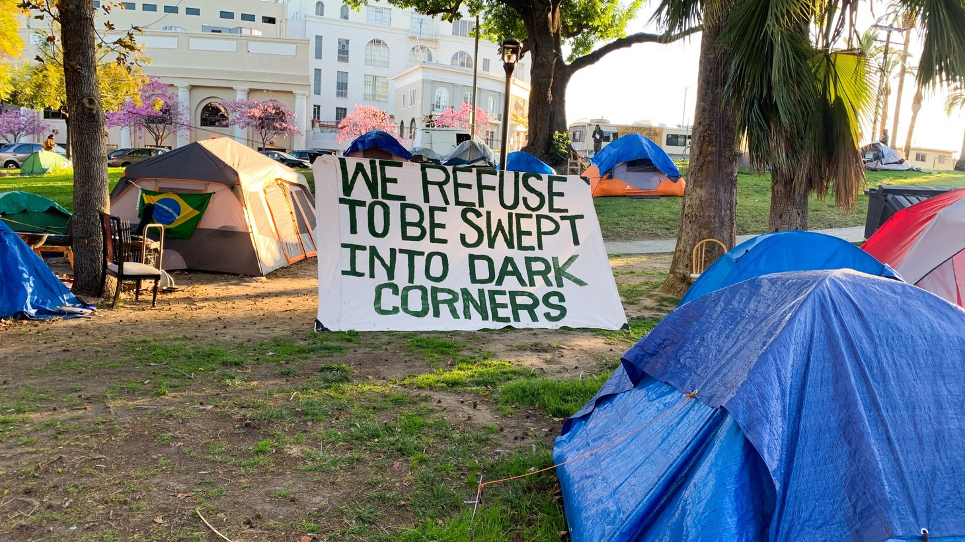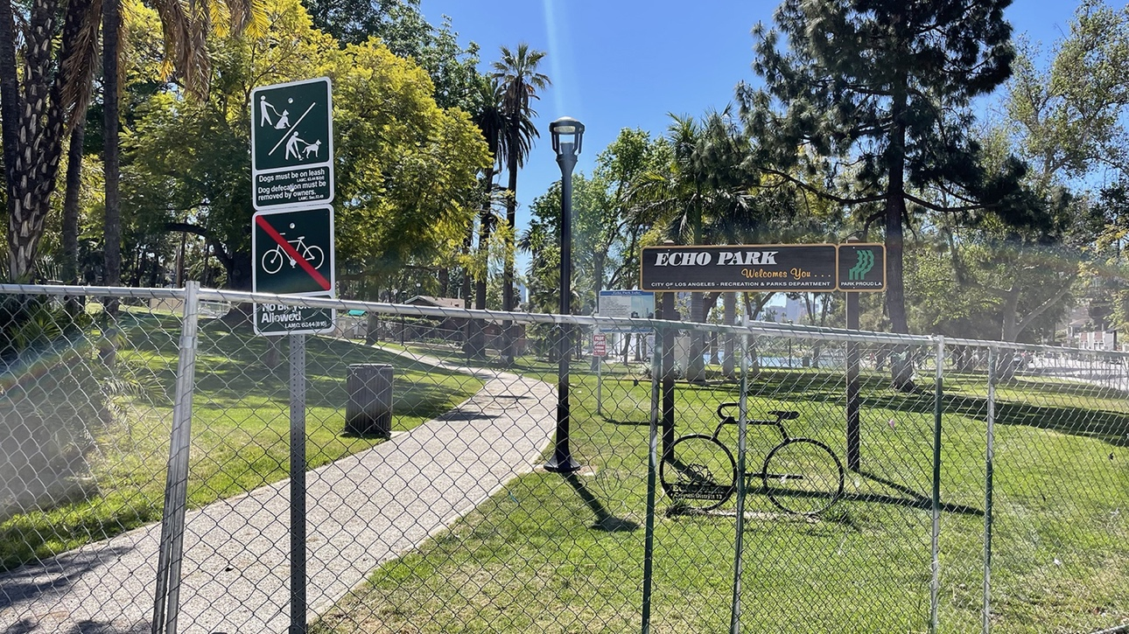
The chain link fence remains at Echo Park Lake in March 2022, one year after it was erected to clear a large houseless encampment. Photo by Thomas MacVicar., KCRW
Echo Park Lake De-Fence
Within 15 minutes, the fences that surrounded Echo Park Lake for over a year were knocked down. They remained strewn across the park grounds for the next few days. A coordinated group of activists worked quickly and swiftly on Sunday, August 7th, 2022, to knock down the chain link fences that policed entry to the park, managing to suspend one of the fences mid-air using rope and a tree. The fence hung heavy and moved slowly in the wind, covered in a black banner with all caps white lettering: “COMMUNITY DE-FENCE!” The double entendre asserts that the physical act of removing the fences is an act of defense, rooted in community care. “De-fencing” is a reminder of the people who once lived in the park, in an unfenced community that made use of living publicly and so proximate to one another.
The next morning, park goers found pamphlets around the park tucked between the wires of the chain link fences and littered through the grass. The pamphlets read as prose; its artful language enhanced the message of the writing, that the fence and policing access to this public space had stolen the “collective power from the people” and given it “to the city and its developers.” In the pamphlet’s words,
“You know already: six people die every day on the streets of L.A. When the Echo Park Lake fence went up last year, the parkgoers, the Karens and Kens, returned and let out a sigh of relief. The City had addressed the ‘homeless issue.’ Good, they said.
A dysphoric distance was installed over night. One could return to the park under the illusion of safety while ignoring the open wounds of abandonment. The fence does more than enforce a curfew. It does more than physically displace people who once made themselves at home in the park. In fact, the fence is not just about displacement, it’s also about the transfer of collective power from the people to the city and its developers.
And that’s why we’re here. For the sweat and love, for dignity, for People’s Parks everywhere, for a glimpse of each other – if only for one night – without the fences, boundaries, borders and diagnoses they put between us. Directly beneath Echo Park Lake lay one of the fifty strike-slip faults waiting dormant under Los Angeles. The strain is underfoot, the heat rises, there’s no slack, there’s no time. Why has life become so miserable? Because we let it. Tonight, we are dumping this bind by tearing down the fence.
‘And, if I know anything at all,
It is that a wall is just a wall
And nothing more at all.’
Assata Shakur”

Instagram post from @solidarityandsnacks showing a pamphlet tucked in one of the chain links fences
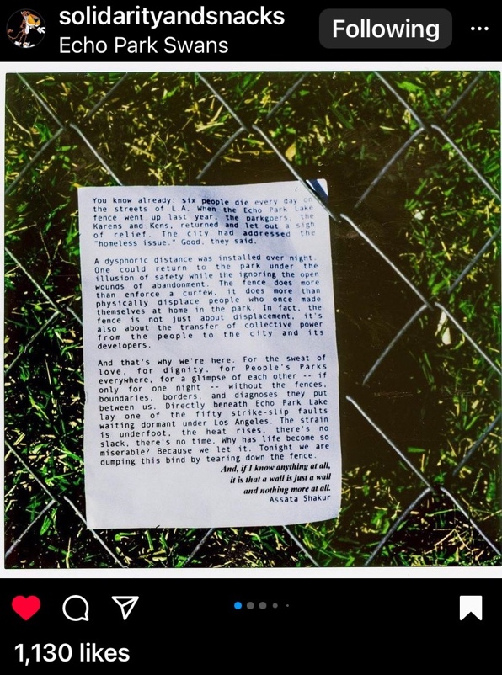

Echo Park Lake De-Fence happened well over a year since the fences were originally installed. The City of Los Angeles, in an initiative led by Councilmember Mitch O’Farrell, installed the fences in March of 2021 for renovations while the park underwent $500,000 worth of repairs. The fences remained up although the park had reopened by the summer of 2021 and repairs had been completed. The pamphlet indicated to park goers the next morning that the fences hadn’t come down at Council member Mitch O’Farrell’s orders. “We” claims responsibility for tearing down the fence, an anonymous and collectivist term that implies a community sentiment that is larger than the few coordinated people who knocked down the barriers.
Images from KnockDotLA Reporter Tweet of Echo Park Lake after chain link fences were knocked down Sunday, August 7th 2022

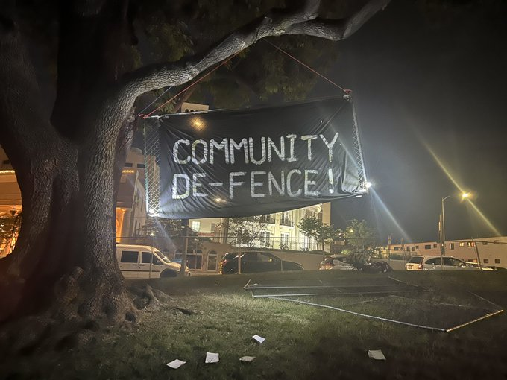
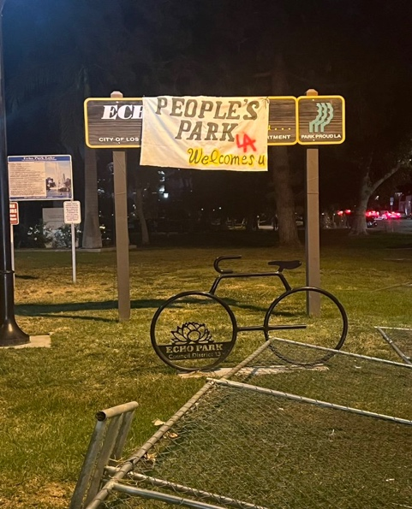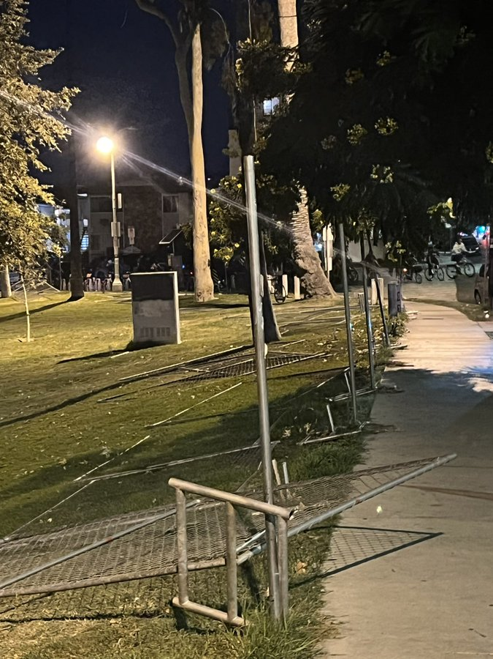
The limitations on public space by Los Angeles City Council did not start with Echo Park Lake. Nearly a year earlier, on September 14, 2021, Los Angeles City Council had voted 12 to 2 to pass an ordinance that would criminalize protests within 300 feet of a private residence, replacing the previous law which allowed protest up to 100 feet of a residence. Furthermore, the new ordinance stated that “the court may award to the aggrieved person a civil penalty of up to $1000 for each violation.” This means the “aggrieved,” which can include the direct targets of the protest as well as their neighbors, can seek fines of up to $1000 per protestor. This excessive financial consequence to gathering in public space limits access to the First Amendment. Poor and low income Angelenos cannot afford the financial consequences of being fined for protest. Ordinances like these limits the use of public space and the First Amendment, consequently limiting who is legally considered a member of the public.
LA Mayor Eric Garcetti responded in the LA Times to concerns over these limitations by explaining that he didn’t understand why protestors would target residences when there is “public space … where you certainly can be heard, where you can make your protest, where you can express your voice.” Garcetti’s statement begs a question: where is the public space where protestors can make their concerns heard? Clearly, city council has worked to limit access to public space, be those the sidewalks in front of their properties or an iconic Los Angeles public park, a year after the renovations are complete. Perhaps Garcetti would prefer protestors use more formal, public avenues to address their concerns. Instead of using these conventionally public, outdoor spaces, Garcetti wants protestors to take their concerns to City Hall, to submit public comments online and speak during the public comment section of city council meetings. This proves difficult, however, as protestors have already made use of this more formal space and seen limitations and criminalization threats as well. At the city council meeting on August 2nd, 2022, now former council president Nury Martinez ended public comment after 15 minutes, 5 minutes less than the 20 allocated in the City Council Rules handbook. All protestors and members of the public were forcibly ejected from the city hall chambers by a group of riot police that Martinez called in. Martinez announced that those who refused to leave would be arrested, and only news media was allowed to stay. Additionally limiting and criminalizing public space, this council meeting resulted in a vote to expand Ordinance 41.18, which criminalizes “sitting, or sleeping or storing, using, maintaining, or placing personal property in the public right of way.” After riot police removed all the protestors, Martinez claimed that “what’s even more disturbing is that so many speakers who spoke about this issue, who claim to care about this issue, don’t even look like the very people who are on the streets,” despite the fact that several speakers firstly identified themselves as unhoused residents of Los Angeles.
LA City Council, through its criminalization of houselessness and other forms of public occupation by members of historically dispossessed communities (such as the poor and the collective black) has, in the words of the Echo Park Lake pamphlet, worked to “transfer [the] collective power from the people to the city and its developers.” More specifically, LA City Council has selectively limited access to public spaces through ordinances, legally redefining who and what constitutes “public” to police, control, and exclude the dispossessed in LA. By redefining the public through the exclusion of certain actions that are directly connected to certain dispossessed identities (here, specifically referenced are the poor, racialized, undocumented, and houseless), Los Angeles can further be understood as a racial project that seeks to violently erase the dispossessed. This displacement is part of a broader legacy of erasure of the poor in Los Angeles, and even more broadly displacement and colonization in the United States. In creating a limited definition of public, Los Angeles works functionally as a capitalist plutocracy, going against the supposed democratic nature of the city and its country.
Who and What is Public? The Los Angeles Municipal Code, Defined
The Los Angeles Municipal Code is a thousand+ page document which details the law and proceedings of the city. The Municipal Code is preceded by the City Charter and Administrative Code, which allocate specific powers to offices and legislative bodies within the city. The Municipal Code, first adopted in 1936 to codify “the regulatory and penal ordinances of the City,” comprises 20 separate chapters, each divided into articles or sections. Many of these articles or sections begin with definitions, which clarify key terms from the legislation by explaining what each of these includes and excludes. For example, in Chapter 1: General Provisions and Zoning, Section 11.01, the Municipal Code defines a street as including “all streets, highways, avenues lanes, alleys, courts places, squares, curbs or other public ways in this City which have been or may hereafter he dedicated and open to public use, or such other public property so designated in any law of this State.” However, the Municipal Code does not include a definition of the term “public.” The term is used several thousand times in the document, present in every one of the 20 Chapters that make up the Code. Given its frequent usage of the term, the Los Angeles Municipal Code seems to intentionally exclude a definition of the term public.
By excluding a definition of the term “public,” the LA Municipal Code is free to make limitations on said public without check, inflating the power of the State to police its residents. Definitions allow constituents to raise issues with policy and provide legal grounding to those issues. Without a specific definition of the term, constituents in Los Angeles are left with a vague understanding of what the public is and may include. As a result, the rights of the public are unenforceable because there is no explicit statement of who or what the public is and what their rights are. Instead, “public” is defined passively, primarily through what it is not instead of what it is outright. This obscures the subject in the same ways grammatical passive constructions do.
In defining the public passively and thereby removing this very public’s ability to easily defend itself from limitations, the State can legally provide the bare minimum and redistribute resources in ways that only benefit an exclusive sector of the public, which often stands in for the whole. The inflated LAPD budget as well as the inflated wages of city councilmembers offer an example of how the State appropriates resources, only to serve the upper classes. Through continually limiting the public through passive definition, the State and those the State recognizes as having economic capital can continue to hoard wealth and resources, deepening the gap of resources between them and the historically dispossessed. This legally mirrors the construction of the chain link fence at Echo Park Lake; through several avenues, including legal and physical barriers, the upper classes in Los Angeles work alongside the State to separate themselves from poverty, the collective black, and other members of the historically dispossessed.
LAMC 41.18: Criminalizing Houselessness, Displacement as Government Policy
On Tuesday, August 2nd, Los Angeles City Council voted to expand Los Angeles Municipal Code (LAMC) 41.18, which continued the ongoing project of redefining who and what the City considers public. The expansion added thousands of sites to an ever-growing list of where “sitting, lying, or sleeping or storing, using, maintaining, or placing personal property in the public right-of-way” is prohibited. 41.18 is primarily enforced against houseless residents of Los Angeles, and because of this geographical increase in prohibitions, houselessness has now effectively become illegal in 20% of the city of Los Angeles. Prior to this Municipal Code revision, in 2021 city council enacted a revision of LAMC 41.18 that first specified a location-based enforcement of the ordinance, in an antecedent to the 2022 changes that expanded this initial geographic reach. City Council made this adjustment following the 2018 Supreme Court case Martin v. Boise, which found that an individual cannot be criminalized for sleeping on public property when local shelters are full. By specifying locations where encampments are not allowed without criminalizing all forms of houselessness everywhere, Los Angeles City Council has, for the moment, found a way around the Supreme Court Ruling. Their actions, argued by them as a means to safeguard these sites for the public, demonstrate a determined insistence on finding ways to police and displace houseless people. Moreover, in arguing this expansion of 41.18 safeguards specific sites for the public, they further prove how houseless people and their livelihoods are not encompassed in their understanding of public.
LAMC 41.18 has a longer history of legal injunctions, calling into question whether the law can ever exist without violating constitutional rights. This iteration of LAMC 41.18 follows Jones v. the City of Los Angeles, another court ruling which found enforcement of the ordinance unconstitutional. In 2006, the Ninth Circuit Court found that the enforcement of 41.18 violated houseless people’s Eighth Amendment rights by criminalizing the unavoidable act of sitting, lying, or sleeping at night while being involuntarily houseless. As a result, the city agreed to stop enforcing 41.18 between the hours of 9 PM and 6 AM as well as halting enforcement until they had built the court ordered 1,250 units of permanent supportive housing, 625 of which would be located in Skid Row. In 2018, Mayor Garcetti declared the settlement agreement completed and enforcement of 41.18 resumed. Los Angeles City Council and the State resumed work expanding 41.18, without questioning the constitutionality of the ordinance or its effectiveness.
Despite these two significant court cases, Los Angeles City Council has spent the last number of years, particularly since 2021 (one year into the pandemic), expanding and amending 41.18 to criminalize specific houseless activities. By specifying which houseless activities are not allowed, City Council has seemingly avoided legal accusations of criminalizing houselessness as an identity, which these two cases found to be unconstitutional. This is yet another legal manipulation employed by City Council to obscure the intentions of 41.18 itself. While seemingly criminalizing only activities in specific sites, the goals of 41.18 are ultimately to displace and erase houseless people from Los Angeles, as evidenced by the exponential expansion in sites over the last 2 years. 41.18 has grown to encompass 20% of the city, with thousands of sites waiting to be heard, approved and added by council. Despite the legal work around, 41.18 still criminalizes houseless people at large clearly seeks to “sweep” them from the landscape without providing other recourse.
Moreover, the vague language set in the ordinance allows the city to avoid pinpointing necessary limitations on 41.18. Instead, the language contributes not only to an expansion of its geographical reach but also an expansion of personnel with enforcement capabilities. According to the Los Angeles City Charter, the agency primarily responsible with enforcing 41.18 is the Los Angeles Police Department (LAPD). However, the vague language set forth in the ordinance’s revision has expanded policing powers to all city workers. Section (e) specifies that anyone who “willfully resists, delays, or obstructs a City employee from enforcing this section or who willfully refuses to comply after being requested to do so by an authorized City employee shall be subject to the penalties set forth in Los Angeles Municipal Code (LAMC) Section 11.00.” This language seems to give these authorized representatives of the city policing powers, effectively allowing them to determine what behaviors may constitute resistance, delays and obstructions in their enforcement of 41.18. The ordinance does not require these workers be trained in mental health crisis intervention, de-escalation techniques, or other tools that emphasize non-punitive outreach. The ordinance also does not specify what city employees should be present during enforcement (for example, houseless case workers, workers with the LA Homeless Services Authority, others who may be trained in crisis management), and those who are present are free to use any methods they deem appropriate to displace houseless people, without regard for their mental health. Furthermore, these employees, due to their lack of training, can misconstrue a houseless resident’s response to displacement (which may include a mental health crisis or other forms of clear distress) in order to further criminalize, and subsequently further traumatize them.
As written in the LA-Community Action Network blog 41.18 Amendment: A Wolf in Wolf’s Clothing, Section (e) is “an expansion of the police state and gives everyday civilians extraordinary decision-making power over other civilians.” The penalty described in Section 11 of the LA City Charter includes a misdemeanor, which grants enforcers power to incarcerate and fine houseless people after their displacement. While those criminalized can avoid the misdemeanor by invoking Section 11 (m), which is an infraction, this outcome also results in financial consequences. An infraction can result in a citation of up to $250 or arrest. The $250 citation is not a static figure and will increase the longer an individual does not pay, which means that citation fees can grow into thousands of dollars. If an individual refuses to move after police issue a citation, police can arrest said individual and charge them with loitering. With all these penalties in place and no legislation directed towards non-punitive consequences to refusing displacement, it is evident that LAMC 41.18 is legislation which seeks to incarcerate, traumatize, and further dispossess the most vulnerable members the Los Angeles public. In using such a carceral response to a highly dispossessed group, LA expands its exclusion of certain people from its legal definitions of the public. This results in the purposeful narrowing of what should be an expansive concept.
The most frequent concern that activists cite is that LAMC 41.18 does not address houselessness at its root, and therefore, it allows for poverty and displacement to continue in ways which support the upper classes expansion into public and private physical spaces. Instead of reducing the number of encampments in the city through housing people, 41.18 ensures houseless people are displaced and moved around without any pathway to housing. The ordinance’s jurisdiction encompasses some of the most tourist trafficked sites in Los Angeles, including Venice Beach, Hollywood, Echo Park Lake and the Downtown/Grand Central area to name a few. Large lower income parts of the city that are not part of tourist routes (mainly South LA) have not had 41.18 sites added to them. The ordinance’s removal of houselessness from tourist and high-income neighborhoods reveals that Los Angeles seeks to erase and render poverty out of the sight of capital. This capital takes the form of upper-class citizen wealth, but also tourists who contribute directly to the Los Angeles economy. Furthermore, this ordinance limits poverty to specific areas, further segregating the city into increasingly stratified high- and low-income swaths.
Researchers Bonds & Martin explain that policies which move houseless individuals around (in their case, they were discussing bus vouchers) treat individuals like pollution, shipping one city’s waste to another city to avoid looking at it. They argue that “To say the homeless are treated as a kind of pollution is to say they are not viewed as members of the community in which they live”. This idea takes up a new meaning in the Los Angeles context., recalling the image of the poster at the start of this chapter saying, “WE REFUSE TO BE SWEPT INTO DARK CORNERS.” Housed and unhoused activists have nicknamed the CARE+ (Comprehensive Cleaning and Rapid Engagement) team enforcement of 41.18 “sweeps,” because they “sweep” up garbage, unhoused people, and their possessions alike. It also recalls former Council President Nury Martinez’ comments on she felt disturbed that those present in the council chambers “don’t even look like the very people who are on the streets.” As Bonds and Martin noted, upper class members of communities seem to only find poverty notable when it is explicitly, visually present. With regards to houseless poverty, this visual is often encampments which may appear dirty or polluted. The upper-class groups this poverty and the people experiencing it in with the pollution that surrounds them, only taking action to address their existence as far as to physically remove them but neglecting to use their power and resources to address the root causes of poverty.
Furthermore, Bonds and Martin wrote how municipal laws that criminalized camping and presence in public spaces were selectively enforced, with police only enforcing anti-camping laws in Texas with regards to houseless people. Enforcing laws against only the houseless community, combined with their systematic physical removal from public spaces directly leads to increasingly limited ideas of community and belonging. These limited ideas on community and who belongs inform legal definitions of these concepts, referred to in legislation using the word “public.” Analyzing ordinances like 41.18, it becomes evident that houseless individuals in Los Angeles are not legally considered a part of their community or public. Houseless individuals are dehumanized legally to the point where policies criminalize behaviors that are considered to be life-sustaining (i.e. sleeping on sidewalks, using tents, living in cars) for houseless individuals.
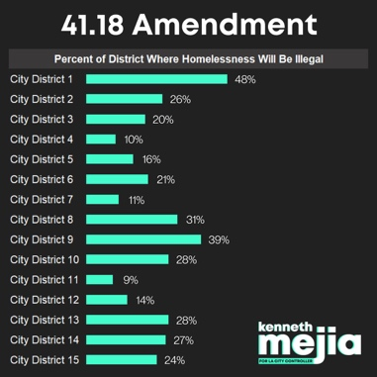
Visuals produced by Kenneth Mejia for City Controller Campaign, posted on Twitter. Kenneth Mejia’s campaign released research findings on Twitter on August 8th, 2022, that showed what percentage of each district, under the revisions to 41.18, criminalize houselessness. In Council District 1, represented by Gil Cedillo, 48% of the district is criminalized under 41.18. Council District 9 (Price): 39%, CD8 (Harris-Dawson): 31%, CD13 (O’Farrell): 28%, CD10 (NA): 28%, CD14 (de León): 27%.
The Dispossessed as Understood by LAMC 41.18
The varied demographic makeup of the houseless community in Los Angeles requires that a person be understood by the multitude of their intersecting identities as opposed to a singular identity such as unhoused. In acknowledging the intersecting identities of Los Angeles’ houseless population, it becomes apparent how these identities have been central to the enforcement of LAMC 41.18 as well as the construction of the ordinance, which normalizes certain behaviors and subsequently identities while criminalizing others. Through normalizing and criminalizing opposing behaviors, LAMC 41.18 has real-time ramifications on Angeleno ideas of community and public. Intersecting identities such as houselessness and members of the collective black are excluded from the legal understanding of “public.” This means that upper-class white and white-adjacent Angelenos’ requests are centered in public policy, and in return LA City Council and LAPD get to further control and police the population of Los Angeles, allowing them to move forward with profitable housing development plans and other revenue-generating developments such as malls, businesses, and other tourist attractions.
Frameworks such as critical race theory acknowledge that race is central to our lives, and that racism is a common occurrence in the lives of people of color. A majority of Los Angeles’ houseless population are people of color; 23% of the population is white, with the remaining 77% identifying as another race. Thus, racism is a common experience in the lives of houseless people of color. Per LAPD data, police disproportionately use force against unhoused people as opposed to housed Angelenos. Given the proportion of white/non-white houseless people in LA, it can be argued that a majority of the unhoused people experiencing police brutality are people of color.
LAMC 41.18 states that “no person” shall sit, lie, or sleep in any public right of way, but discussion around the policy as well as its enforcement make clear that the policy is directed towards unhoused people. The municipal code makes one exemption from the ordinance: attending and sitting in the public right of way during a parade. Parade goers are engaging in essentially the same activities as unhoused people; the difference is that one is for entertainment and the other is for survival. Both are temporary, assuming a parade has an end, and the governing body of Los Angeles intends to permanently house its poor population. One however is a temporary status with no bearing on socioeconomic identity, the other is a consequence of poverty, potentially and likely alongside other intersecting identities that Critical Race Theory recognizes are discriminated against in American society.
The 41.18 ordinance sets up being housed as a status quo that mirrors the social role of whiteness as that which is the norm, and from which all other identities diverge. 41.18 is listed in the municipal code under “Public Welfare” and more specifically under “Disorderly Conduct.” This means that legally, being unhoused in Los Angeles is considered a disorderly or disruptive behavior, going against what is legally assumed as normal behavior. By criminalizing public houselessness as an identity, Los Angeles normalizes the experience of living inside a home. This further legitimizes prejudice and state violence against the houseless: if living inside a home is normal and being houseless is abnormal or disorderly, there are social incentives to outright criminalizing and supporting the criminalization of houselessness. Condemning and punishing poverty instead of allocating resources to end it means those with power and capital can continue to hoard the capital they accumulate. Through criminalization, the upper classes draw attention away from their inflated capital (attained often through stolen labor and wages) and instead onto how poverty is abnormal, disorderly, and a consequence of an individual’s poor decisions instead of a larger issue with systems such as capitalism.
The City of Los Angeles further deepens the identity gap between housed and unhoused people with its lack of comprehensive programs or policy to move unhoused individuals into permanent housing, which continues to alienate unhoused people from the public. In early September of this year, the LA Homeless Services Authority (LAHSA) released a report which found the current number of unhoused people in Los Angeles County has reached 69,144, a 4.1% increase since 2020. Unhoused Latinos as a demographic rose by 26%; the report attributed the increase to the likely fact that many of these people may have been ineligible for federal unemployment help due to an unauthorized/undocumented work status. Other identities such as language barriers, level of education and internet access likely also influenced this increase. There are currently 13,089 temporary shelter beds available in the city of Los Angeles as of a February 2022 count. Given the amount of shelter beds and unhoused people, LA can only house 18.9% of the unhoused population if they were to fill every bed, while 81.1% of unhoused people would remain on the streets. 41.18 does not detail any solutions as to where to house displaced people, nor has city council approved any of council members Mike Bonin and Nithya Raman’s attempts to add clauses that would increase the amount of shelter beds and outreach programs. Instead, LAMC 41.18 leaves it up to city employees and LAPD to decide what strategies are most effective at displacing unhoused people and their belongings, without requiring any follow up real offer of housing. Given council members repeated votes against Bonin and Raman’s proposals, it seems the city has no system in place to ensure that unhoused people, who are a disproportionately people of color, undocumented, and with language barriers, find permanent shelter.
The City’s disproportionate targeting of unhoused, undocumented, people of color results in housed people's increasingly limited and bigoted understandings of community. By criminalizing such a large portion of the Los Angeles public, the City has essentially excluded those people from its legal definition of public, and more importantly, from the community that the city’s slogan promises, is “for all.” When the legal definition of public is so dramatically altered, housed white and white-adjacent Angelenos gain disproportionate power in city politics. This is favorable to the city. Through catering to its housed population, Los Angeles politicians can continue an agenda of private development and capitalistic investment. This can look like a variety of things in legislation, a prominent example are the increasingly frequent and lucrative deals with luxury housing developers. Just a few months ago, in a 12-0 vote, LA City Council approved the construction of 2 multistory luxury housing developments at the edge of Chinatown and Echo Park. The development will be comprised of 2 towers, one 30 and the other 49 stories, as well as a 17-story building and two 2-4 story structures. The property may also include a hotel and a commercial business space. Clearly, a project like this will be extremely lucrative for the city as well as ideal for the city’s upper-class residents, which seek to expand their social, economic, and political capital in the form of land ownership.
Los Angeles’ priority to approve projects like this over solutions to house people signals to the city’s residents that being a recognized as a member of the LA public means being housed. The city does not seem to recognize unhoused people as contributing members of the community and larger public but instead, as researchers Martin and Bond put it, pollution to be moved and removed from the city’s landscape. These researchers found that police enforce laws like 41.18 when community members observe and report visible houselessness, with the goal of accomplishing their removal. This is true of Los Angeles, as the group “Friends of Echo Park” demonstrates: in 2021, they started a Change.org petition that gathered thousands of signatures seeking to displace the large houseless community at the park. Laws like 41.18 sanction and continue this exclusionary concept of public and right to public space.
Groups like Friends of Echo Park view 41.18 as a progressive policy, more specifically because it now removes unhoused people from within 500 feet of schools and daycares. Councilmember Gil Cedillo compared this section of 41.18 to Brown v. Board of Education as it “protects our children.” In arguing 41.18 protects children, a vulnerable and majority person of color population in Los Angeles, councilmembers have set up unhoused people to be viewed as threats. In this instance, white and white-adjacent Angelenos engage with each other and the city council in what Critical Race Theory defines as interest convergence. Interest convergence is when the white upper class accepts or allows for policies considered racially progressive because, those policies, while seeming progressive, really serve to continue the status quo and legacy of oppression in more covert and arguably more heinous ways. 41.18 is far from being racially progressive, and instead continues legacies of displacement and state violence against the unhoused in Los Angeles.
All this considered, the continued expansion of 41.18 is representative of the growth of state sanctioned violence against the unhoused. Instead of seeking to affirm unhoused people as a part of the Los Angeles public, 41.18 further alienates the historically dispossessed, collective black, and poor residents of Los Angeles by legally excluding them from their definition of public. This, in turn, reaffirms bigoted housed community ideas on public and right to spaces that LA seems to promise are “for all,” directly leading to the policing and criminalization of public spaces beyond directly where unhoused residents reside. The continued fencing of Echo Park Lake is a perfect example of how this new concept of public and right to public space has allowed the city of Los Angeles to expand its police and surveillance state, to the benefit of the upper classes. The displacement at Echo Park Lake is just one example of the expanded militarism of LAPD. The history of state violence in Los Angeles goes beyond legislation and back as far as 70 years, when LAPD carried Aurora Vargas out of her home in Chávez Ravine. Legislative violence has worked for generations in Los Angeles to physically violate and displace historically dispossessed residents.

CONCLUSION: HONORING ACTIVISTS, CONDEMNING VIOLENCE
Chávez Ravine women property owners in sit-down strike at Mayor Fletcher Bowron's office. Photograph dated May 11, 1951. Herald Examiner Collection
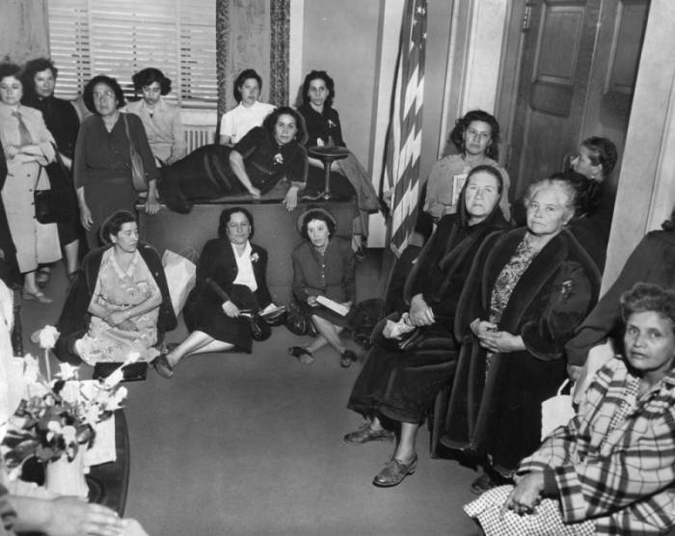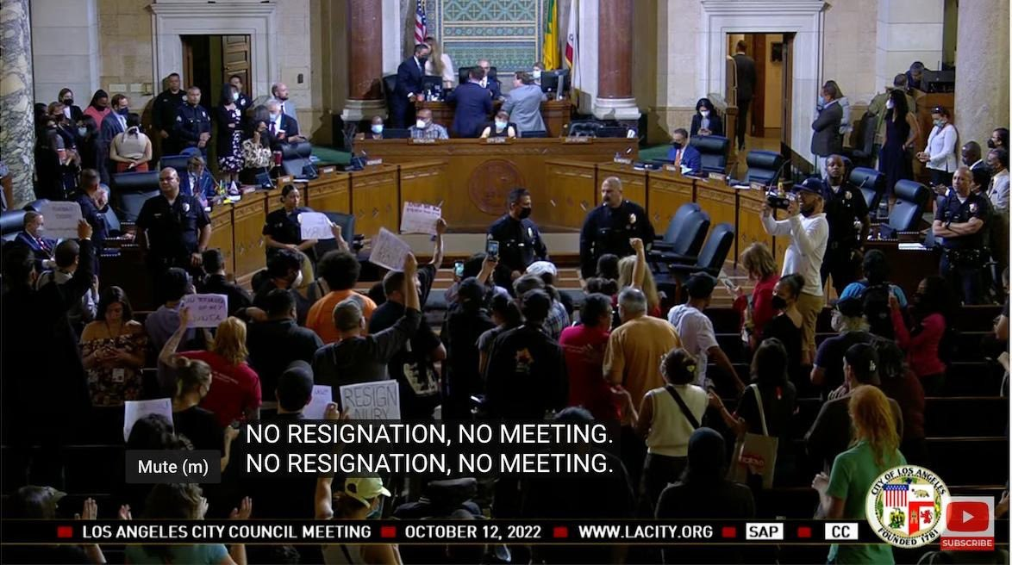
Los Angeles City Council Meeting, October 12, 2022
Living Los Angeles: How the City Moves Forward
I didn’t internalize how formative it was to be born and raised in Los Angeles until I first moved to Cambridge, Massachusetts. As an 18-year-old, Cambridge, and by extension Boston, represented everything Los Angeles lacked: a long colonial history embodied in historic red brick buildings, walkable communities connected by cobblestoned pathways, and clean streets devoid of houseless encampments and other visible signs of poverty. Yes, there is still houselessness and poverty visible in Cambridge, especially where I live now in Central Square, but it is nothing like the kind of poverty to which one becomes scarily accustomed growing up in LA. It wasn’t until I moved to Massachusetts and returned to Los Angeles with my college best friend that I saw for the first time what I had unintentionally invisibilized.
Before, my peripheral vision remained out of focus. My family, alongside the city’s larger culture of denial, had taught me to ignore the trash, ignore the poverty, ignore my unhoused neighbors, and especially ignore anything they said to me. Now, acknowledging the periphery has given me a fuller picture of what Los Angeles really is. It has allowed me to honor the hurt and harm that the continued legacies of state violence in LA have caused, while simultaneously aspiring for more. Acknowledging the State-driven poverty and dispossession in Los Angeles asks us to imagine what a different city, a different future could be like. I believe in that city.
I wrote a majority of this thesis in Central Square, surrounded by its own unhoused community. On my block, I have become friends with an unhoused neighbor named Olaf. He and I have spoken for hours at a time; he calls himself a “human data specialist” after his 20+ years living on the streets. He refuses to eat vegetables because they are “the fruits of large group exploitation,” citing his distaste for the treatment and abuse of farm workers across the United States. He calls the large group of unhoused folks who sit, listen to music, eat and laugh at the corner of Massachusetts Avenue and Prospect Street “the best retirement home in the country.” There are clear signs of drug use, syringes hidden in bushes and under benches, and almost daily I hear sirens and see ambulances parked amongst the unhoused. Still, Olaf and I talk about our dreams for what the Central Square community could look like if we all started talking to and taking care of each other. He says our conversations are projections of our “grandma wisdom,” the learnings we’ve carried on from our ancestors to each other now.
My relationship with Olaf has provided me a different kind of education that the one I received in college, one that centers oral history and individual experiences. This kind of knowledge and education has been a central part of completing this academic research. Academic writing and research are only one form of knowledge construction, one that is often limited to those with education, who are generally members of the upper classes. Acknowledging other forms of knowledge construction has allowed me to create a project that integrates knowledge from several economic and social classes and members of my communities.
I left Central Square to visit my now 93-year-old grandmother in Los Angeles from October 14th to the 24th. I returned to Cambridge 3 days before submitting this thesis on the 27th. I spent 10 days with her and my mother working on the companion to this project, an artwork submitted to the department of Art, Film and Visual Studies at Harvard. Together, the three of us continued a quilt I started mapping Los Angeles, each census district made from the fabric of the LA Police and Sherriff’s Department Uniforms. Quilting is one of these “grandma wisdoms” to which Olaf so often connects my thoughts. Getting to work on a quilt with my mother and grandmother for 10 days, talking together for hours about my research and its conclusions on State-inflicted dispossession was extremely generative. For the first time, I connected the displacement of people on the streets of Los Angeles to the larger displacement of people of the Global South from their homelands as imports to the United States. My mother and grandmother, as Latin American immigrants, were able to connect their stories of displacement from Uruguay and experiences with undocumented immigration across national borders to the displacement of unhoused Angelenos across district borders.
They too knew what it felt like to have their lives swept away like trash, having lived through the Uruguayan military dictatorship from 1973 to 1985. My father’s education at an arts university was promptly swept away when the dictatorship seized power; his professors fled and his art classes ended within days, the teachers replaced with soldiers. They all knew what it was like to see the State and military change your home and community into something entirely different, something entirely unlivable. They know the pain of a community that the State has erased, the pain of later physically leaving that long-gone community in hopes of a more livable one abroad. It was painful to recognize that the failures of Los Angeles’ present government and community were the same as those in the homeland. It was our first time acknowledging together that US state violence has a global and historical reach spanning the entirety of our 3 lifetimes. The hurt felt massive, big, scary, unmovable.
We talked about our continentally sized pain to a backdrop of Spanish language commercials on Latine TV channels. The ones we became most familiar with (as they played at every commercial break) were those for Los Angeles mayoral candidates Rick Caruso and Karen Bass, who are both on the ballot for the November 2022 election. Rick Caruso is a third generation Angeleno billionaire, formerly registered as a Republican and developer of The Grove shopping center, which “attracts more visitors per year than the Great Wall of China or Disneyland” according to his campaign site. The Grove is situated between Fairfax and Melrose, two streets known for their high end, luxury businesses. These locations attract Angelenos through promises of luxury items and Instagrammable photo opportunities. From the affluent, to influencers to celebrities, all of them wishing to be seen when at the Grove. In his ad Conocer a Rick Caruso, a narrator explains in Spanish that Caruso believes that “esta ciudad merece algo mejor que un liderazgo corrupto”— this city deserves more than corrupt leadership. This message reaches the Latine community in Los Angeles especially hard following a Reddit audio leak on October 9, 2022, which exposed that four Latine Los Angeles government officials discussed in 2021 how to redraw district boundaries during the redistricting process to conserve Latine power in the city (to their own benefit). These officials, newly resigned and former president of LA city council Nury Martinez, councilmember Gil Cedillo, councilmember Kevin de Leon and now resigned former labor leader Ron Herrera, called themselves “a little Latino caucus” in the recording while engaging in explicitly racist conversations. They laugh together as Martinez calls Oaxacan immigrants “little dark people” and disparages gay councilmember Mike Bonin (who she calls a “bitch”) and his Black son (who she calls changuito, Spanish for “little monkey”). She continues to say how his son “needed a beatdown” after misbehaving on a parade float. Bonin’s son was less than 3 years old at the time.
While the leaked audio’s revelations have shocked the country, leading President Biden to call for the resignation of the 3 councilmembers, this kind of controversy is not new for the LA City Council. Martinez’s resignation is one of many in Los Angeles’ recent history. Before her, Councilmember Mark Ridley-Thomas resigned last year after his indictment on bribery and conspiracy charges, and in 2020 Jose Huizar resigned after being charged with racketeering, bribery and fraud. Councilmember Mitchell Englander resigned in 2018 after a federal investigation which convicted him of scheming to obstruct federal inquiry into Huizar. During her resignation speech, Martinez told her constituents in Council District 6 that she hopes “you stay engaged and continue to fight for your fair share of the city’s resources… please know I was in this fight for you.” After addressing her colleagues, those who could be affected by her racist and classist comments, and other members of the city, she finished by saying “and last, to all the little Latina girls across this city – I hope I’ve inspired you to dream beyond that which you can see.”
Martinez’s resignation, coupled with the leaked audio, have been overwhelming and validating for what I’ve argued in the preceding pages. Martinez, Cedillo and De Leon’s comments explicitly prove how white and “honorary white” members of Los Angeles align themselves with entrenched power structures. These entrenched structures take several forms in the Los Angeles context; they include actions such as intentionally gerrymandering city council district lines to consolidate their political power over the land, but they also extend to legislation that manipulates the land and its public use in more covert and sinister ways.
Martinez, Cedillo and De Leon were central in housing related legislation on city council; collectively, they were chairs of the Housing Policy, COVID Recovery, Homelessness & Poverty committees. Motivated by alliances with developers (including developers in charge of 2028 Olympics construction), they worked to weaken renter’s rights as well as violently displace houseless residents to empty out power from those who do not belong to the upper echelons of society and render poverty out of sight. In March of 2022, Councilmembers Mike Bonin, Marqueece Harris Dawson, and Nithya Raman proposed a package of fair housing legislation that would outlaw historically discriminatory barriers to rental housing. Councilmember Cedillo refused to discuss the items in the Housing Committee he led. In 2020, Councilmembers Harris Dawson and Bonin proposed an “Anti-Displacement Fund,” which would have helped small landlords protect their properties and stop large real estate developer from buying out their neighborhoods, who have a strong history of evicting and gentrifying communities. Martinez did not allow discussion of the proposal in the Covid Recovery committee. In 2021, Councilmember Raman and Bonin proposed 7 requirements for homeless outreach that would make sure city funds and programs working to enforce ordinance 41.18 were trained in mental health crisis and conflict resolution responses. These requirements would ensure houseless individuals were getting off the streets and into housing, as opposed to Los Angeles Municipal Code 41.18’s enforcement, which would lead to criminalization. De Leon refused to schedule discussion of the proposal in the Homelessness & Poverty Committee.
The recording makes explicit what Angelenos have already witnessed and seen repeatedly in legislation like 41.18: the systems of State and their mechanisms, in the form of white and white-adjacent Councilmembers, work to turn Los Angeles into a white, capitalist racial project that removes the historically dispossessed from its landscape. This legacy goes back at least 70 years to the city council organism which approved the Chávez Ravine displacement in the 50s and originally wrote Ordinance 41.18 in 1963, written as an anti-loitering law that would target Black and Brown residents. A leaked, private conversation between 3 councilmembers has made this legacy explicit. Confronted with this evidence, Los Angeles has been given the opportunity to reckon with our history in order to reshape our communities.
This process has already begun. In 2022, Councilmembers Dawson-Harris, Raman and Bonin proposed legislation that would make it easier to open shelters or interim housing on property owned by churches and nonprofits. While this legislation passed through De Leon’s committee, Martinez had refused to place it on the council agenda for vote. However, it is now scheduled to be heard in council on Wednesday, October 26. Similarly, in 2021 Councilmember Bonin proposed legislation that would give residents of public housing a voice in budgeting. Cedillo refused to schedule it for discussion in the Housing Committee. This legislation is also now being discussed in a committee meeting on October 26th. In the Houselessness & Poverty committee on October 27, Councilmember Bonin’s proposal to create a commission based on Lived Experience with Homelessness will be heard, after De Leon refused to schedule a motion to create this commission for years. Evidently, white and white adjacent members of the City Council have worked tirelessly to deny resources to unhoused people to instead hoard those resources for the upper classes.
While these developments show a significant degree of change, this reckoning with Los Angeles’ history of displacement cannot be limited to the State and its actors. Residents of Los Angeles need to sustain their own strong history of radical community and care in the face of continued State violence. At the Echo Park Lake Displacement in 2021, 202 protestors were arrested, many of whom were housed. Before then, housed and unhoused community members worked together in Echo Park Lake to find solutions where the state provided none: to create temporary showers, to light the park through generators when the State turned off the lights, to share meals and celebrate marriage in community with one another. This is one instance of the radical community that grows in Los Angeles, that protects each other when the State does not. I am honored to be part of such a strong, praxis oriented, diverse, and unrelenting community. While my writing has acknowledged us as historically dispossessed members of society for different reasons, be it race, gender, documentation, income; I hope my conclusion honors those who stand outside of the structures of power for the strong collective we have become. While we have been historically dispossessed, together, we are empowered to create an abundantly loving future, where all our needs are met, and Los Angeles can truly become a city “For All.”

“Amie Roe, with Wilderness International Church, helps Valerie Zeller with her makeup outside her tent Saturday as they prepare for the wedding.” (Francine Orr/Los Angeles Times)
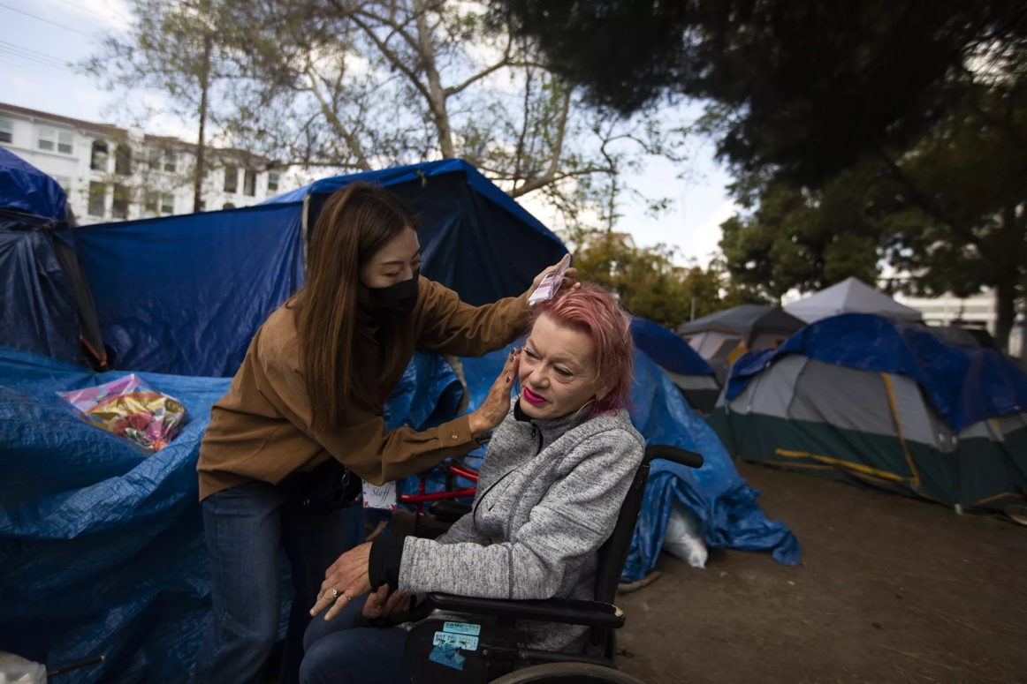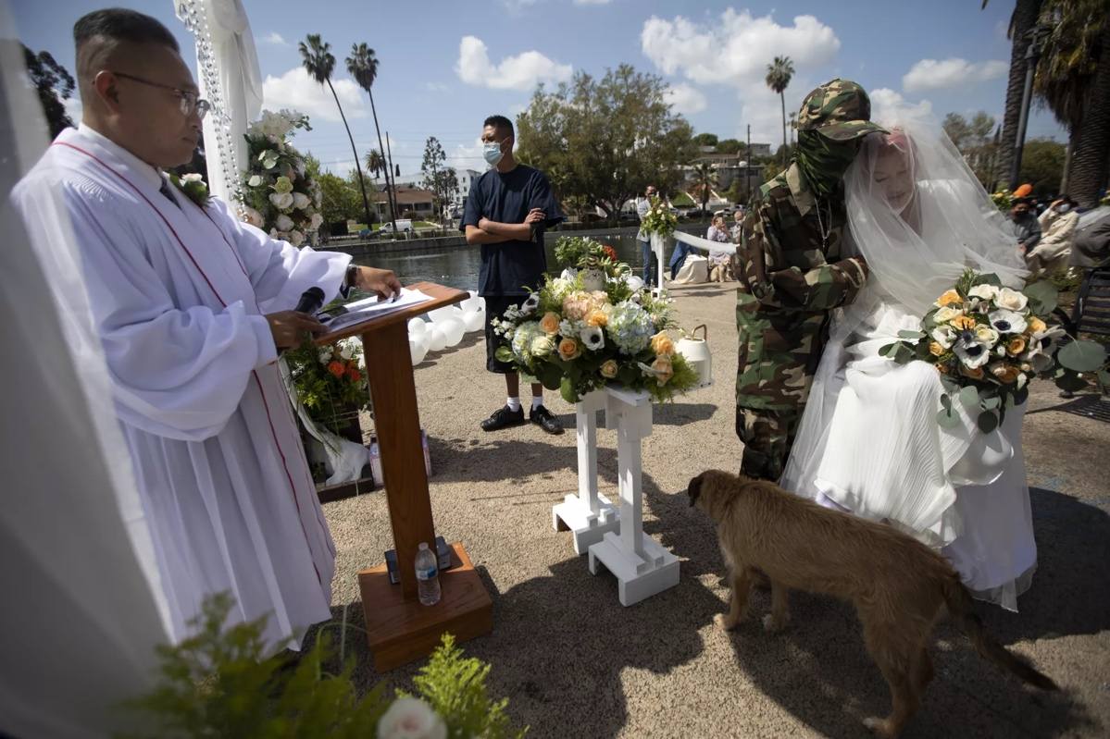
“Pastor Billy Roe conducts the wedding between Henry and his bride, Valerie Zeller, with her dog Redd, near Echo Park Lake” (Francine Orr /Los Angeles Times)
“Heather Yoo, left, and Amie Roe, right, help Valerie Zeller with her veil as they prepare for the wedding at her tent.” (Francine Orr /Los Angeles Times) (https://www.latimes.com/california/story/2021-03-20/with-rumors-of-eviction-swirling-an-echo-park-homeless-couple-take-their-wedding-vows)
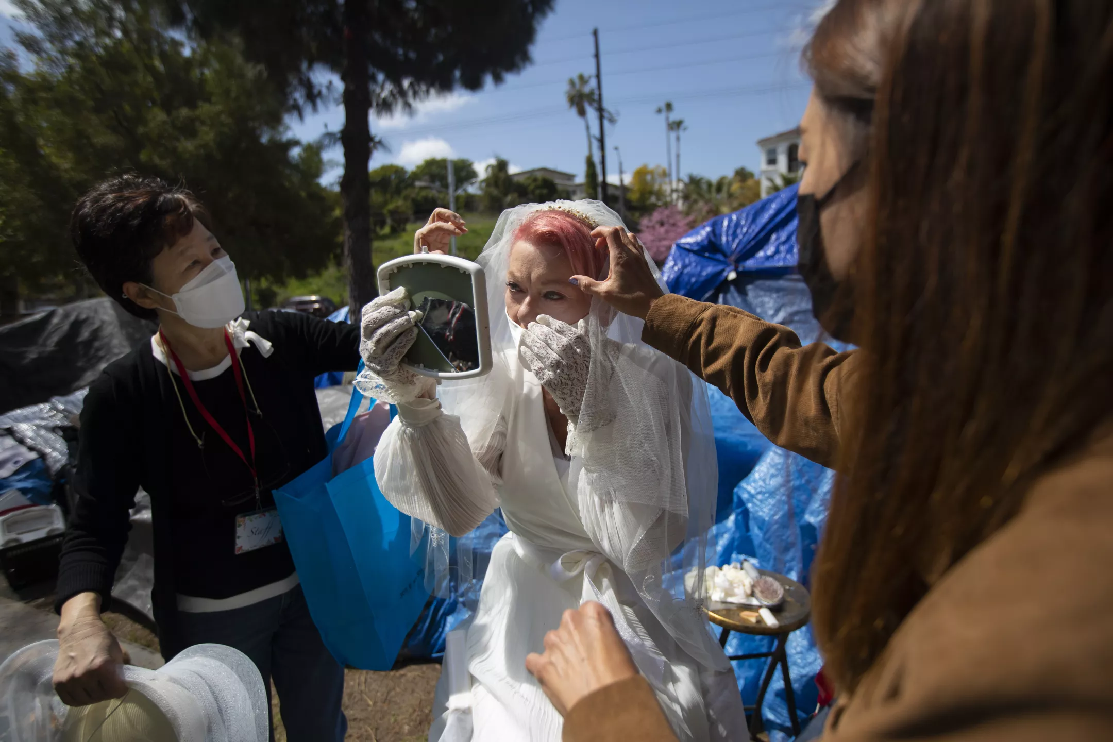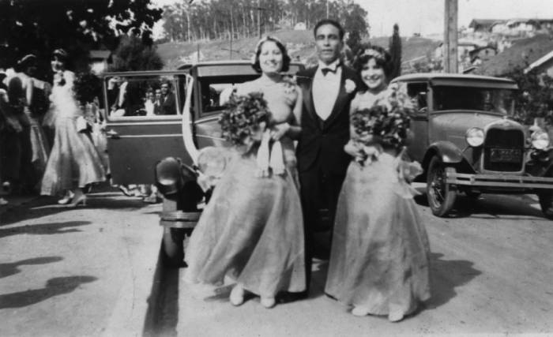
Bridesmaids and Best man in Chávez Ravine, 1929 Accessed through the Shades of L.A. Collection through the Digital Collections of the Los Angeles Public Library (https://tessa2.lapl.org/digital/collection/photos/id/76941/rec/104)
Evicted Family in a tent in Chávez Ravine, 1959, Accessed through the Los Angeles Herald Examiner Photo Collection through the Digital Collections of the Los Angeles Public Library
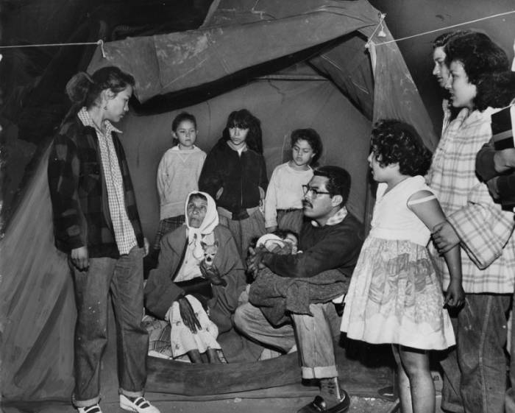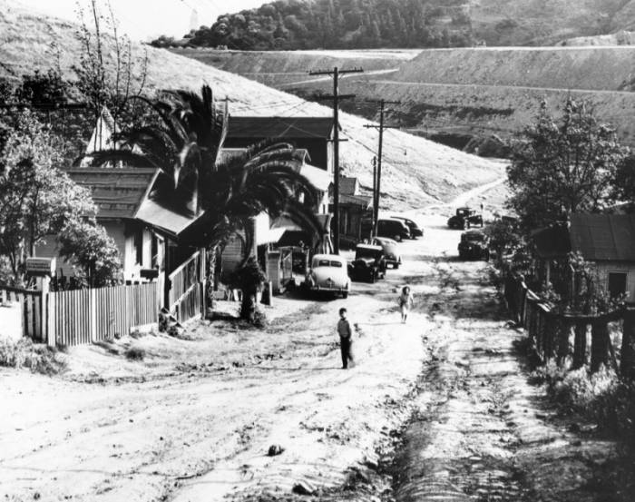
Two children walk up a dirt road in Chávez Ravine, 1950, Leonard Nadel, Accessed from the Housing Authority collection through the Digital Collections of the Los Angeles Public Library
Bibliography
Avila, Eric. Popular Culture in the Age of White Flight. Berkeley and Los Angeles, California: University of California Press, 2004.

Bonilla-Silva, Eduardo. “From Bi-Racial to Tri-Racial: Towards a New System of Racial Stratification in the USA.” 27, no. 6 (2004): 931–50. https://doi.org/10.1080/0141987042000268530.

Callinicos, Alex. Race and Class. London: Bookmarks, 1993.

Chandler, Jenna. “Street Vending Is Finally Legal in Los Angeles.” Curbed LA, November 28, 2018. https://la.curbed.com/2018/11/28/18116698/street-vending-los-angeles-legalization-vote.

Civil + Human Rights and Equity Department. “City Leaders Launch ‘LA for All’ Campaign Against Hate,” May 26, 2021. https://civilandhumanrights.lacity.org/get-involved/highlights/city-leaders-launch-la-all-campaign-against-hate.

City News Service. “LA City Council Approves Revised $11.8B Budget for 2022-23.” Spectrum News 1, May 18, 2022. https://spectrumnews1.com/ca/la-west/politics/2022/05/18/los-angeles-city-council-to-review-2022-23-budget.

City News Service News Partner. “Echo Park Closed, Repair And Renovation Project Proceeds.” Patch, March 27, 2021. https://patch.com/california/echopark/echo-park-closed-repair-renovation-project-proceeds.

Conocer a Rick Caruso, 2022. https://www.youtube.com/watch?v=d4J2exu2BLY.

County of Los Angeles. “Los Angeles County Homelessness & Housing Map.” ArcGIS StoryMaps, June 3, 2022. https://storymaps.arcgis.com/stories/400d7b75f18747c4ae1ad22d662781a3.

County of Los Angeles, Department of Public Health. “Mobile Food Facility Plan Check Guidelines,” n.d. http://publichealth.lacounty.gov/eh/docs/permit/mobile-food-facility-plan-check-guidelines.pdf.

Davidson, Mark. “Displacement, Space and Dwelling: Placing Gentrification Debate.” Ethics, Place & Environment 12, no. 2 (June 1, 2009): 219–34. https://doi.org/10.1080/13668790902863465.

Frankenberg, Ruth. “Growing up White: Feminism, Racism and the Social Geography of Childhood.” Feminist Review, no. 45 (1993): 51–84. https://doi.org/10.2307/1395347.

Harris, Cheryl I. “Whiteness as Property.” Harvard Law Review 106, no. 8 (1993): 1707–91. https://doi.org/10.2307/1341787.

Hernandez, Melissa. “Echo Park Lake Chain-Link Fence Erected for Repairs Taken Down.” Los Angeles Times, August 8, 2022. https://www.latimes.com/california/story/2022-08-08/echo-park-lake-chain-link-fence-taken-down-homeless-encampment.

History com Editors. “LAPD Officers Beat Rodney King on Camera.” HISTORY, March 2, 2021. https://www.history.com/this-day-in-history/police-brutality-caught-on-video.

Lee, Andrew. “How the Nextdoor App Modernized Racial Profiling.” Anti-Racism Daily, January 31, 2022. https://the-ard.com/2022/01/31/nextdoor-racist-problem-modernizes-racial-profiling/.

Liu, Yvonne Yen, Burns, Patricks, Flaming, Daniel, and East LA Community Corporation. “Sidewalk Stimulus.” Economic Roundtable, June 22, 2015. https://economicrt.org/publication/sidewalk-stimulus/.

Lomibao, Lynn. “Blueprint for Displacement: Breaking Down LAPD’s “Echo Park Rehabilitation After-Action Report.” Stop LAPD Spying Coalition, September 21, 2021. https://stoplapdspying.org/zine-blueprint-for-displacement/.

Lopez, Lorraine A. “Cruelty Will Not Solve the ‘homeless Problem’ in LA.” Daily Journal, July 15, 2021. https://www.dailyjournal.com/articles/363510-cruelty-will-not-solve-the-homelessness-problem-in-la.

Los Angeles Homeless Services Authority. “2019 Greater Los Angeles Homeless Count Results,” June 4, 2019. https://www.lahsa.org/news?article=557-2019-greater-los-angeles-homeless-count-results.

Los Angeles, Cal., Municipal Code Foreword.

Los Angeles, Cal., Section 11 § 01. DEFINITIONS AND INTERPRETATION (2004).

Los Angeles, Cal., Section 41§ 18. SITTING, LYING, OR SLEEPING OR STORING,
USING MAINTAINING, OR PLACING PERSONAL PROPERTY IN THE PUBLIC RIGHT-OF-WAY (2021).

Los Angeles, Cal., Section 42 § 13. SIDEWALK AND PARK VENDING PROGRAM.
(2019.)

Los Angeles, Cal., Section 56 § 45. PEACE AND SECURITY PROTECTION (2021).

Los Angeles, Cal., Section 103 § 111. PARADES AND ASSEMBLIES (2005).

MayorOfLA [@MayorOfLA]. “Los Angeles Is a City Where Everyone Belongs and Where No One Should Face Hate or Discrimination. If You Personally Experience or See Hate in Our City, You Can Report Anonymously by Calling 3-1-1. Visit Http://CivilAndHumanRights.LACity.Org/LAforAll for Resources and Information. #LAforAll Https://T.Co/5xf5BkT9SS.” Tweet. Twitter, July 23, 2021. https://twitter.com/MayorOfLA/status/1418613124618362880.

McLaren, Peter. “Unthinking Whiteness.” REVOLUTIONARY PEDAGOGIES, January 1, 2000. https://www.academia.edu/26794742/Unthinking_Whiteness.

Montgomery, Riley. “Save Echo Park Lake.” Change.org. Accessed October 26, 2022. https://www.change.org/p/save-echo-park-lake.

Oreskes, Benjamin and Smith, Doug. “L.A. Just Changed Its Entire Approach to Homelessness. Does It Place Politics above Need?” Los Angeles Times, November 3, 2021. https://www.latimes.com/homeless-housing/story/2021-11-03/la-changed-approach-to-homelessness-politics-need.

“Profile of the Foreign-Born Population in Los Angeles, California.” Vera Institute of Justice, n.d. https://www.vera.org/downloads/publications/profile-foreign-born-population-los-angeles-long-beach.pdf.

Regular City Council - 8/2/22, 2022. https://www.youtube.com/watch?v=E6Ilzh-Fhr8.

Roy, Ananya, Ashley Bennett, Jennifer Blake, Jonny Coleman, Hannah Cornfield, La Donna Harrell, Terrie Klein, et al. (Dis)Placement: The Fight for Housing and Community After Echo Park Lake, 2022. https://escholarship.org/uc/item/70r0p7q4.

Reyes, Emily Alpert. “Spurred by Trump’s Immigration Crackdown, L.A. City Council Moves to Decriminalize Street Vending.” Los Angeles Times, February 1, 2017. https://www.latimes.com/local/lanow/la-me-ln-street-vending-decriminalize-20170130-story.html.

Rick Caruso for Mayor. “Meet Rick Caruso.” Accessed October 27, 2022. https://www.carusocan.com/meet-rick-caruso/.

Roediger, David R., The Wages of Whiteness: Race and the Making of the American Working Class. London: Verso, 2007.

Smith, Dakota. “L.A. City Council Tightens Law around Protests Outside Private Homes.” Los Angeles Times, September 14, 2021. https://www.latimes.com/california/story/2021-09-14/la-city-council-passes-strict-law-over-protesting-outside-residences.

Smith, Dakota and Ormseth, Matthew. “It Took a While, but L.A. Formally Declares Itself a ‘City of Sanctuary.’” Los Angeles Times, February 8, 2019. https://www.latimes.com/local/lanow/la-me-ln-city-of-sanctuary-cedillo-20190208-story.html.

Swanson, Abbie Fentress. “LA’s Moves To Protect Immigrant Street-Food Vendors Come With A Catch.” NPR, February 16, 2017, sec. Food For Thought. https://www.npr.org/sections/thesalt/2017/02/16/515257761/las-moves-to-protect-immigrant-street-food-vendors-come-with-a-catch.

The Times Editorial Board. “Editorial: Legalize Street Food. L.A.’s Iconic Sidewalk Vendors Are Still Being Penalized.” Los Angeles Times, December 13, 2021. https://www.latimes.com/opinion/story/2021-12-13/editorial-legalize-street-food.

UCLA School of Law Community Economic Development Clinic, Inclusive Action for City, Community Power Collective, East LA Community Corporation, and LA Street Vendor Campaign. “UNFINISHED BUSINESS: How Food Regulations Starve Sidewalk Vendors of Opportunity and What Can Be Done to Finish the Legalization of Street Food,” n.d.

“U.S. Census Bureau QuickFacts: Los Angeles City, California.” Accessed October 26, 2022. https://www.census.gov/quickfacts/fact/table/losangelescitycalifornia/POP010220)%204%20Vera%20Institute%20of%20Justice,%20(https://www.vera.org/downloads/publications/profile-foreign-born-population-los-angeles-long-beach.pdf.

Wagner, David. “More Than 69,000 People Are Experiencing Homelessness in LA – An Uptick From Last Count.” LAist, September 8, 2022. https://laist.com/news/housing-homelessness/lahsa-los-angeles-homeless-count-2022-pandemic-covid-homelessness-point-in-time-4-point-1-percent-increase.

White, Pete. “41.18 Amendment: A Wolf in Wolf’s Clothing.” Accessed October 27, 2022. https://cangress.org/41-18-amendment-a-wolf-in-wolfs-clothing/.

Zahniser, David, Wick, Julia, Smith, Dakota and Oreskes, Benjamin. “Nury Martinez Resigns from L.A. City Council in Wake of Audio Leak Scandal.” Los Angeles Times, October 12, 2022, sec. California. https://www.latimes.com/california/story/2022-10-12/la-me-nury-martinez-resigns.

“City Leaders Launch 'La for All' Campaign against Hate.” City Leaders Launch 'LA for All' Campaign Against Hate | Civil + Human Rights and Equity Department, https://civilandhumanrights.lacity.org/get-involved/highlights/city-leaders-launch-la-all-campaign-against-hate.
David Randall [@collectiveyawn], “Very cool, can I report LAPD?,” Twitter post, July 23, 2021, https://twitter.com/MayorOfLA/status/1418613124618362880
“U.S. Census Bureau QuickFacts: Los Angeles City, California” (2021), https://www.census.gov/quickfacts/fact/table/losangelescitycalifornia/POP010220
“Profile of the Foreign-Born Population in Los Angeles, California” (Vera Institute of Justice, 2020), https://www.vera.org/downloads/publications/profile-foreign-born-population-los-angeles-long-beach.pdf
History com Editors, “LAPD Officers Beat Rodney King on Camera,” HISTORY, March 2, 2021, https://www.history.com/this-day-in-history/police-brutality-caught-on-video.
Dakota Smith and Matthew Ormseth, “It Took a While, but L.A. Formally Declares Itself a ‘City of Sanctuary,’” Los Angeles Times, February 8, 2019, https://www.latimes.com/local/lanow/la-me-ln-city-of-sanctuary-cedillo-20190208-story.html.
“New Money” is a pop culture concept that is the foil to “Old Money.” Culturally, “New Money” represents individuals who attain wealth rapidly and generally with instability, examples would include many prominent performers, singers, rappers, and actors. For example, MC Hammer, whose wealth was estimated by Forbes to be more than $33 million in 1991, filed for bankruptcy in 1996 after reportedly being $13 million in debt. This would be an example of the “New Money” crisis. (Numbers taken from https://www.oprah.com/oprahshow/whatever-happened-to-mc-hammer/all#:~:text=Forbes%20Magazine%20estimated%20Hammer's%20net,matter%20of%20losing%20his%20head. ) On Youtube, a channel with 2.58k subscribers posted a video titled “Get Rich Quick vs Get Rich Slow – New Money vs Old Money – Spirit of Los Angeles vs Spirit of Omaha.” The video connects the city of LA directly to the concept of New Money. (https://youtu.be/iPuJyAt8j0o)
“Historically dispossessed” will continue to be used in this thesis. In writing, many terms came up: minority, People of Color, marginalized, etc. None of these felt broad enough to capture the intersections of identities that the State violently attacks. “Historically dispossessed” or at times just “dispossessed” recognizes the legacies of State violence that have hurt a wide range of identities and communities. For now, it is the most apt term with which I can succinctly describe the diverse populations I am interested.
Emily Alpert Reyes, “Spurred by Trump’s Immigration Crackdown, L.A. City Council Moves to Decriminalize Street Vending,” Los Angeles Times, February 1, 2017, https://www.latimes.com/local/lanow/la-me-ln-street-vending-decriminalize-20170130-story.html.
Yvonne Yen Liu et al., “Sidewalk Stimulus,” Economic Roundtable, June 22, 2015, https://economicrt.org/publication/sidewalk-stimulus/.
County of Los Angeles, Department of Public Health, “Mobile Food Facility Plan Check Guidelines,” http://publichealth.lacounty.gov/eh/docs/permit/mobile-food-facility-plan-check-guidelines.pdf, 9-10
The Times Editorial Board, “Editorial: Legalize Street Food. L.A.’s Iconic Sidewalk Vendors Are Still Being Penalized,” Los Angeles Times, December 13, 2021, https://www.latimes.com/opinion/story/2021-12-13/editorial-legalize-street-food.
UCLA School of Law Community Economic Development Clinic et al., “UNFINISHED BUSINESS: How Food Regulations Starve Sidewalk Vendors of Opportunity and What Can Be Done to Finish the Legalization of Street Food,” accessed October 27, 2022.
Abbie Fentress Swanson, “LA’s Moves to Protect Immigrant Street-Food Vendors Come with a Catch,” NPR, February 16, 2017, sec. Food for Thought, https://www.npr.org/sections/thesalt/2017/02/16/515257761/las-moves-to-protect-immigrant-street-food-vendors-come-with-a-catch.
UCLA School of Law Community Economic Development Clinic et al., 2.
UCLA School of Law Community Economic Development Clinic et al., 3.
Los Angeles, Cal., Section 42 § 13. SIDEWALK AND PARK VENDING PROGRAM. (2019.)
Abbie Fentress Swanson, “LA’s Moves To Protect Immigrant Street-Food Vendors Come With A Catch.”
Los Angeles, Cal., Section 42 § 13. SIDEWALK AND PARK VENDING PROGRAM. (2019.)
Jenna Chandler, “Street Vending Is Finally Legal in Los Angeles,” Curbed LA, November 28, 2018, https://la.curbed.com/2018/11/28/18116698/street-vending-los-angeles-legalization-vote.
David R Roediger, Mike Davis, Michael Sprinker, and the American Council of Learned Societies discuss in their 2007 book The Wages of Whiteness: race and the Making of the American Working Class how proximity to whiteness grants certain forms of capital such as reliable employment, access to education, and entrepreneurship. The coin these forms of power as “the wages of whiteness.” This concept is further developed in Chapter 1.
Derrick Bell. 1980. “Brown V. Board of Education and the Interest-Convergence Dilemma.” Harvard Law Review 93 (3): 518–33. https://doi.org/10.2307/1340546.
Eduardo Bonilla-Silva, “From Bi-Racial to Tri-Racial: Towards a New System of Racial Stratification in the USA.” 27, no. 6 (2004): 931–50, https://doi.org/10.1080/0141987042000268530.
David R. Roediger, The Wages of Whiteness: Race and the Making of the American Working Class (London: Verso, 2007).
Carl Degler. 1986 Neither Black nor White: Slavery and Race Relations in Brazil and the United States, Madison, WI: The University of Wisconsin Press Peter Wade. 1997 Race and Ethnicity in Latin America, London: Pluto Press
Displacement studies is often situated within the social sciences, and consequently many works focus on data and a statistical understanding of displacement. Examples cited in this thesis include: Chris Hamnett. (1984). Gentrification and residential location theory: A review and assessment. In David T. Herbert & Ronald J. Johnson (Eds.), Geography and the urban environment: Progress in research and applications (pp. 283–319). London: Wiley & Sons. David Ley. (1986). Alternative explanations for inner-city gentrification: A Canadian assessment. Annals of the Association of American Geographers, 76, (4), 521–535. Howard Sumka. (1979). Neighborhood revitalization and displacement: A review of the evidence. Journal of the American Planning Association, 45(4), 480–487.
United States. Congress 1954). House. 1954. Housing Act of 1954. Hearing before the Committee on Banking and Currency, House of Representatives, Eighty-Third Congress, Second Session, on H.R. 7839, a Bill to Aid in the Provision and Improvement of Housing, the Elimination and Prevention of Slums, and the Conservation and Development of Urban Communities .. Washington: U.S. Govt. Print. Off.
Eric Avila, Popular Culture in the Age of White Flight (Berkeley and Los Angeles, California: University of California Press, 2004), 156.
Avila, 156.
Frank Wilkinson, interview by Eric Avila in Popular Culture in the Age of White Flight (Berkeley and Los Angeles, California: University of California Press, 2004), Los Angeles, Calif., 24 January 1996. Tape Recording
As argued in the introduction, “Revitalize,” in Los Angeles, means to remove current (often poor or racialized) life with the promise to replace it with new vitality. The new life takes the form of renewed green spaces, businesses, and other forms of private capital development. “Revitalization” rarely if ever adequately addresses the lives that came before it, instead opting to erase life for capital expansion
Eric Avila, Popular Culture in the Age of White Flight, 158
Avila, 156.
Thomas Hines. “Housing, Baseball, and Creeping Socialism: The Battle of Chavez Ravine, Los Angeles, 1949-1959.” Journal of Urban History 8, no. 2, (1982): 125
United States. Congress 1954). House. 1954. Housing Act of 1954. Hearing before the Committee on Banking and Currency, House of Representatives, Eighty-Third Congress, Second Session, on H.R. 7839, a Bill to Aid in the Provision and Improvement of Housing, the Elimination and Prevention of Slums, and the Conservation and Development of Urban Communities .. Washington: U.S. Govt. Print. Off.
Fried, Marc. (1966). Grieving for a lost home: Psychological costs of relocation. In James Q. Wilson (Ed.), Urban renewal: The record and the controversy (pp. 359–379). Cambridge, MA: M.I.T. Press.
Hamnett, Chris. (1984). Gentrification and residential location theory: A review and assessment. In David T. Herbert & Ronald J. Johnson (Eds.), Geography and the urban environment: Progress in research and applications (pp. 283–319). London: Wiley & Sons. Ley, David. (1986). Alternative explanations for inner-city gentrification: A Canadian assessment. Annals of the Association of American Geographers, 76, (4), 521–535.
Smith, Neil. 1996. The New Urban Frontier: Gentrification and the Revanchist City. London; New York: Routledge.
Grier, George W., & Grier, Eunice S. (1978). Urban displacement: A reconnaissance. Washington, DC: U.S. Department of Housing and Urban Development.
Sumka, Howard J. (1979). Neighborhood revitalization and displacement: A review of the evidence. Journal of the American Planning Association, 45(4), 480–487.
Davidson, Mark. (2009). Displacement space and dwelling: Placing gentrification debate. Ethics, Place & Environment: A Journal of Philosophy & Geography, 12(2), 225.
Davidson, 228
Mills, Charles W. 2000. “Race and the Social Contract Tradition.” Social Identities 6 (4): 441–62. https://doi.org/10.1080/13504630020026404.
Ruth Frankenberg, “Growing up White: Feminism, Racism and the Social Geography of Childhood,” Feminist Review, no. 45 (1993): 51–84, https://doi.org/10.2307/1395347.
Peter McLaren, “Unthinking whiteness: Rearticulating diasporic practice.” In Revolutionary pedagogies: Cultural politics, instituting education, and the discourse of theory, (2000): 155, Routledge, https://doi.org/10.4324/9780203901557-11.
Eduardo Bonilla-Silva, “From Bi-Racial to Tri-Racial: Towards a New System of Racial Stratification in the USA.”
Cheryl I. Harris, “Whiteness as Property,” Harvard Law Review 106, no. 8 (1993): 1707–91, https://doi.org/10.2307/1341787.
Harris, 280
Peter McLaren, “Unthinking whiteness: Rearticulating diasporic practice,” 145.
McLaren, 147.
Alex Callinicos, Race and Class (London: Bookmarks, 1993).
Gentefication refers to the gentrification of Latine neighborhoods by capital accumulating Latines. This capital can take the form of higher education, property ownership, and other identities which may bring economic prosperity.
Mark Davidson, “Displacement, Space and Dwelling: Placing Gentrification Debate,” Ethics, Place & Environment 12, no. 2 (June 1, 2009): 219–34, https://doi.org/10.1080/13668790902863465.
“Street Strategies.” Office of Los Angeles Mayor Eric Garcetti. Accessed October 27, 2022. https://www.lamayor.org/street strategies.
Benjamin Oreskes and Doug Smith, “L.A. Just Changed Its Entire Approach to Homelessness. Does It Place Politics above Need?,” Los Angeles Times, November 3, 2021, https://www.latimes.com/homeless-housing/story/2021-11-03/la-changed-approach-to-homelessness-politics-need.
Frank Finch, “Dodgers Approve L.A. Deal, Will Play Here Next Season,” Los Angeles Times, 9 October 1957, part 1, p.1
Torch Reporter, September 1957, 11. Edward R. Roybal Papers, Special Collections, Young Research Library, University of California, Los Angeles. For a photographic essay on the life of Chavez Ravine prior to the arrival of the CHA and Dodgers, see Don Normark, Chavez Ravine, 1949: A Los Angeles Story (San Francisco: Chronicle Books, 1999).
City News Service News Partner, “Echo Park Closed, Repair And Renovation Project Proceeds,” Patch, March 27, 2021, https://patch.com/california/echopark/echo-park-closed-repair-renovation-project-proceeds.
Ananya Roy et al., (Dis)Placement: The Fight for Housing and Community After Echo Park Lake, 2022, https://escholarship.org/uc/item/70r0p7q4.
Lynn Lomibao, “Blueprint for Displacement: Breaking Down LAPD’s “Echo Park Rehabilitation After-Action Report” (Stop LAPD Spying Coalition, September 21, 2021), https://stoplapdspying.org/zine-blueprint-for-displacement/.
Roy et al., (Dis)Placement: The Fight for Housing and Community After Echo Park Lake.
Roy et al.
Riley Montgomery, “Save Echo Park Lake,” Change.org, https://www.change.org/p/save-echo-park-lake.
Andrew Lee, “How the Nextdoor App Modernized Racial Profiling,” Anti-Racism Daily, January 31, 2022, https://the-ard.com/2022/01/31/nextdoor-racist-problem-modernizes-racial-profiling/.
Benjamin Oreskes and Doug Smith, “L.A. Just Changed Its Entire Approach to Homelessness. Does It Place Politics above Need?”
Benjamin Oreskes and Doug Smith.
Eric Avila, “The Nation’s “White Spot”: Racializing Postwar Los Angeles,” Popular Culture in the Age of White Flight. Berkeley: University of California Press. 2004.
Dial Togerson, “Which Way for Echo Park – Inner City Oasis or Slum?” Los Angeles Times, September 19, 1971.
Matthew Fleischer. “How did Echo Park become so stratified with landed gentry and poverty? There was a plan 50 years ago.” Los Angeles Times, March 23, 2021.
Ana Muñiz, "Maintaining racial boundaries: Criminalization, neighborhood context, and the origins of gang injunctions." Social Problems 61, no. 2 (2014): 216-236.
Kimberly M. Soriano, Getting Up: Gentrification, Gang Injunctions, and Graffitti in Echo Park, Los Angeles, University of California: Santa Barbara, June 2019.
Melissa Hernandez. “Echo Park Lake Chain-Link Fence Erected for Repairs Taken Down.”
Melissa Hernandez.
Dakota Smith, “L.A. City Council Tightens Law around Protests Outside Private Homes.” Los Angeles Times, September 14, 2021. https://www.latimes.com/california/story/2021-09-14/la-city-council-passes-strict-law-over-protesting-outside-residences.
Los Angeles, Cal., Section 56 § 45. PEACE AND SECURITY PROTECTION (2021).
Dakota Smith, “L.A. City Council Tightens Law around Protests Outside Private Homes.”
Rules of the Los Angeles City Council As Amended (January 2019), page 2
LACITYVOTES. “Regular City Council - 8/2/22.” YouTube. YouTube, August 3, 2022. https://www.youtube.com/watch?v=E6Ilzh-Fhr8.
Eduardo Bonilla-Silva. 2004. “From Bi-Racial to Tri-Racial: Towards a New System of Racial Stratification in the USA.” Ethnic and Racial Studies 27 (6): 931–50. https://doi.org/10.1080/0141987042000268530.
Los Angeles, Cal., Municipal Code Foreword.
Los Angeles, Cal., Section 11 § 01. DEFINITIONS AND INTERPRETATION (2004).
City News Service. “La City Council Approves Revised $11.8B Budget for 2022-23.” spectrumnews1.com, May 18, 2022. https://spectrumnews1.com/ca/la-west/politics/2022/05/18/los-angeles-city-council-to-review-2022-23-budget.
Los Angeles, Cal., Section 41§ 18. SITTING, LYRING, OR SLEEPING OR STORING, USING MAINTAINING, OR PLACING PERSONAL PROPERTY IN THE PUBLIC RIGHT-OF-WAY (2021).
“‘Where Will People Go?".” Mike Bonin, November 29, 2021. https://11thdistrict.com/4118-faq/.
“Supreme Court Lets Martin v. Boise Stand.” National Homelessness Law Center, October 3, 2022. https://homelesslaw.org/supreme-court-martin-v-boise/.
“Jones v. City of Los Angeles - 444 F.3d 1118 (9th Cir. 2006).” Community. Accessed October 27, 2022. https://www.lexisnexis.com/community/casebrief/p/casebrief-jones-v-city-of-l-a-444-f-3d-1118-9th-cir-2006.
Volume I “Governance”, Article V “Departments”, Section 570, states that “The Police Department shall have the power and duty to enforce the penal provisions of the Charter, City ordinances and state and federal law”
Los Angeles, Cal., Section 41§ 18. SITTING, LYRING, OR SLEEPING OR STORING, USING MAINTAINING, OR PLACING PERSONAL PROPERTY IN THE PUBLIC RIGHT-OF-WAY (2021).
Pete White. “41.18 Amendment: A Wolf in Wolf's Clothing.” LACAN. Accessed October 27, 2022. https://cangress.org/41-18-amendment-a-wolf-in-wolfs-clothing/.
The only existing visual database of 41.18 sites has been created by the Kenneth Mejia for City Controller Campaign. It can be accessed at https://4118.mejiaforcontroller.com/
Eric Bonds and Leslie Martin. “Treating People like Pollution: Homelessness and Environmental Injustice.” Environmental Justice 9, no. 5 (2016): 137–41. https://doi.org/10.1089/env.2016.0021.
LACITYVOTES. “Regular City Council - 8/2/22.” YouTube. YouTube, August 3, 2022. https://www.youtube.com/watch?v=E6Ilzh-Fhr8.
Eric Bonds and Leslie Martin. “Treating People like Pollution: Homelessness and Environmental Injustice.” Environmental Justice 9, no. 5 (2016): 137–41. https://doi.org/10.1089/env.2016.0021.
National Law Center on Homelessness and Poverty. Housing Not Handcuffs: Ending Criminalization of Homelessness in U.S. Cities. National Law Center on Homelessness and Poverty, 2016.
“2019 Greater Los Angeles Homeless Count Results.” Go to main LAHSA website, 2019. https://www.lahsa.org/news?article=557-2019-greater-los-angeles-homeless-count-results.
Several interest groups work with politicians to ensure their hold on capital in the form of private developments. In KnockLA, Jonny Colman reported on May 19, of 2022 how “Landlord Lobbyists Pour Nearly $2 Million into LA County Political Ads.” Jonny Coleman. “The California Apartment Association Is Spending Millions on La Political Ads.” Knock LA, May 21, 2022. https://knock-la.com/california-apartment-association-political-ad-spending/?link_id=12&can_id=cd7542ea5be91f13f13fcf82e9b6bd5d&source=email-dsa-la-voter-guide-drops-thorn-west-issue-no-108&email_referrer=email_1551499&email_subject=council-approves-increase-in-lapd-budget-thorn-west-issue-no-109.
Richard Delgado and Jean Stefancic. 2012. Critical Race Theory :an Introduction. Second edition. New York: New York University Press.
“2019 Greater Los Angeles Homeless Count Results.” Go to main LAHSA website, 2019. https://www.lahsa.org/news?article=557-2019-greater-los-angeles-homeless-count-results.
Leila Miller. “Use-of-Force Incidents against Homeless People Are up, LAPD Reports.” Los Angeles Times. Los Angeles Times, January 22, 2020. https://www.latimes.com/science/story/2020-01-21/use-of-force-incidents-against-homeless-people-are-up-lapd-reports.
Los Angeles, Cal., Section 103 § 111. PARADES AND ASSEMBLIES (2005).
David Wagner. “More than 69,000 People Are Experiencing Homelessness in LA – an Uptick from Last Count.” LAist, September 8, 2022. https://laist.com/news/housing-homelessness/lahsa-los-angeles-homeless-count-2022-pandemic-covid-homelessness-point-in-time-4-point-1-percent-increase.
County of Los Angeles. “Los Angeles County Homelessness & Housing Map.” ArcGIS StoryMaps. Esri, June 3, 2022. https://storymaps.arcgis.com/stories/400d7b75f18747c4ae1ad22d662781a3#:~:text=to%20overall%20Total.-,Current%20Interim%20Housing,countywide%20with%2013%2C089%20beds%20available.
“City Leaders Launch 'La for All' Campaign against Hate.” City Leaders Launch 'LA for All' Campaign Against Hate | Civil + Human Rights and Equity Department, https://civilandhumanrights.lacity.org/get-involved/highlights/city-leaders-launch-la-all-campaign-against-hate.
David Zahniser. “L.A. Clears the Way for Skyscraper Project, Remaking The Edge of Echo Park and Chinatown.” Los Angeles Times. Los Angeles Times, June 29, 2022. https://www.latimes.com/california/story/2022-06-29/los-angeles-city-council-approves-sunset-boulevard-skyscraper-project.
Eric Bonds and Leslie Martin. “Treating People like Pollution: Homelessness and Environmental Injustice.” Environmental Justice 9, no. 5 (2016): 137–41. https://doi.org/10.1089/env.2016.0021.
Riley Montgomery, “Save Echo Park Lake,” Change.org, https://www.change.org/p/save-echo-park-lake.
LACITYVOTES. “Regular City Council - 8/2/22.” YouTube. YouTube, August 3, 2022. https://www.youtube.com/watch?v=E6Ilzh-Fhr8.
“City Leaders Launch 'La for All' Campaign against Hate.” City Leaders Launch 'LA for All' Campaign Against Hate | Civil + Human Rights and Equity Department, https://civilandhumanrights.lacity.org/get-involved/highlights/city-leaders-launch-la-all-campaign-against-hate.
Scott Harrison. “From the Archives: 1959 Evictions from Chavez Ravine.” Los Angeles Times. Los Angeles Times, May 9, 2017. https://www.latimes.com/visuals/photography/la-me-fw-archives-1959-evictions-from-chavez-ravine-20170328-story.html.
“Meet Rick Caruso,” Rick Caruso for Mayor, accessed October 27, 2022, https://www.carusocan.com/meet-rick-caruso/.
“Conocer a Rick Caruso.” YouTube. YouTube, October 4, 2022. https://www.youtube.com/watch?v=d4J2exu2BLY.
David Zahniser, et al. “Racist Remarks in Leaked Audio of L.A. Council Members Spark Outrage, Disgust.” Los Angeles Times. Los Angeles Times, October 9, 2022. https://www.latimes.com/california/story/2022-10-09/city-council-leaked-audio-nury-martinez-kevin-de-leon-gil-cedillo.
David Zahniser et al., “Nury Martinez Resigns from L.A. City Council in Wake of Audio Leak Scandal,” Los Angeles Times, October 12, 2022, https://www.latimes.com/california/story/2022-10-12/la-me-nury-martinez-resigns.
David Zahniser et al., “Nury Martinez Resigns from L.A. City Council in Wake of Audio Leak Scandal,” Los Angeles Times, October 12, 2022, https://www.latimes.com/california/story/2022-10-12/la-me-nury-martinez-resigns.
“Hear the Full Leaked Audio of L.A. City Hall Officials.” Los Angeles Times. Los Angeles Times. Accessed October 27, 2022. https://www.latimes.com/california/jabfj4ghp28-123.
Lorraine A. Lopez, “Cruelty Will Not Solve the ‘homeless Problem’ in LA,” Daily Journal, July 15, 2021, https://www.dailyjournal.com/articles/363510-cruelty-will-not-solve-the-homelessness-problem-in-la.
Lynn Lomibao. “Zine: Blueprint for Displacement.” Stop LAPD Spying Coalition, December 15, 2021. https://stoplapdspying.org/zine-blueprint-for-displacement/.
“City Leaders Launch 'La for All' Campaign against Hate.” City Leaders Launch 'LA for All' Campaign Against Hate | Civil + Human Rights and Equity Department, https://civilandhumanrights.lacity.org/get-involved/highlights/city-leaders-launch-la-all-campaign-against-hate.

