Putian Jianshan Catholic Church Case study: the elicitation of awe and sacredness
Abstract
This case study examines how Jianshan Catholic Church in Wengcuo, Putian, elicits sacred experience by translating the Catholic grammar of awe into a modern language. Tracking the visitor’s path, it analyzes threshold, controlled sightlines that lift the gaze, a starry inner canopy with a day lit perimeter, an encircling altar plan, intimate acoustics, and a coastal material palette. The study sets these choices against named Gothic and Baroque precedents and situates them within post Vatican II priorities of active participation. It finds that Jianshan Catholic Church produces attentional focus and communal bonding through proportion, light, sound, and sequence while remaining locally rooted.

Purpose

The purpose of this study is to demonstrate how the modern Jianshan Catholic church reinterprets traditional cues of sacredness through architectural language, responding to post-Vatican II liturgical reforms and localizing itself in Putian culture. It is informed by my Literature Review on Catholic Church Design and the Elicitation of Awe and Sacredness, but further shows sacredness as psychological resonance evoked by specific physical traits, even when traits are unconventional.

Method

All observations were conducted in Wengcuo village, Putian City, Fujian Province, including photography, interview, and participation in church activities. Study also references design details provided by Jianshan Church’s design team. Observations focus on church’s architectural choices and local worshippers’ reported feelings of sacredness in religious spaces. The analysis is organized into 8 sections, following the order of an actual visit to the church.

- Approaching the church
On the way to the church, road lifts over empty fields. Near the edge of the roadway is where I first glimpsed a perfect cube sitting on the boulders, facing its east and overlooking Jinmen. There are two routes to the church. Visitors arrive first at a reception point on the foot of the boulders to park, where after a rammed earth and stone path, a zig-zag stairway leads upward until the cube appears between trees. Villagers follow a mountain path through the forest and join the same approach.
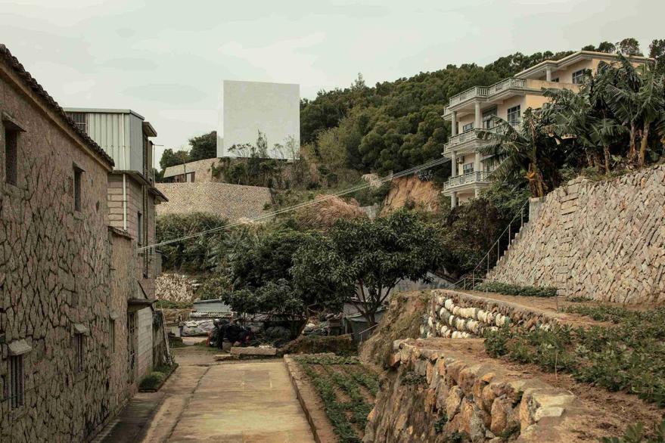
The climb leading up to the church alternates compression and release, during which the glimpse of the cube registers as a threshold into sacred time. Almost like a ritualized passage from secular to sacred where the distant luminous volume acts as a marker. Traditional Romanesque cathedrals created threshold and refuge through massive walls and dim interiors, for example Speyer Cathedral whose thick walls, limited windows, and barrel vaults presented permanence and security for a world in turmoil. Jianshan aims at the same mental shift with a different approach. The work presents a complete geometric body borne on great rocks so that a floating power appears in contrast and relation to nature and the settlement.
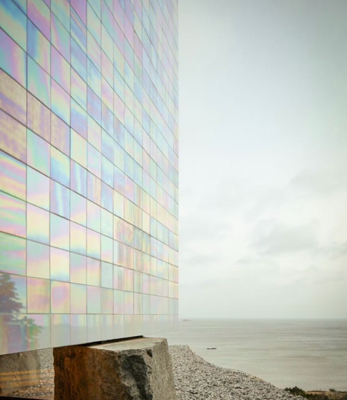
The approach also translates theological light into a coastal material language. Situating on the seaside in Wencuo Village and facing the sea to the east, the church has a unique tie with the ocean. To capture this, glazed ceramic tiles were tested to achieve a seashell sheen that catches seasonal changes of light, allowing the surface to register sky and earth, mountain and sea. The building fabric therefore mediates creation and Creator by luminous change rather than by medieval stained glass. This fulfils the long Catholic use of light as theological matter while adopting local cues.
The design team describes three terraces set into the site. Everyday functions including entry, reception, dining, study, and simple lodging occupy the first two levels at domestic scale, while stairs with rest platforms rise to the chapel on the highest terrace through woodland. A free, terrain shaped path therefore resolves into a precise interior geometry.

- On the terrace and entrance
At the end of the stairs, the view opens into two paths: one to the church door and another to an open platform facing the sea. There are no spires, yet standing at the foot of the cube I felt immensity. In both upward and outward directions, I approached the church door in a path that descended with each step, sinking into small boulders that humbled the body and urged to get to the door.
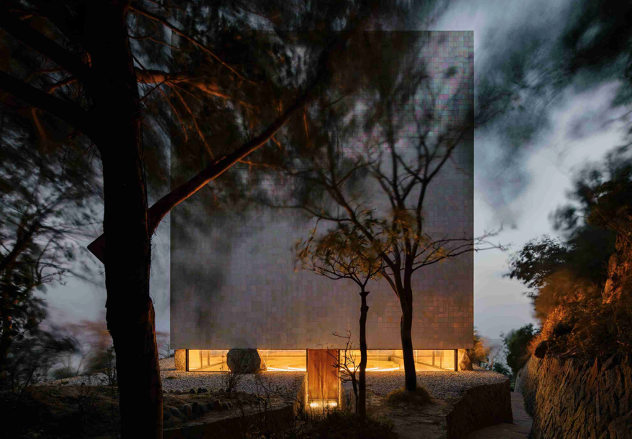
Gothic vertical awe was engineered by the trio of the pointed arch, rib vault, and flying buttress which permitted soaring height and thin walls. Chartres Cathedral, for instance, embodies this logic, its double flying buttresses and asymmetrical spires rising while interior piers lift the gaze to rib vaults. Jianshan Church, however, elicits immensity without spires by letting the body descend into stones under a poised cube. The movement is one of humility and anticipation. The exterior remains a precise volume, while the interior promises a concentrated optical ascent.
Baroque churches elevate approach through theatrical sequence, curved façades, and grand stairways. St Peter’s Basilica represents this dramatic program and its interiors couple illusionistic ceilings and cupola light with reflective gilding to intensify divine presence. At Jianshan the spectacle is reduced to a geometric mass, a descent into boulders, and a controlled first view. The bodily script still prepares reverence before the threshold but through restraint rather than ornament.
A complete geometric body is supported by rocks to produce mystery and sanctity in relation to the surroundings, and within that body the star river dome asserts a cosmological focus. This is awe through enclosure and sequence rather than through structural height

- Entry
Desending and reaching the door, I crossed the threshold. The light dimed. Instinctively the gaze is directed upward, to the cave-like irregular dome studded with points of light like a star field, an inward universe of its own. At my own level, a horizontal band of daylight surrounds the church interior, dividing the world from where my view was, into two.
Controlled sighlines and verticality
Jianshan produces vertical ascent by control of the first view. The threshold darkens and funnels the gaze to the canopy so a mental lift replaces the long processional pull of a medieval nave. Gothic cathedrals achieved that lift through rib vaults that directed the eye along a longitudinal axis. Here the ascent is compressed and immediate which sharpens the small self response at entry, a known driver of awe.

The starry dome and light
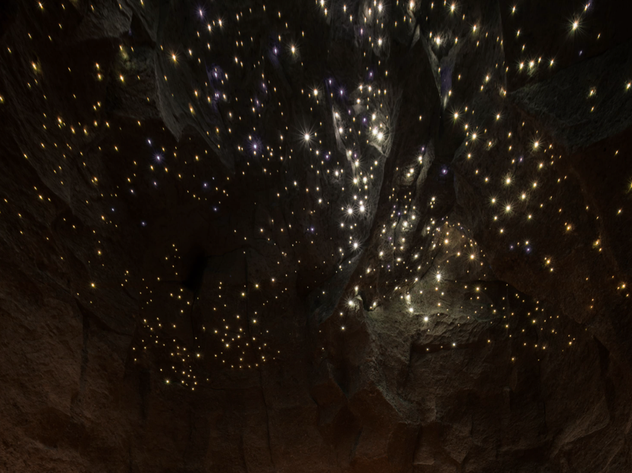
Upon entry the view is intentionally constrained upward to artificial light in the canopy. The floor is sunken and inlaid into earth, with kneelers and altar arranged concentrically so an encircling upward pull focuses feeling on the man made starry cosmos. The architects describe this as a dialogue space among earth, human, and cosmos. Medieval builders also theologized light. Abbot Suger at Saint Denis treated light as a primary theological material and refined structure to admit it, asserting that illumination manifests the divine. Jianshan translates this theology by pairing a symbolic firmament above with a timed reveal of creation so contemplation and mission are staged sequentially.

Daylit perimeter and chiaroscuro
The perimeter band of daylight is the counterpoint to the canopy. It distinguishes transcendent register above from worldly orientation at eye level and sustains a legible two part order. With the bright day light and the dark interior, Jianshan achieves chiaroscuro, a very strong contrast between the light and dark. In additional, a spiritual guidance is achieved through a calibrated contrast of dark and bright, artificial and natural, such that the mind reads a vertical hierarchy without relying on figurative imagery.

- Walking through the church
Continuing inward, the alter seemed close at hand. Seats ripple outward in 3 concentric rows enclosing the center.
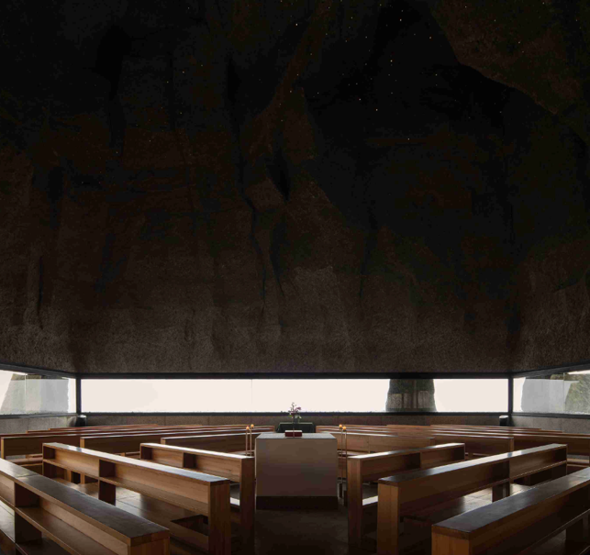
This floor plan makes a theological argument from the reforms of the Second Vatican Council. Those reforms emphasized the active participation of the laity in the liturgy and sought to reduce barriers between priest and people. In place of a long nave leading to a distant, elevated altar, many churches adopted centralized or hybrid plans, lowered and moved altars closer to the congregation, and pursued a style regarded as authentic for our time that fosters community and shared worship.
Jianshan implements that program as form. The altar is the spatial center and origin of the rites. Kneeling places are arranged concentrically so that the priest leads from the center and action radiates outward, drawing the faithful into a single shared performance. The project brief states exactly this. The plan is encircling, kneeling around the altar, with the altar as the center from which all rites proceed. The priest leads and the congregation is drawn in to participate.
Theologically, this articulates the “Church as the People of God” gathered around the Eucharistic table. In Catholic understanding the Eucharist constitutes the Church, so proximity, mutual visibility, and a shared acoustic field serve ecclesiology as well as experience.
A clergy member, Mr. Chen, described going to the altar as holy, joyful, and proud in a sacred way. The testimony corroborates that proximity intensifies reverence.

- Participation in the mass
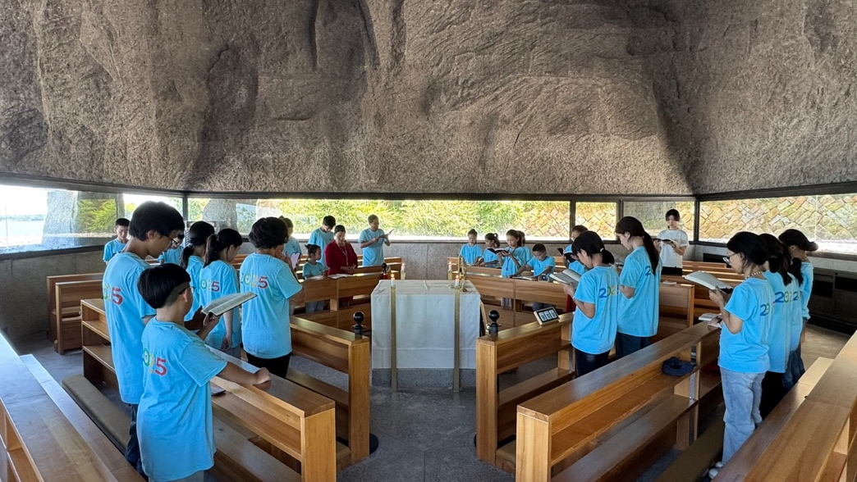
2025 is a Catholic Jubilee Year (Holy Year), celebrating the 25th anniversary of the incarnation of Jesus Christ. On my visit, I was joined by a group of children on pilgrimage during liturgy, I watched as they entered into the seats in two orderly rows, spreading out in a diamond shaped arrangement of seats. Before the mass, low conversations and whispers softly echoed. They looked up and around. When the mass began, the priest’s voice landed clearly. He was in one of the rows rather than the center. The group, including me, gathered around the altar with a slender crucifix.
This moment shows how the plan, acoustics, and posture create a single act of prayer. Theologically, a shared act matters because the Eucharist is the sacrament that makes the Church. The circle shortens distances and allows bodies to synchronize in kneeling, standing, and response. Psychology research ties awe to the small self and to increased social connectedness. Here, the sunken floor and upward optic create humility, the concentric seating creates mutual visibility, and the short acoustic path renders the priest’s words clearly among the people. Those mechanisms together yield both self diminishment and bonding.
A youth pilgrim remarked that the experience felt almost like one body around the crucifix, connecting sacred feeling to community closeness and to the nearness of the starry dome which helps her recenter.

- Acoustics
Inside, I was aware of my presence in every moment. Any sound coming from my body lives, though briefly and then it dissolves. Standing at the center, I hummed a phrase of Agnus Dei. I felt my voice rising up to the irregular dome and washing back from the sides in a smooth, circular motion.
Historical acoustic trategies, such as the one used in Westminster Abbey, produces long reverberation, reported at five and a half to eight seconds, creating an enveloping sound field that wraps chant and heightens awe. Jianshan, in contrast, calibrates reverberation for participatory clarity. The volume of the church is compact, about one hundred forty four square meters, and although there was no specialized acoustic engineering, the twelve by twelve meter cube produces strong enclosure so that speech lands cleanly and short resonance gives music warmth without obscuring words. The silence worshippers report upon entry is therefore a designed acoustic effect of enclosure and surface rather than a byproduct of monumental size.
The design team states that the church mainly serves nearby villagers with small assemblies focused on Mass and prayer, and that the enclosing cube strengthens presence and quiet.

- Bigger environment
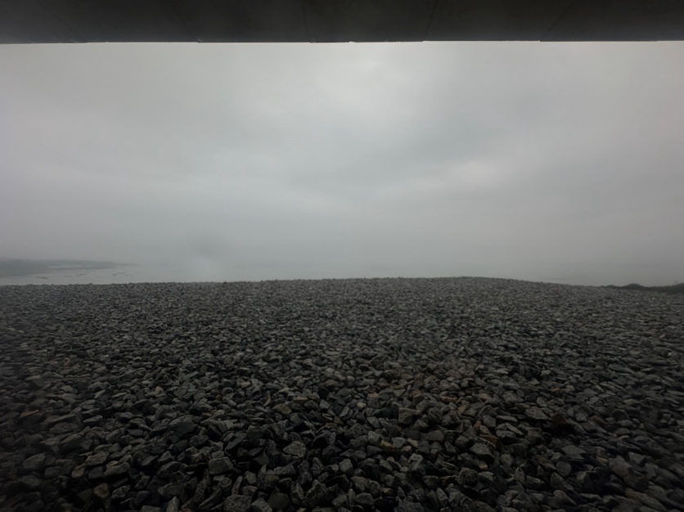
From the daylit parameter, I already saw what is far: distant shore, beach, calm sea, and trees moving with the wind. Stepping out, the wind pressed stronger. The gravel shifts under my feet as I follow the path around to an open terrace behind the church, feeling how the church sits within nature.
Site conditions of the church allow sea views in many directions, yet inside the views are controlled during rites so that when kneeling attention remains around the altar and the canopy. Only after the rite, when one stands, does the sea return and the visitor re enter the site’s reality. This sequencing is part of the project’s stated aim to set up dialogue among earth, human, and cosmos and to place worldly horizon after prayer rather than during it.
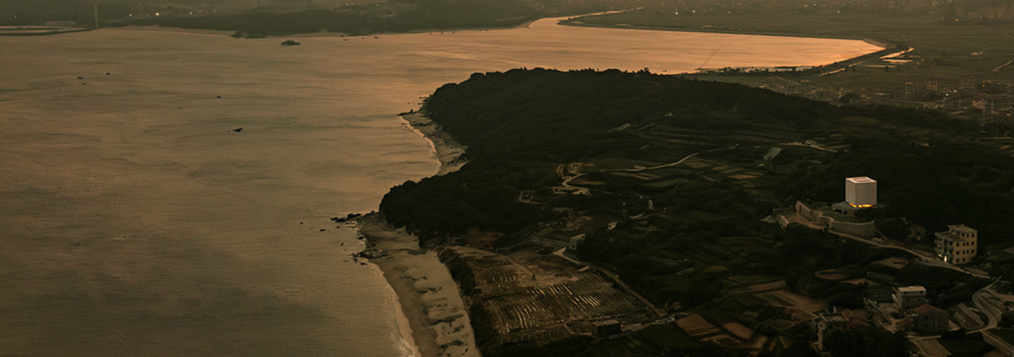
Baroque churches often staged approach through grand stairs and comprehensive sensory theater to inspire surprise, emotion, and awe for the Counter Reformation. St Peter’s is the canonical interior precedent in your review, where dramatic effects, illusionistic ceilings, and cupola light intensify divine presence. Jianshan uses wind, light, horizon, and gravel underfoot as a natural liturgical suite after the door. The landscape is theologized as material for re entry into the world The secular and the sacred is thinned through light, proportion, and landscape.

- Community and craft
On the path leading to the church, I passed a family and their crop field. To the west, villagers continue their day.
Before carrying out the design, the design team surveyed local churches for scale, form, and materials, and studied surrounding construction systems, then synthesized options suited both to desired effects and to the site. The stated pastoral purpose includes serving those who cannot travel far for Mass, which enacts the Church as a people gathered in place. This community orientation echoes the post Vatican II aim to nurture shared worship and belonging in plans that bring clergy and laity together.
A project design document also cites “occultism” as a theme and formal inspiration for the building’s shape. In this case, the term marks a turn to cosmological mystery as a generative image rather than a doctrinal claim, reframing sacred imagery beyond imported European iconography. It sits alongside the shell-like glazed tile and the sea-facing siting, so the symbolic register is drawn from local landscape and from an abstracted “cosmos.” This reading is consistent with Catholic uses of the heavens as an anagogical sign in historic ceilings and domes, while the liturgy here remains centered on the altar and crucifix. The result is a localized symbolic vocabulary that reaches for the numinous through natural and cosmological cues.
Local testimony supports this outcome. Mr. Chen speaks of arriving here with a calm heart, as if in conversation with God, and Ms. Chen describes how parish life quickly forms good habits through shared song and film. These observations match a space in which symbolic mystery, local material, and communal practice reinforce one another.

Final Synthesis: A Modern Grammar for Sacred
Jianshan catholic church demonstrates how a modern chapel can evoke sacredness by translating the traditional architectural grammar of awe into a modern language. The design team articulates two aims for sacred feeling. The first is height through a twelve meter interior so visitors feel sublimity on entry. The second is holy light where the canopy produces dreamlike colored effects like descending divine light, strengthening reverence. Where Gothic cathedrals employ pointed arches, ribbed vaults, and flying buttresses to achieve height and flood stained glass, and where Baroque churches deploy illusionistic heavens and cupola light for theatrical presence, Jianshan works with a poised cube, a starry canopy, a perimeter band of daylight, an encircling plan, and intimate acoustics to produce humility, peace, and shared participation. The result is a faithful translation of Catholic architectural language into a coastal Putian idiom that leads from entry awe to communal prayer to a theologized landscape beyond the door.

