**Feinaki 2025 Beijing Animation Week**

**Competition Program Entry Form**

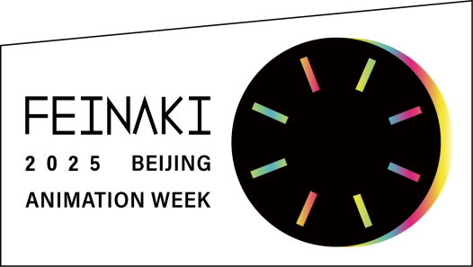

**About Us**

A festival curated from the eyes of animation artists, a screening journey to explore poetry and inspiration, with audience together we create a garden for our mind.

Feinaki Beijing Animation Week is an animation festival curated by the internationally well connected Chinese animation artists, researchers and curators who frequently travel between animation festivals across the world. The festival was established in 2019 and has been held 6 times by 2024. We dedicate our efforts to inspiring and encouraging Chinese animation filmmakers, presenting Chinese animation art and keeping them in the international spotlight. At the same time, we introduce high-quality international works, provide Chinese audiences with fresh aesthetic experiences, and establish the possibility of face-to-face exchanges with filmmakers from around the world, to promote a prosperous ecosystem for animation creatives.

The 7th edition of Feinaki Beijing Animation Week will be held in mid-November 2025. Our competition program is open for international submission.

**Call for Entries**

**May 1 - August 1, 2025**

**Entry Regulation**

**Submission Eligibility**

No submission fee is required.

Submitted animated films need to be made after November 2023, less than 60 minutes.

Works that have already submitted for previous Feinaki Beijing Animation Week cannot be accepted.

Artificial intelligence-assisted films can be accepted, but entrants must be truthful about the scope of use.

Non-English language films must have English subtitles.

**Submission Requirements**

For individual submission, each film should be submitted with its own entry form.

Every submitted film should include the following materials:

1. The download link of the film file (MOV or MP4 format, please compress to less than 1GB), or a password-protected online preview link. Please ensure the link remains active until September 1

2. Completed and signed entry form

3. A profile picture of the director (300dpi)

4. 3 screen shots of the film (300dpi)

5. (Optional) 1 poster of the film (300dpi)

6. (Optional) Trailer of the film (MOV or MP4)

**Technical Requirements**

Submitted file needs to be in MOV or MP4 format (please compress to less than 1GB).

If the submitted film is officially selected for screening, an HD version of the film needs to be provided in MOV format (Codec: H.264 or ProRes422, Full HD Resolution, Stereo Sound, DCP file is not supported)

**Awards**

**Grand Prix**

5000 RMB, 1 best film in short film competition program

**Feinaki Award**

5000 RMB, 1 best Chinese film in short film competition program

*Chinese film must meet at least one of the following conditions:

1. The nationality of the director or one of the co-directors is Chinese
2. The production country of the film includes China

**Student Award**

3000 RMB, 1 best student film in short film competition program

**MV Award**

1 best film in MV competition program

**Commissioned Animation Award**

1 best film in commissioned animation competition program

**Children's Animation Award**

1 best children’s animation in short film competition program, voted by audiences of all ages program

**Jury's Choice Award**

6 films from the short film competition program will be awarded, each jury will choose 2 films, including 1 Chinese film and 1 foreign film

**\*In addition to the above awards, the Feinaki Beijing Animation Week Executive Committee reserves the right to introduce further awards to the competition.**

**Selection Process and Awarding Rules**

The official selection decision will be made by Feinaki 2025 Beijing Animation Week Preliminary Selection Committee, which consists of both specialists in the field of animation and related art and members of the Feinaki Beijing Animation Week Executive Committee. The Preliminary Selection Committee is also responsible for organizing screenings of competition programs and panorama special selection.

The official selection results will be announced on our official Wechat account “FeinakiAnimationWeek” and official website “www.feinaki.com” in early September 2025.

The board of Final Juries is composed of international animation experts invited by Feinaki Beijing Animation Week Executive Committee. Grandprix, Feinaki Award, Student Award, MV Award, Commissioned Animation Award and Jury’s Choice Award will be selected by the board of Final Juries. Children’s Animation Award will be voted by audiences of all ages program. The list of winners will be announced at the closing ceremony of the 7th Feinaki Beijing Animation Week.

**Festival Authorization**

All submitted materials for the competition program need to be authorized by the copy rights holder.

For works that infringe on the copyrights of others, the Feinaki Beijing Animation Week Executive Committee has the right to disqualify them from participating.

The Feinaki Beijing Animation Week Executive Committee has the right to use all materials related to the submission as well as a film excerpt up to 10 percent of the total length of the film for promotional purposes.

The films which selected in competition program will be screened at Feinaki 2025 Beijing Animation Week. The Feinaki Beijing Animation Week Executive Committee does not need to pay the screening fee for the entries during the festival.

**Contact**

Please submit all materials in one email to **[entry@feinaki.com](mailto:entry@feinaki.com)**

**\* You will receive an email receipt, when the submission is successful.**

Facebook: [www.facebook.com/FeinakiBeijing](https://www.facebook.com/FeinakiBeijing/)

Website: [www.feinaki.com](http://www.feinaki.com)

**费那奇动画周·2025 竞赛单元报名表**

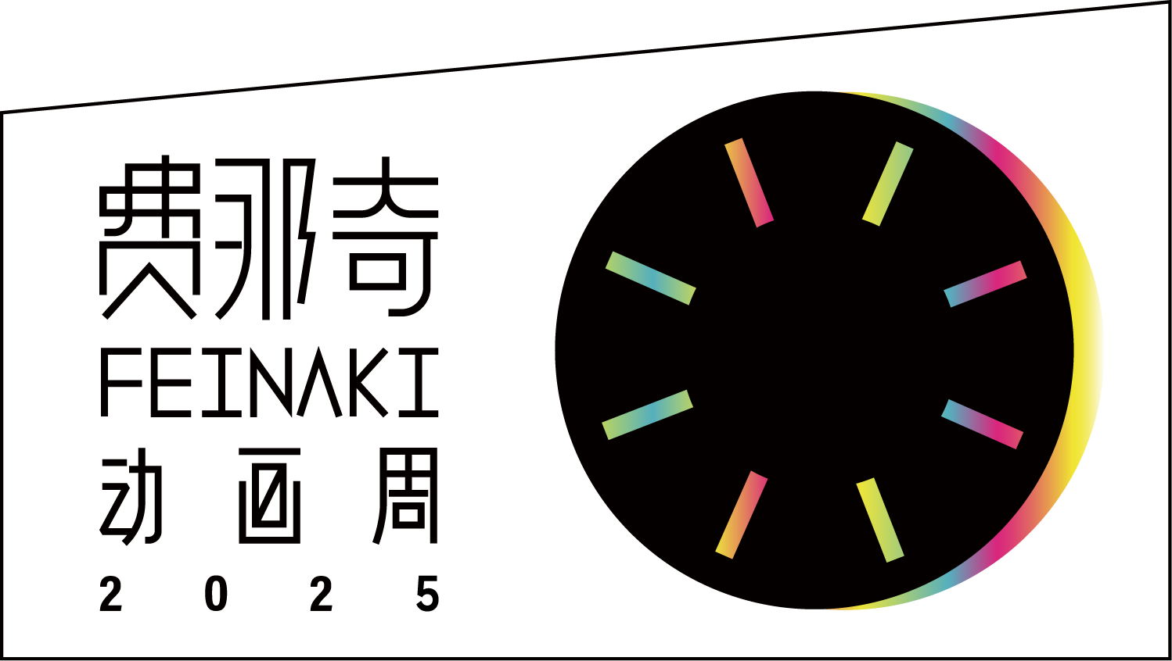

**简介**

基于作者视角的动画之旅，探索诗性和灵感的动画盛宴，与观众共筑彼此的精神家园。

费那奇动画周是一个由与国际动画节交流频繁的中国动画艺术家、研究者与策展人组织策划的国际动画交流活动，于2019年首次在北京发起，至2024年已成功举办六届。

我们致力于鼓励动画创作者，让中国动画艺术持续在国际舞台上被关注。同时，我们引进优质国际资源，提供优质审美体验，建立与世界作者面对面交流的可能性，真正成为沟通中国和世界动画交流的纽带。

第七届费那奇动画周将于2025年11月中旬举办，竞赛单元面向公众公开征集动画作品。

**征集时间**

**2025 年 5 月 1 日 至 2025 年 8 月 1 日**

**征集章程**

**一、参赛条件**

本竞赛无须报名费。

2023年11月之后完成的动画短片作品（60分钟以下）可以参赛。

曾报名参加过往届费那奇动画周的作品不得重复参赛。

人工智能辅助创作的作品可以参赛，但参赛者需如实告知使用范围。

非英语对白的参赛作品应添加内嵌的英文字幕。

**二、报名材料**

由个人投递时，每个作品应单独报名，单独填写报名表。

报名邮件中需提交的资料列表：

1. 作品文件的下载链接（MOV或MP4格式，请压缩至1GB以下），或者有密码保护的线上播放链接，请保持链接在9月1日前有效

2. 完整填写并签字的报名表

3. 一张导演照片（300dpi）

4. 三张作品静帧图片（300dpi）

5. （非必须）一张作品海报（300dpi）

6. （非必须）作品的预告片（MOV或MP4格式）

**三、技术要求**

参加初审的作品文件格式：MOV或MP4（请压缩至1GB以下）

如果作品入围，请提供高清播放文件：MOV（编码：H.264 或 ProRes422，全高清分辨率，立体声，不接受DCP文件）

**四、奖项设置**

**大奖 1名**

奖金5000元人民币，短片竞赛单元所有作品中的最佳作品。

**费那奇奖 1名**

奖金5000元人民币，短片竞赛单元中的最佳中国作品。

* 中国作品须满足以下至少一个条件：

1. 导演或其中一位联合导演是中国国籍
2. 作品的制片国家中包含中国

**学生作品奖 1名**

奖金3000元人民币，短片竞赛单元中的最佳学生作品。

**MV大奖 1名**

MV竞赛单元作品中的最佳作品。

**委托创作类作品奖 1名**

委托创作类作品竞赛单元中的最佳作品。

**儿童动画奖 1名**

全年龄场单元中的最佳儿童动画作品，由全年龄场观众现场投票选出。

**评委选择奖 6名**

短片竞赛单元每位终审评委个人选择的2部作品，包括1部中国作品和1部外国作品。

**\* 除以上奖项外，费那奇动画周执行委员会保留在本次赛事中增设奖项的权利。**

**五、评选和颁奖规则**

初审评委会由动画及相关艺术领域专家和费那奇动画周执行委员会成员组成，初审评委会负责选定入围作品，组织分配各竞赛单元及平行宇宙单元的展映片目。

初审结果将于2025年9月初在“费那奇动画周”官方微信公众号和“费那奇动画周”官方网站公布。

终审评委由费那奇动画周执行委员会邀请的国际专家组成，终审评委会将决定大奖、费那奇奖、学生作品奖、MV大奖、委托创作类作品奖、评委选择奖的评审结果，儿童动画奖将由全年龄场观众现场投票选出，获奖名单将在第七届费那奇动画周闭幕式上公布。

**六、作品授权**

所有提交的参赛材料都需要获得版权所有者的授权。

对于侵犯他人著作权的作品，费那奇动画周执行委员会有权取消其参赛资格。

费那奇动画周执行委员会有权使用参赛作品的所有图片、文字资料和不超过总长度10％的作品片段，用于费那奇动画周的宣传推广。

竞赛入围作品将在费那奇动画周·2025活动中放映。活动期间的放映，费那奇动画周执行委员会无需支付参赛作品放映授权费。

**七、联系方式**

报名表投递邮箱：**[entry@feinaki.com](mailto:entry@feinaki.com)**

**\* 收到邮件回执，代表报名成功。**

官方微信客服：费那奇小助手（feinaki2019）

官方微信公众号：费那奇动画周

官方Facebook账号： [www.facebook.com/FeinakiBeijing](https://www.facebook.com/FeinakiBeijing/)

官方网站：www.feinaki.com

竞赛单元报名表

**ENTRY FORM**

|  |
| --- |
| **作品标题 FILM TITLE** |
| 中文标题： 英文标题：  ORIGINAL TITLE： ENGLISH TITLE： |

|  |  |
| --- | --- |
| **作品信息 FILM INFO** |  |
| 完成年份  YEAR OF PRODUCTION |  |
| 制片国家  PRODUCTION COUNTRY |  |
| 时长  RUNNING TIME | 分 Minute 秒 Second |
| 对白  DIALOGUE OR NARRATION | □ 无对白 None  □ 中文 Chinese  □ 英文 English  □ 其他语言 Other Language ______________ |
| 字幕  SUBTITLE | □ 无字幕 None  □ 中文字幕 Chinese  □ 英文字幕 English  □ 其他语言 Other Language ______________ |
| 技法（可多选）  TECHNIQUE  (MULTIPLE CHOICE) | □ 二维数字动画 2D Digital  □ 三维数字动画 3D Digital  □ 人工智能辅助 AI-Assisted  □ 纸上手绘动画 Hand-drawn on Paper  □ 偶动画 Puppet  □ 剪纸动画 Cut-out  □ 粉末动画 Powder  □ 真人定格动画 Pixilation  □ 玻璃彩绘动画 Paint-on-Glass  □ 针幕动画 Pinscreen  □ 其他技法 Other Technique ______________ |

|  |  |
| --- | --- |
| **作品类别**  **CATEGORY** | 可多选，初审评委会将根据此条信息决定你的作品所在的参赛单元。 Multiple categories can be selected. The Preliminary Selection Committee may decide the competition program of your work based on this information. |
| □ 专业动画作品 Professional Animation  □ 学生动画作品 Student Animation  □ 全年龄动画作品 All-aged Animation  □ 音乐动画作品 Animated Music Video  □ 由他人委托创作的动画作品 Commissioned Animation | |

|  |  |
| --- | --- |
| **作品简介**  **SYNOPSIS** | 少于50字的作品简介（中国作品请提供中英文） Synopsis less than 50 words. |
|  | |

|  |  |  |  |
| --- | --- | --- | --- |
| **导演 DIRECTOR** | | | |
| 姓名 NAME |  | 国籍 NATIONALITY |  |
| 邮箱E-MAIL |  | | |

|  |  |
| --- | --- |
| **导演简介**  **DIRECTOR’S**  **BIOGRAPHY** | 少于80字的导演 / 团队简介（中国作品请提供中英文） Director / Team biography less than 80 words. |
|  | |

|  |  |
| --- | --- |
| **制片人 PRODUCER** | |
| 姓名 NAME |  |
| 制片单位 / 学校  PRODUCTION  COMPANY / SCHOOL |  |
| 邮箱 E-MAIL |  |

|  |  |  |  |
| --- | --- | --- | --- |
| **报名联系人 CONTACT** | | | |
| 姓名 NAME |  | | |
| 电话 PHONE |  | 微信 SNS |  |
| 邮箱 E-MAIL |  | | |

|  |  |
| --- | --- |
| **作品链接**  **LINK TO WORK** | 请使用百度网盘、Google Drive、Vimeo、Dropbox等网络文件传输服务来发送您的作品文件。请保持链接在9月1日前有效。  Please use Baidu Pan, Google Drive, Vimeo, Dropbox and other online file transfer services to send your film. Please ensure the link remains active until September 1. |
| 密码 PASSWORD： | |

关于以下问题，参赛者需在回答前咨询版权所有者。  
Regarding the following questions, entrant should consult the entry work’s copyrights holder before answering.

|  |
| --- |
| 1. 作品中所使用的所有素材均已获得使用权，或者使用的是公有领域的素材。   All the materials used in the work are authorized by the copyrights holder or copyrights free. |
| □ 是 Yes □ 否 No |

|  |
| --- |
| 1. 参赛作品在创作过程中是否使用了人工智能？如有使用，请填写主要在哪些过程中使用了人工智能。   Was artificial intelligence used in the creation process? If yes, please illustrate the main processes in which artificial intelligence was used. |
| □ 是，用途 Yes, used for __________________________________  □ 否 No |

|  |
| --- |
| 1. 作品是否已在网络上公开发表？该选项不会影响作品的参赛。   Has the work been publicly published online? This option will not affect the entry of the work. |
| □ 是 Yes □ 否 No |

|  |
| --- |
| 1. 如作品曾在其他节展上展映，请填写节展的名称、国家、时间及所获奖项。   If the submitted work has been shown in other festivals, please write down the festival names, country, year and winning awards. |
| 例：费那奇动画周，中国，2019年，费那奇奖  Example: Feinaki Beijing Animation Week, China, 2019, Feinaki Award |

**声明 DECLARATION**

我已阅读并接受费那奇动画周・2025的竞赛单元作品征集章程。我保证以上填写的信息真实准确。我同意费那奇动画周执行委员会在本次活动相关场景下对作品图文资料的使用和作品的展映。

I have read and agree to the regulations of Feinaki 2025 Beijing Animation Week Competition Program. I certify that the provided information is true and accurate. The Feinaki Beijing Animation Week Executive Committee have my consent to use my submitted materials in festival related scenarios for screening and promotional purpose.

签名 日期

Signature Date

**ATTENTION**

Please submit all materials in one email to **[entry@feinaki.com](mailto:entry@feinaki.com)**

Please state the entry email subject in the format of “2025 | film title_director”

Applications for 2025 entry are open from May 1 to August 1

**\* You will receive an email receipt, when the submission is successful**

**CHECKLIST**

1. The download link of the film file (MOV or MP4 format, please compress to less than 1GB), or a password-protected online preview link. Please ensure the link remains active until September 1

2. Completed and signed entry form

3. A profile picture of the director (300dpi)

4. 3 screen shots of the film (300dpi)

5. (Optional) 1 poster of the film (300dpi)

6. (Optional) Trailer of the film (MOV or MP4)

**注意事项**

报名表投递邮箱： **[entry@feinaki.com](mailto:entry@feinaki.com)**

投递邮件主题请以“2025 | 作品名称_作者名称”的格式命名

报名提交时间为2025年5月1日至2025年8月1日

**\* 收到邮箱回执，代表报名已成功**

**报名文件列表**

1. 作品文件的下载链接（MOV或MP4格式，请压缩至1GB以下），或者有密码保护的线上播放链接，请保持链接在9月1日前有效

2. 完整填写并签字的报名表

3. 一张导演照片（300dpi）

4. 三张作品静帧图片（300dpi）

5. （非必须）一张作品海报（300dpi）

6. （非必须）作品的预告片（MOV或MP4格式）