*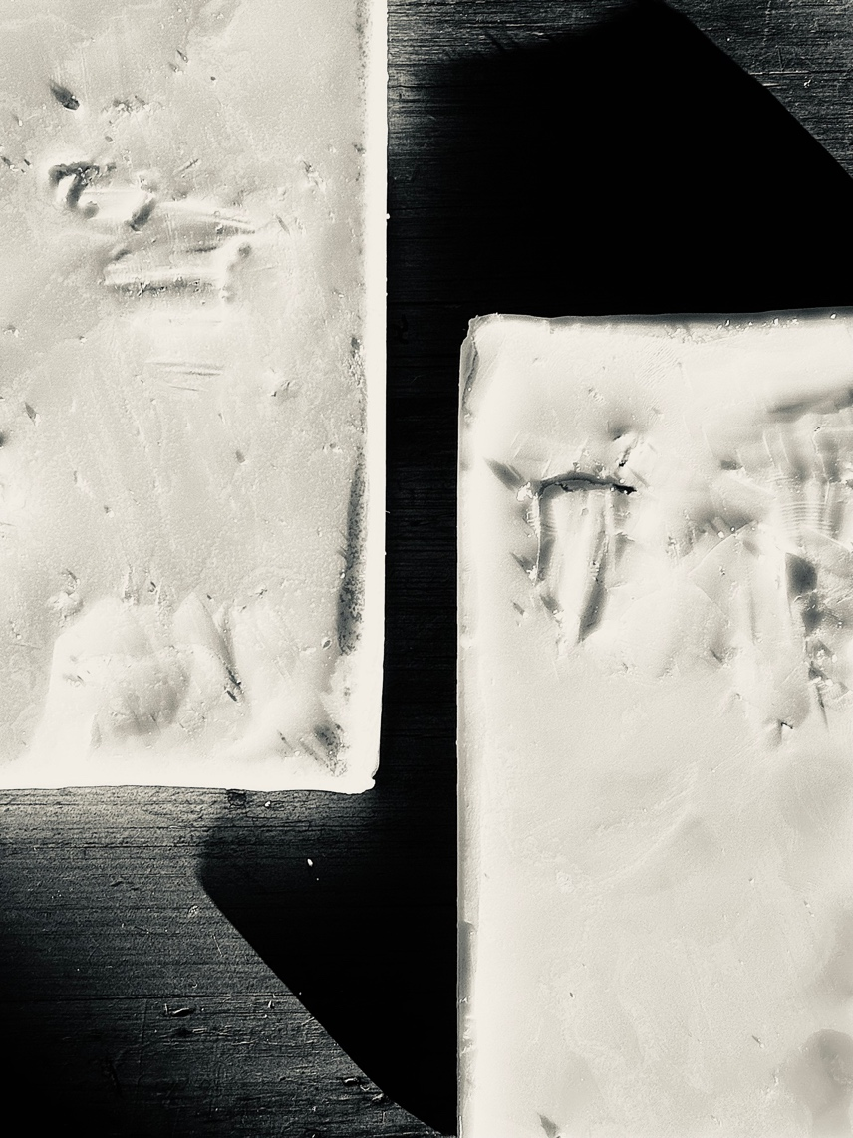*

*bone-deep*

Soph Gibson

@sophgibsonart

Trocadero Projects, Footscray, VIC

Aug 20 – Sep 21, 2025

Resting in the gallery are two hundred and six tiles, one for each bone in my body. The slabs of wax are as sensitive to touch as my body in pain. I tend to them, pouring, trimming, paring, massaging and softening each by hand. This laborious process is not foreign to me; it is akin to the constant, everyday management of a chronically ill body. Pale against the white gallery wall, the tiles are bones or fat or tissue or cartilage. In the skin of each tile, integrated pockets of pain management ointments and creams cause chemical instability, leaving behind puckering scars and perfumed cells. The universal elements of our bodily architecture are externalised and forced to navigate the architecture of the space they inhabit. Architectural features expected to be hardy, the skirting boards and floor tiles in the thoroughfare, are instead points of vulnerability and instability. The space itself becomes the disabled body, holding up its weakest points. A *bone*-*deep* pain refusing collapse, demanding tending to, quietly enduring the everyday.